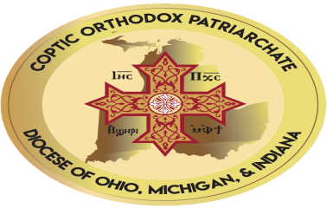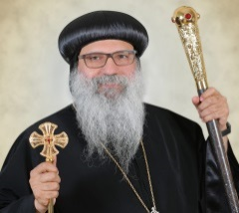

Dear Business owners and Professionals:
During the last few years, we have grown tremendously within our community, and we are sure that we have a lot of talents and a lot of people who can serve and help the community through the services they provide and because of this, with the grace and blessings of Anba Seraphim, we decided to come up with the first business directory for the dioceses of Ohio, Michigan, and Indiana.
We are also coming up with a personal directory and data base for our members so we can communicate and help each other and let the clergy and the servants know that we are here.
This is why, we are going to hold our first banquet with the grace of God of the dioceses on May 15th, 2022, and we are asking you to advertise for your services at the brochure of the event that will be widely distributed at the event and to some other places.
These ads will be also included at the website of the church for one full year and will be at the directory of the church and its data base.
This way your services will be exposed to the entire congregation as well as the public in each state and you can offer a discounts or special offers to whoever will refer to this ad.
Advertising of prices will be as follows:
-The first two pages of the brochure will be $2500 each with 3 free tickets.
-The last two pages will be $2500 each with 3 free tickets.
-The last pages Back Cover) will be $3000 with 3 free tickets, and this will be on first come first serve.
-A full page will be $1200 with two free tickets.
-Half the page will be $600 with one free ticket.
Please Call your agent at the church which will be announced soon at your church or any one of the main committees persons
Main Committee members:
Dr.Yehia Hanna Shelby. 2484137177
Dr. Samir Hanna Troy 248-224-2040
Evette Hanna Shelby 248-670-4413
Dr. Ghada Hanna Troy 248-515-0205

