

***Semaglutide: Tips and Tricks for success:***

**Rules:**

* Drink plenty of **water**. It is important to drink **90-100 oz** of water daily.
* Do **NOT** drink your calories
* For best results, **avoid** sugar and carbs. Eat **whole** foods and **avoid** processed foods.
* Cut out all sugar
* Intermittent fasting helps speed up the weight loss process and is healing on a cellular level. Ex: eat **ONLY** during these windows: 10am-6pm; 11am-7pm; 12pm-8pm
* Eat plenty of **fibrous** foods: vegetables
* Listen to your body and do not eat if you are not hungry. Stop eating before you are full.

**OTC Medications:**

* Ginger lozenges **(sugar free)** can assist with nausea. You can find these on amazon.
* Omeprazole can help with acid reflux.
* Mag07 can be used for constipation that might occur.

Injections are done subcutaneously **ONCE A WEEK**

**VIAL ONE:**

* Weeks 1-4 inject **5 units** on syringe once weekly
* Weeks 5-8 inject **10 units** on syringe once weekly
* Weeks 9-12 inject **20 units** on syringe once weekly

~ Some people may need to titrate slower and only increase by 5 units per month

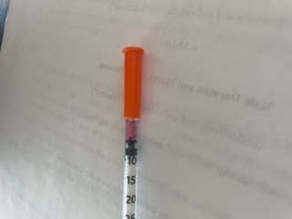 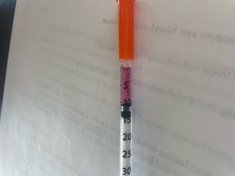 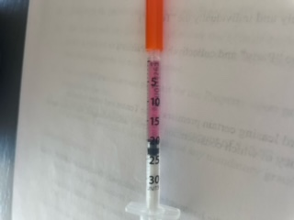

5 units 10 units 20 units

See provider for **3 month** (12 week) follow up to discuss additional vials and to review your individual treatment plan.

**WARNING:** Some people experience an increase in sensitivity to alcohol; limit intake.