Ankle Pumps/Circles

Move your foot up and down, or in circles, from the ankle.

This may be done while you are doing the Heel-Leg Prop. Repeat 4-8 times per day.

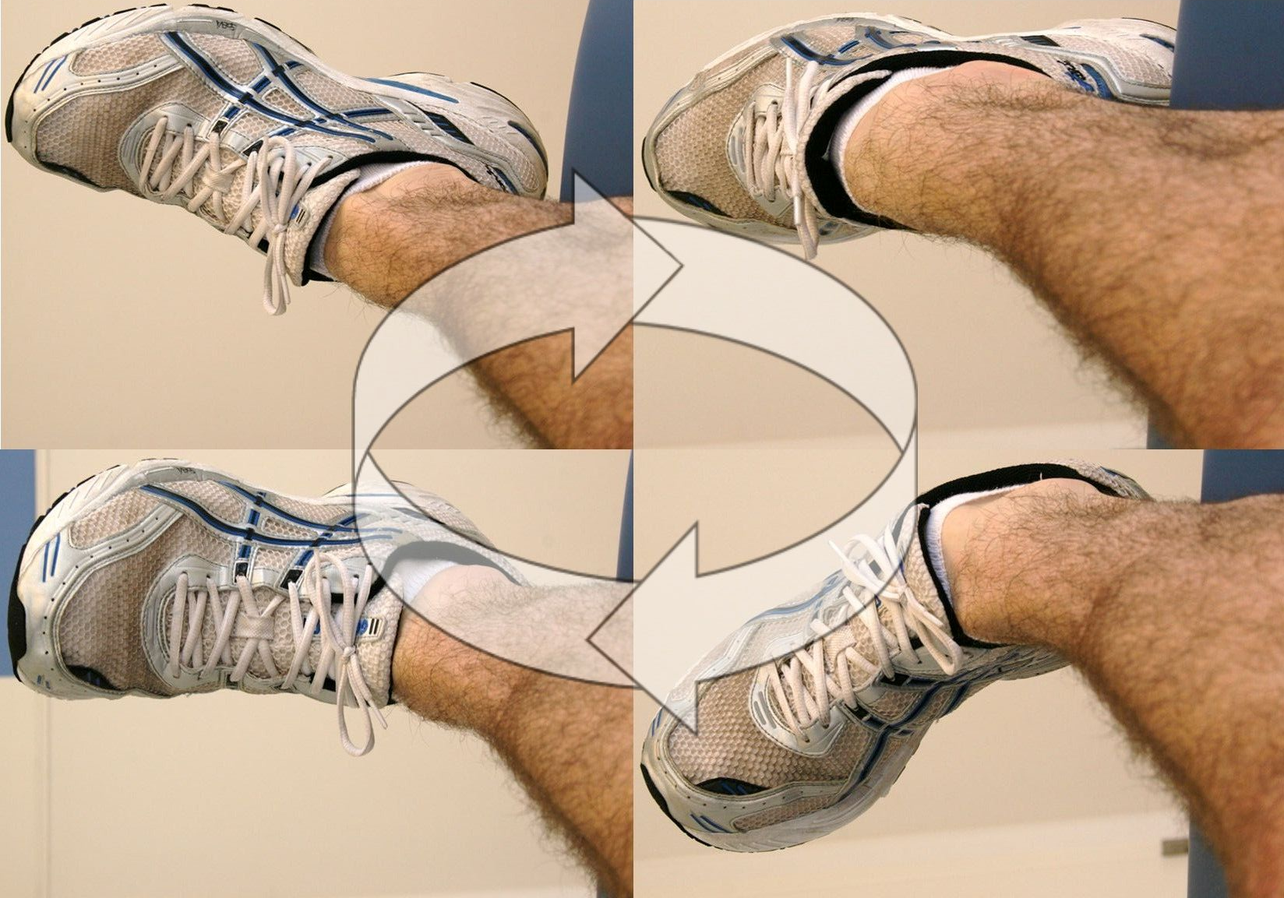

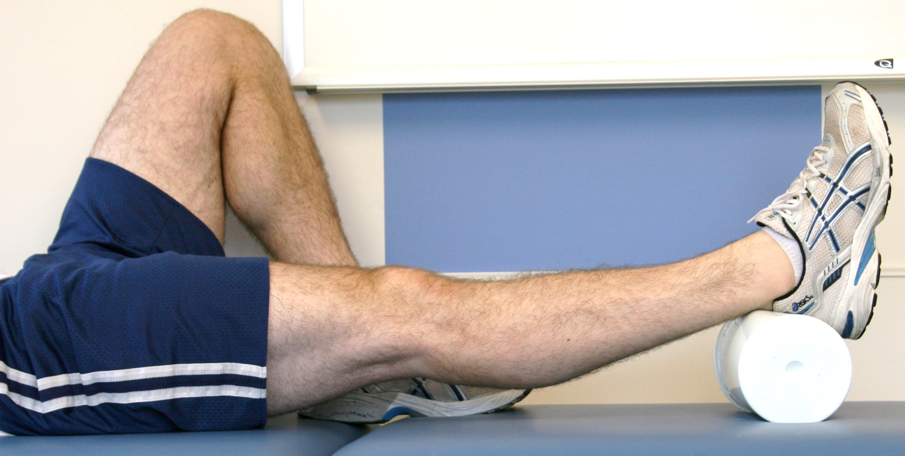

Heel-Leg Prop:

Elevate your leg by placing a cushion underneath your lower leg or heel as shown. Do this 4-8 times per day for 15-20 minutes. You may also sleep with your leg elevated.

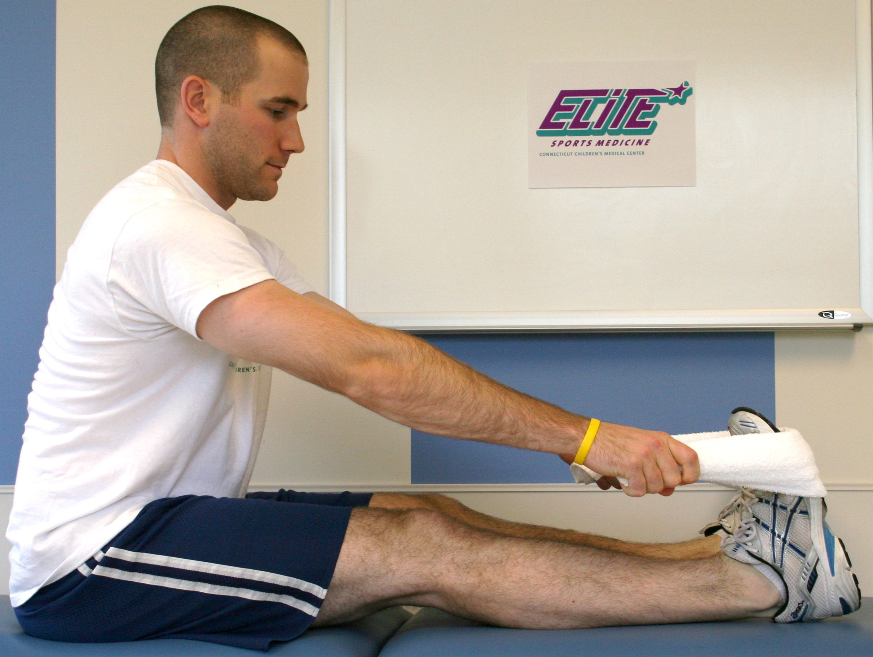

Calf Stretch:

Using a towel or a belt, gently stretch you calf muscles as pictured. Keep your knee straight. Hold the stretch for 20-30 seconds. Do this 4-6 times per day.

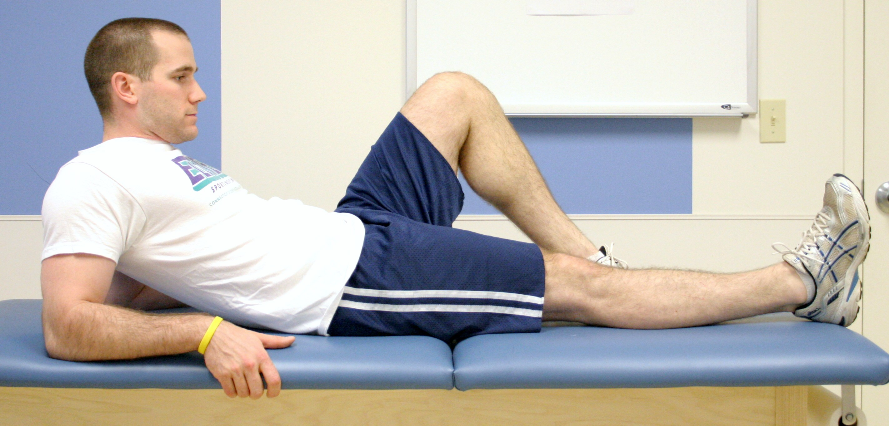

Quad Set:

Squeeze thigh muscles tightly, as if pressing the back of your knee into the surface you are lying on top of. Hold contraction for 10 seconds, repeat 30 times. Do this 4-6 times per day.

Assisted Knee Flexion:

When seated in a chair, allow your knee to bend a comfortable amount. Use your other foot to control bending and straightening your knee. Stop if this becomes uncomfortable. This may be done several times throughout the day.

