Ankle Strengthening Exercises
Directions: All exercises should be completed in the following method; three (3) set of ten (10) repetitions unless otherwise noted. Ankle strengthening exercises should be completed 3-4 times per day and should be done to both sides. Greatest gains will be made when the muscles are warm.
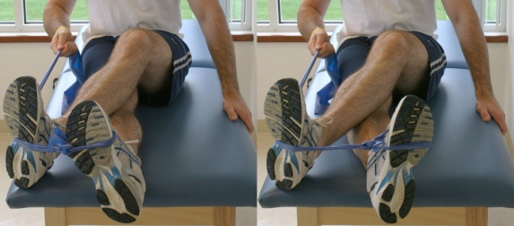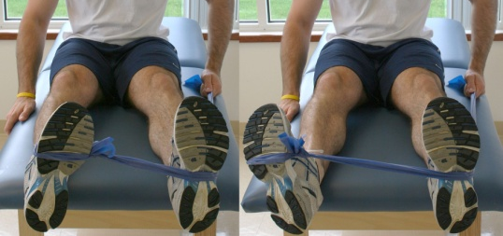
Resistance Band –

Inversion – (Pictured Top Left) Loop a resistance band over your toes. Move your toes in a direction toward your other foot without rotating at your knee.

Eversion – (Pictured Middle) Loop a resistance band over your toes. Move your toes in a direction away from your other foot without rotating at your knee.

Plantar Flexion – (Not pictured) Loop a resistance band over your toes holding the band in your hands. Push your toes in a direction away from your body.

Dorsi Flexion – (Not pictured) Loop a resistance band over your toes. Pull your toes in a direction toward your body.

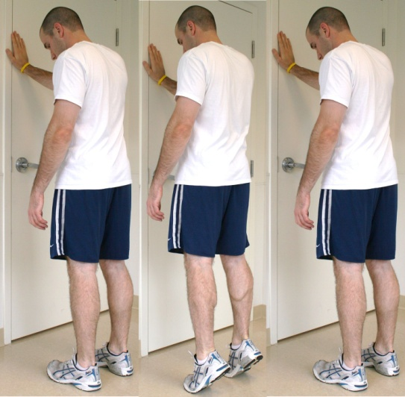
Double Leg Heel Raises –
While standing on both feet at shoulder width apart, raise your heels off of the ground as far as you can. Hold at the top for 1-2 seconds, and then slowly lower your heels back to the ground. Progress from flat level ground to a step where your heels sag off of the end of the step.

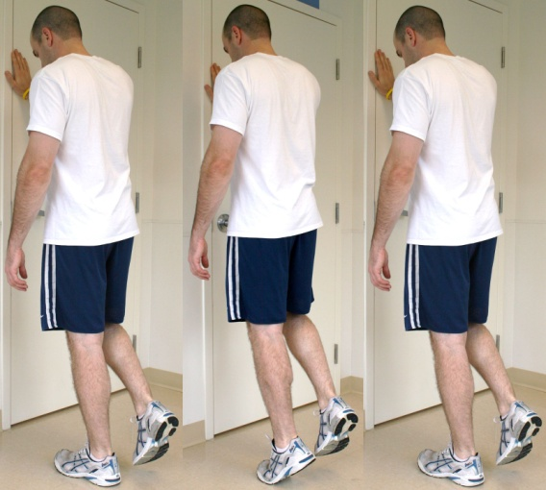
Single Leg Heel Raises –
While standing on one foot, raise your heel off of the ground as far as you can. Hold at the top for 1-2 seconds, and then slowly lower your heel back to the ground. Progress from flat level ground to a step where your heel sags off of the end of the step.

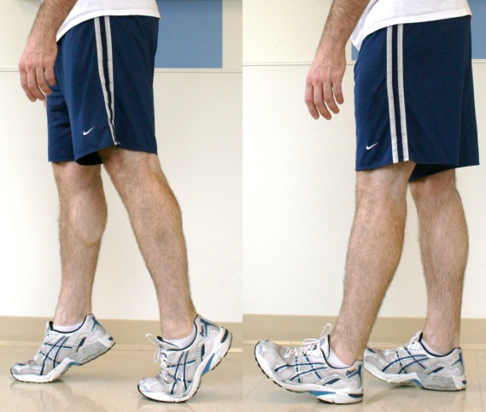
Heel & Toe Walking –
Raise your heels off of the ground as far as you can. Proceed to walk around for 3 minutes in this same position. Make sure that your heels do not move closer to the ground while walking. For heel walking do the same process but keep your toes as high off the ground as possible.

