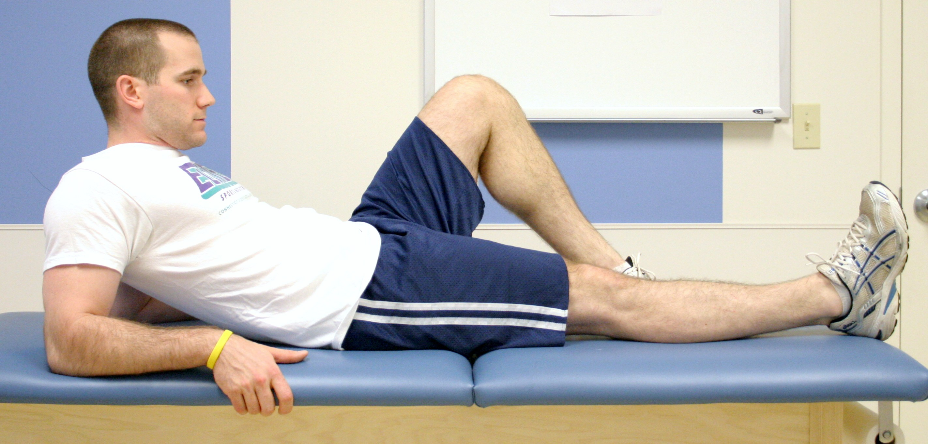

Quad Set:

Squeeze thigh muscles tightly, as if pressing the back of your knee into the surface you are lying on top of. Hold contraction for 10 seconds, repeat 30 times. Do this 4-6 times per day.

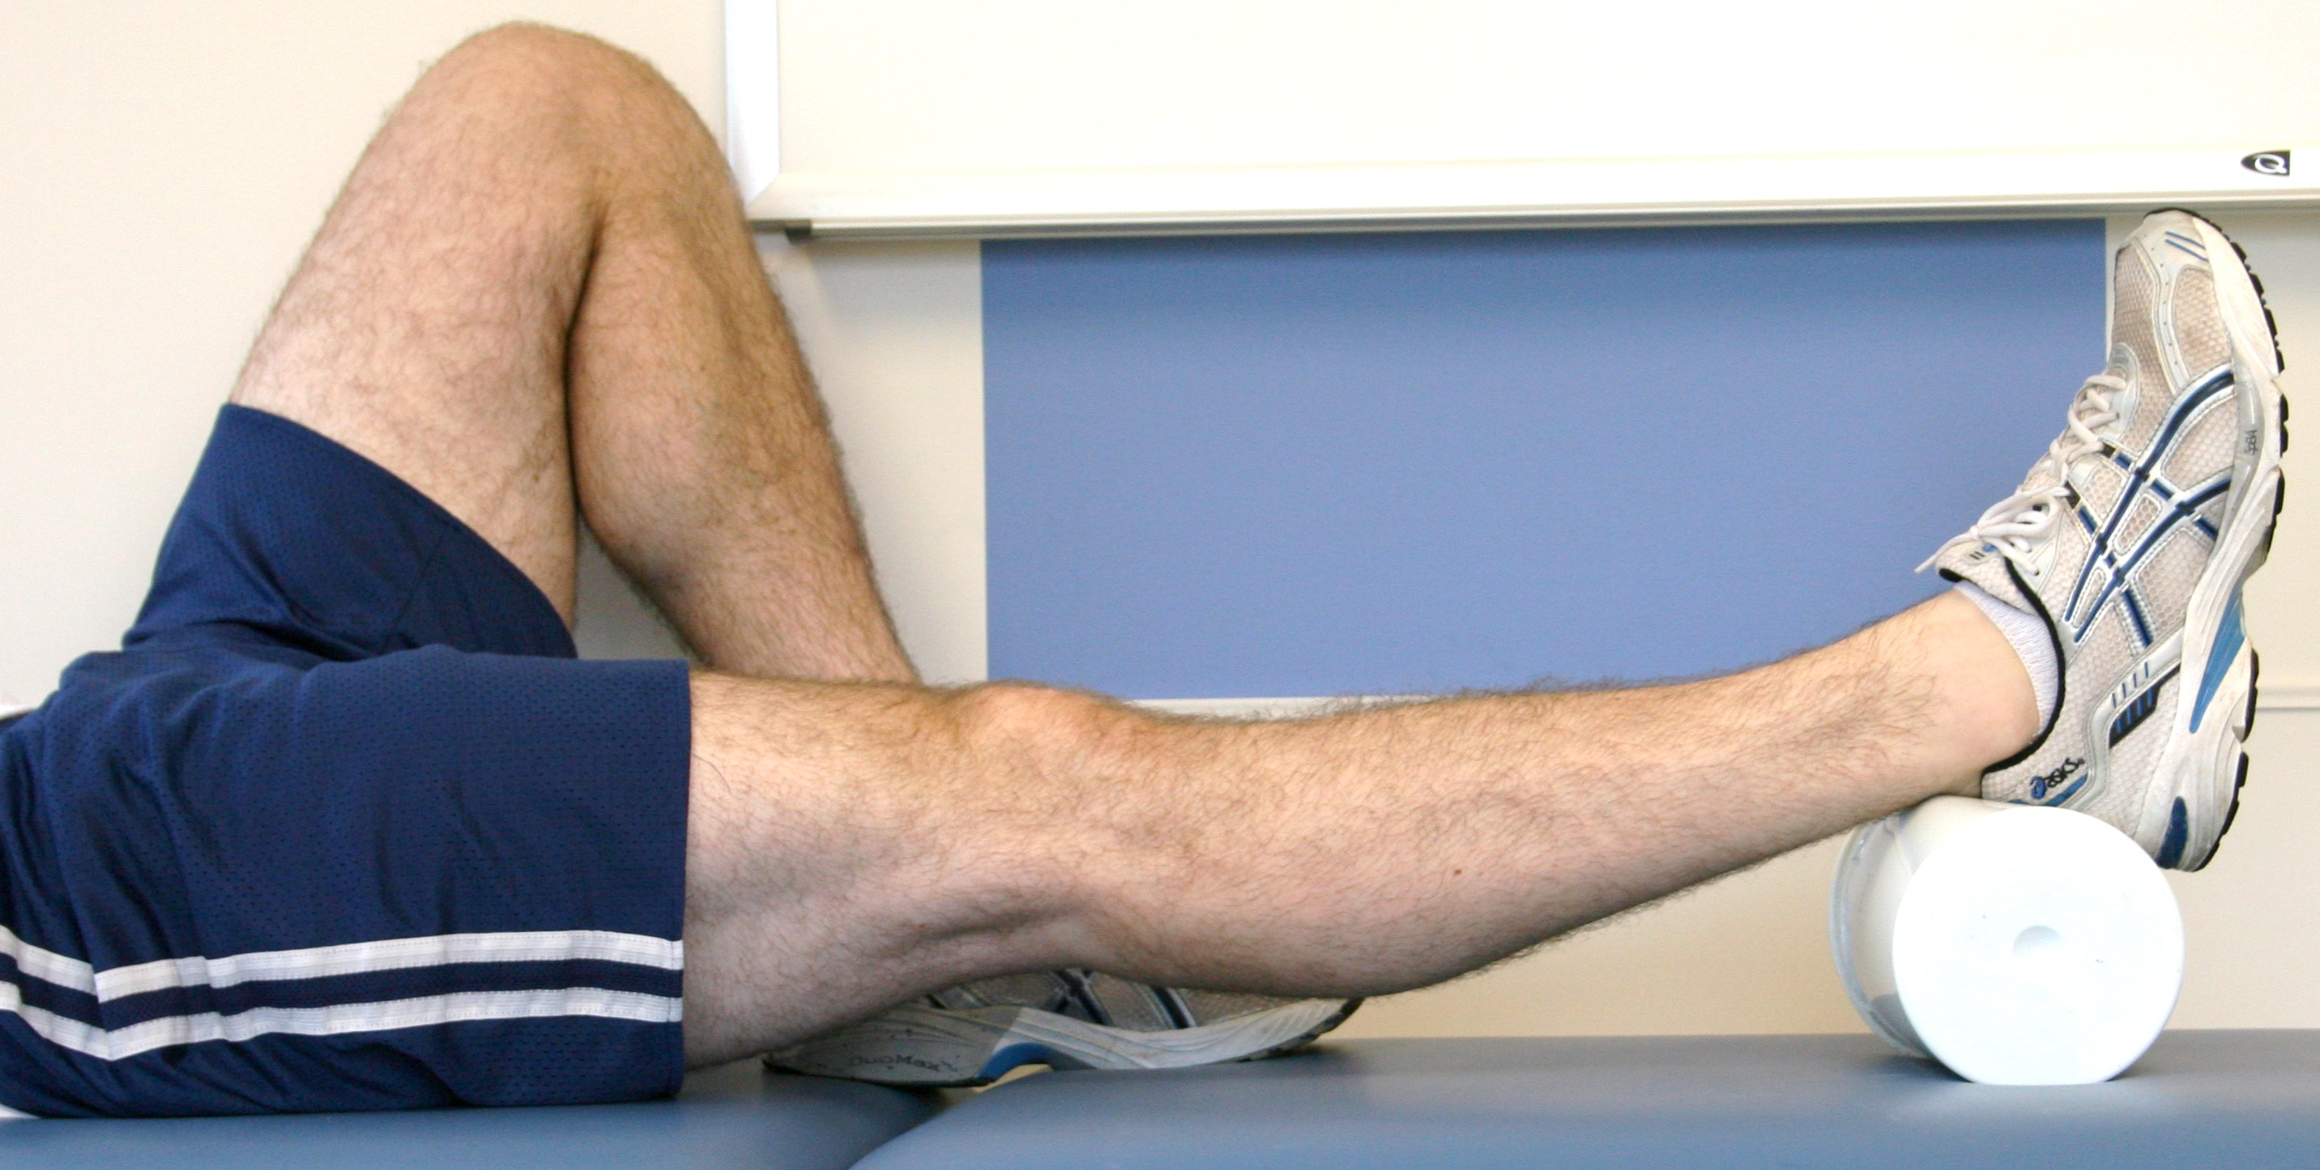

Heel-Leg Prop:

Elevate your leg by placing a cushion underneath your lower leg or heel as shown. Do this 4-8 times per day for 15-20 minutes. You may also sleep with your leg elevated.

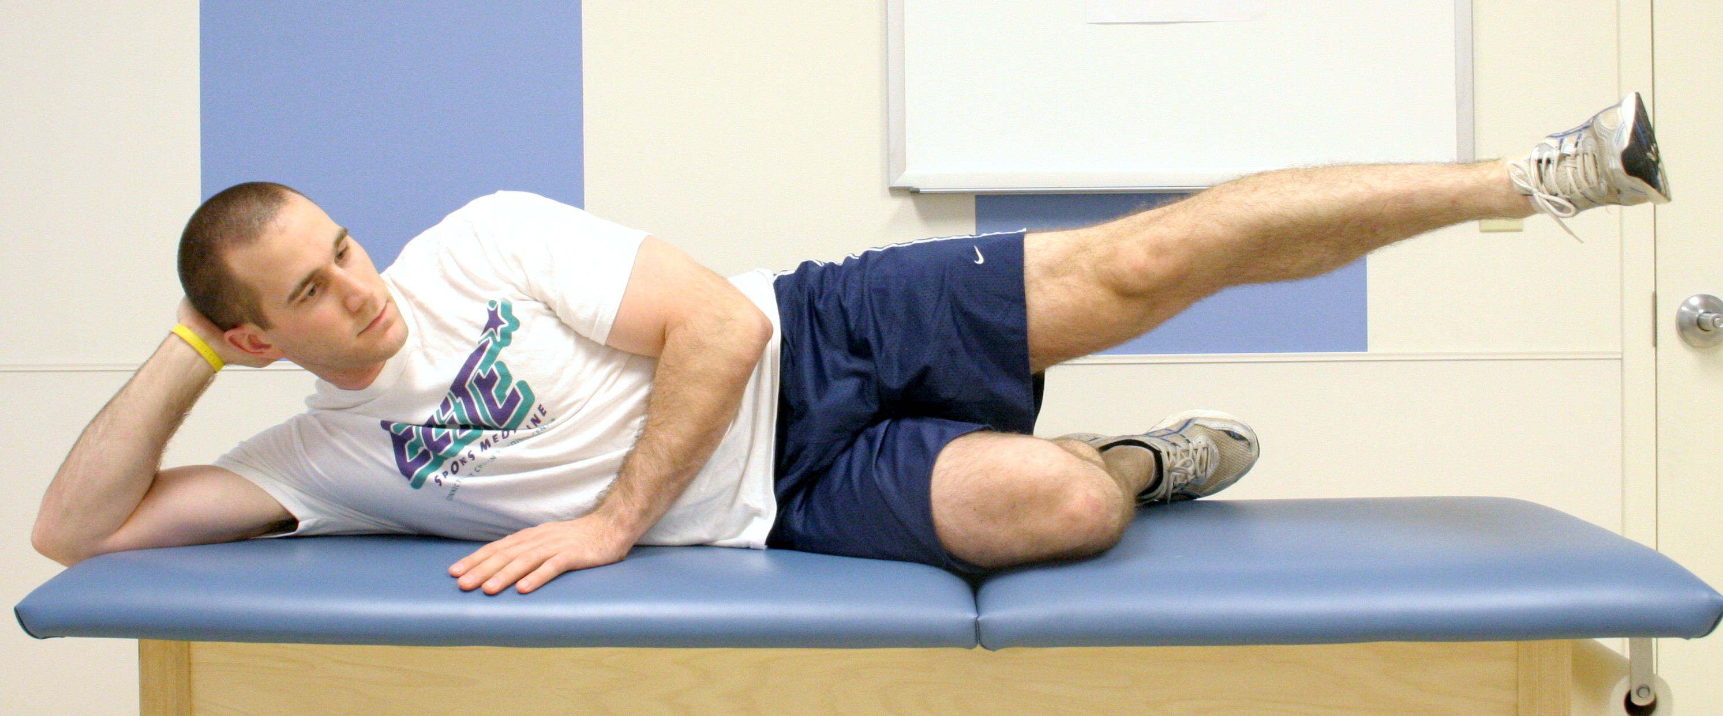

Straight Leg Raise, Abduction:

Squeeze thigh muscles tightly, then lift leg from the surface as

shown in the picture. Raise and lower your leg slowly. Repeat

15-30 times. Do this 4-6 times per day.

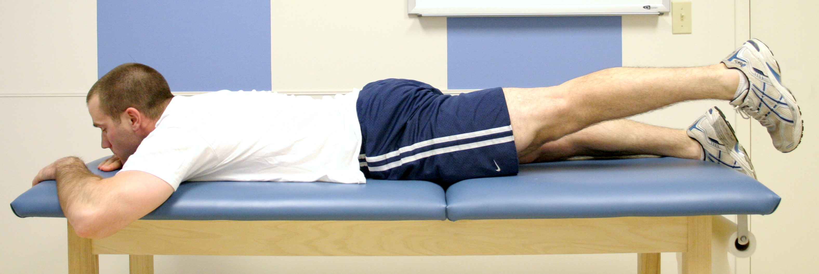

Straight Leg Raise, Extesion:

Squeeze thigh muscles tightly, then lift leg from the

surface as shown in the picture. Raise and lower your

leg slowly. Repeat 15-30 times. Do this 4-6 times

per day.

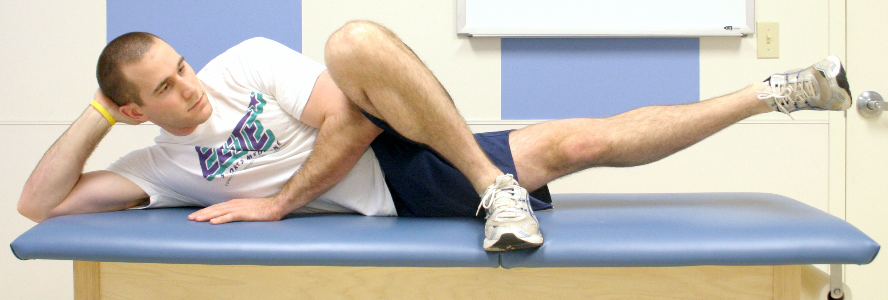

Straight Leg Raise, Adduction:

Squeeze thigh muscles tightly, then lift leg from the surface as shown in the picture. Raise and lower your leg slowly. Repeat 15-30 times. Do this 4-6 times per day.

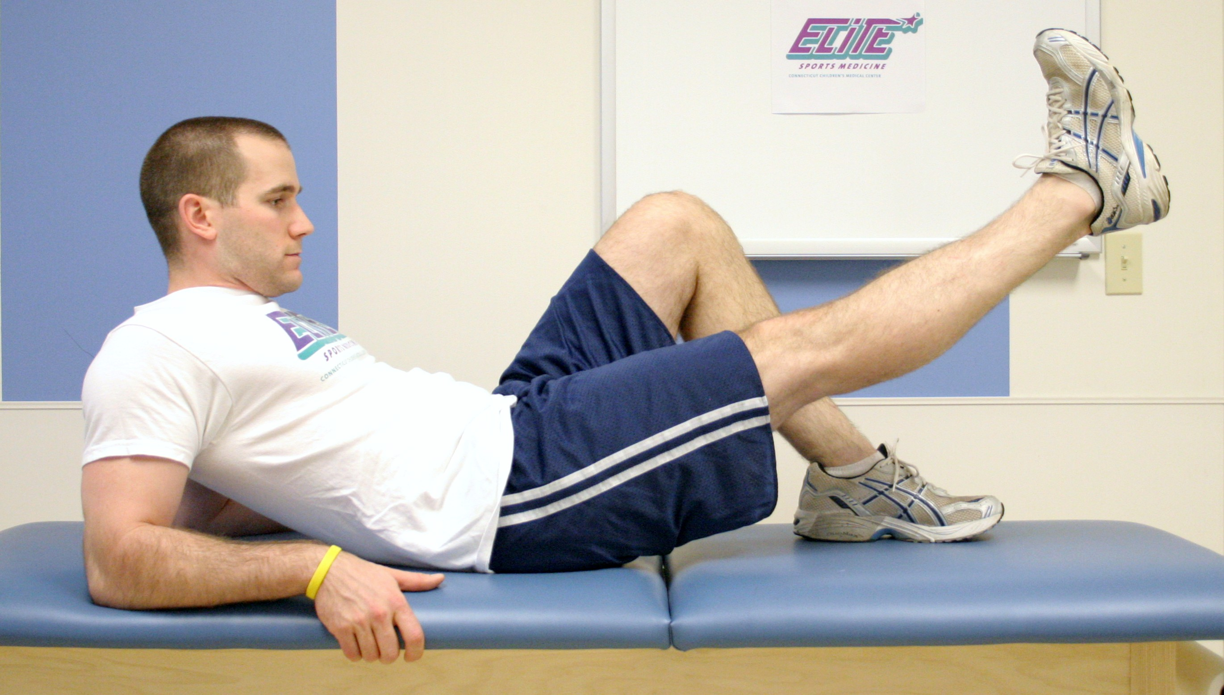

Straight Leg Raise, Flexion:

Squeeze thigh muscles tightly, then lift leg from the surface as

shown in the picture. Raise and lower your leg slowly. Repeat

15-30 times. Do this 4-6 times per day.