Lower Extremity Foam Rolling
Directions: All foam rolling exercises should be completed in the following method; each position should be completed for one (1) minute from your bottom or hip to your knee. Each picture is a progression of 45 degrees from the previous position. Foam rolling should be completed 2-3 times per day and should be done to both sides.

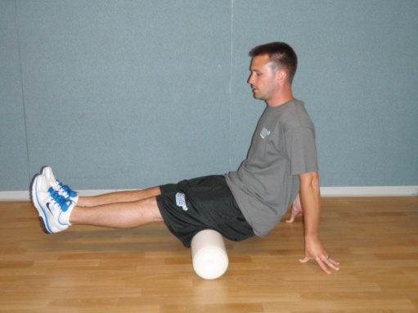
Hamstrings (Both Legs) –
Sit with the back of both legs on the foam roller. Using your hands, walk yourself back and forth from your bottom to the back of your knees. If you find an area that has a knot in it, roll back and forth over this area until the knot goes away. Repeat this for approximately 1 minute.
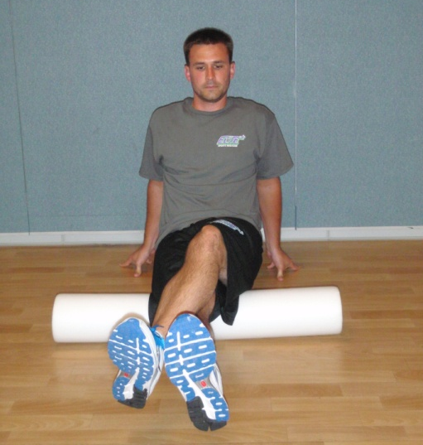
Hamstrings (Single Leg) –
Sit with the back of one of your legs on the foam roller with the other leg crossed over the top. Using your hands, walk yourself back and forth from your bottom to the back of your knee. If you find an area that has a knot in it, roll back and forth over this area until the knot goes away. Repeat this for approximately 1 minute.

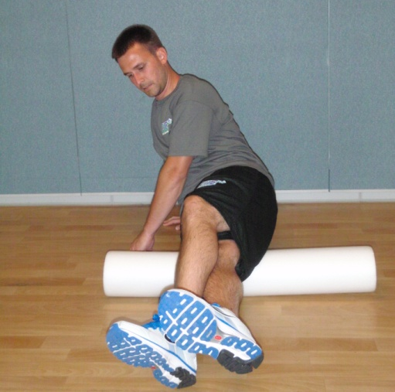
Lateral Hamstring/Posterior Iliotibial Band (ITB) –
Rotate 45 degrees from the previous position. Sit with the outside/back portion of your leg on the foam roller between your hamstring muscles and ITB. Using your hands, walk yourself back and forth from your bottom/hip to your knee. If you find an area that has a knot in it, roll back and forth over this area until the knot goes away. Repeat this for approximately 1 minute.

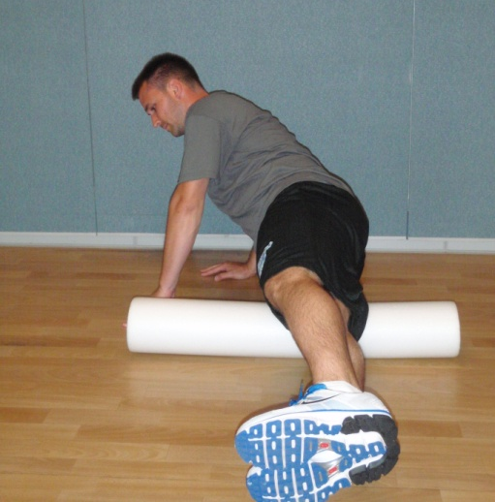
Anterior Iliotibial Band (ITB)/Lasteral Quad –
Rotate 45 degrees from the previous position. Sit with the outside/front portion of your leg on the foam roller between the ITB the quad muscles with the other leg crossed over the back. Using your hands, walk yourself back and forth from the front/outside of your hip to just above your knee. If you find an area that has a knot in it, roll back and forth over this area until the knot goes away. Repeat this for approximately 1 minute.

Iliotibial Band (ITB) –
Rotate 45 degrees from the previous position. Sit with the outside portion of your leg on the foam roller over the ITB. Using your hands, walk yourself back and forth from the outside of your hip to your knee. If you find an area that has a knot in it, roll back and forth over this area until the knot goes away. Repeat this for approximately 1 minute.

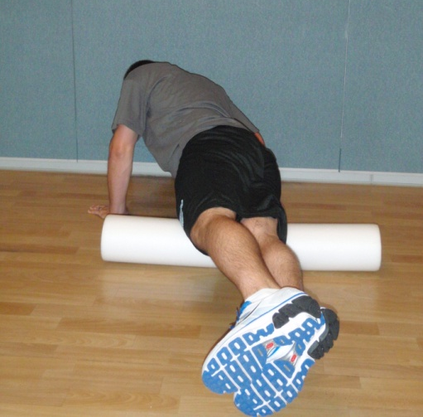
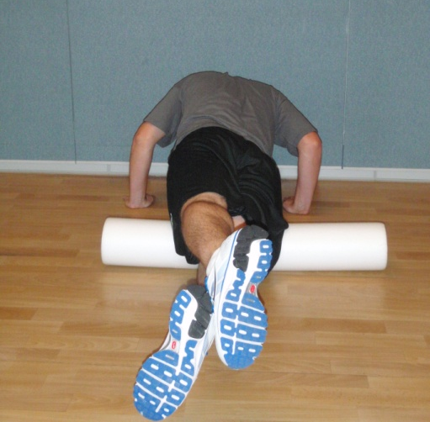
Quad (Single Leg) –
Rotate 45 degrees from the previous position. Sit with the front portion of your leg on the foam roller over the quad muscles with the other leg crossed over the back. Using your hands, walk yourself back and forth from the front of your hip to just above your knee. If you find an area that has a knot in it, roll back and forth over this area until the knot goes away. Repeat this for approximately 1 minute.

