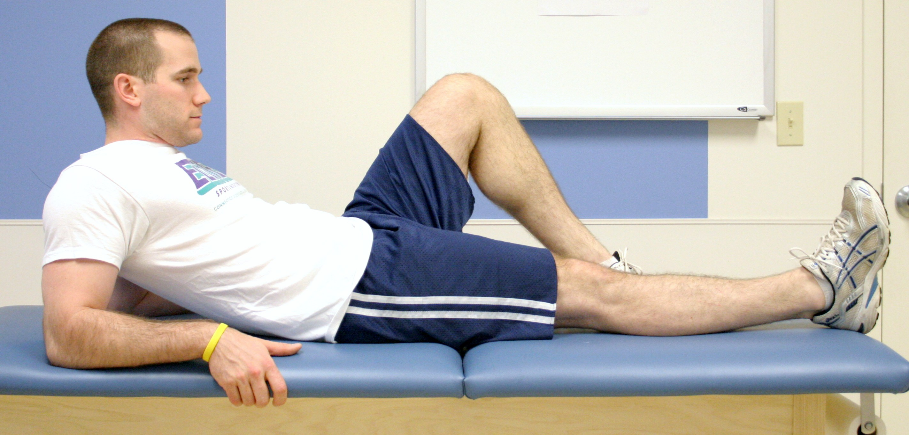

Quad Set:

Squeeze thigh muscles tightly, as if pressing the back of your knee into the surface you are lying on top of. Hold contraction for 10 seconds, repeat 30 times. Do this 4-6 times per day.

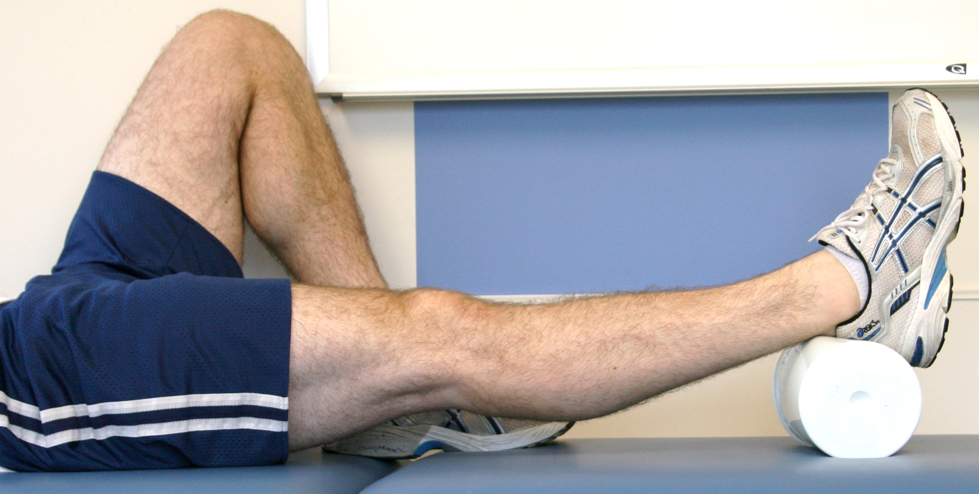

Heel-Leg Prop: Elevate your leg by placing a cushion underneath your lower leg or heel as shown. While the leg is elevated, you may also bend your ankle so your foot moves up and down or in circles (not pictured). Do this 4-8 times per day for 15-20 minutes. You may also sleep with your leg elevated.

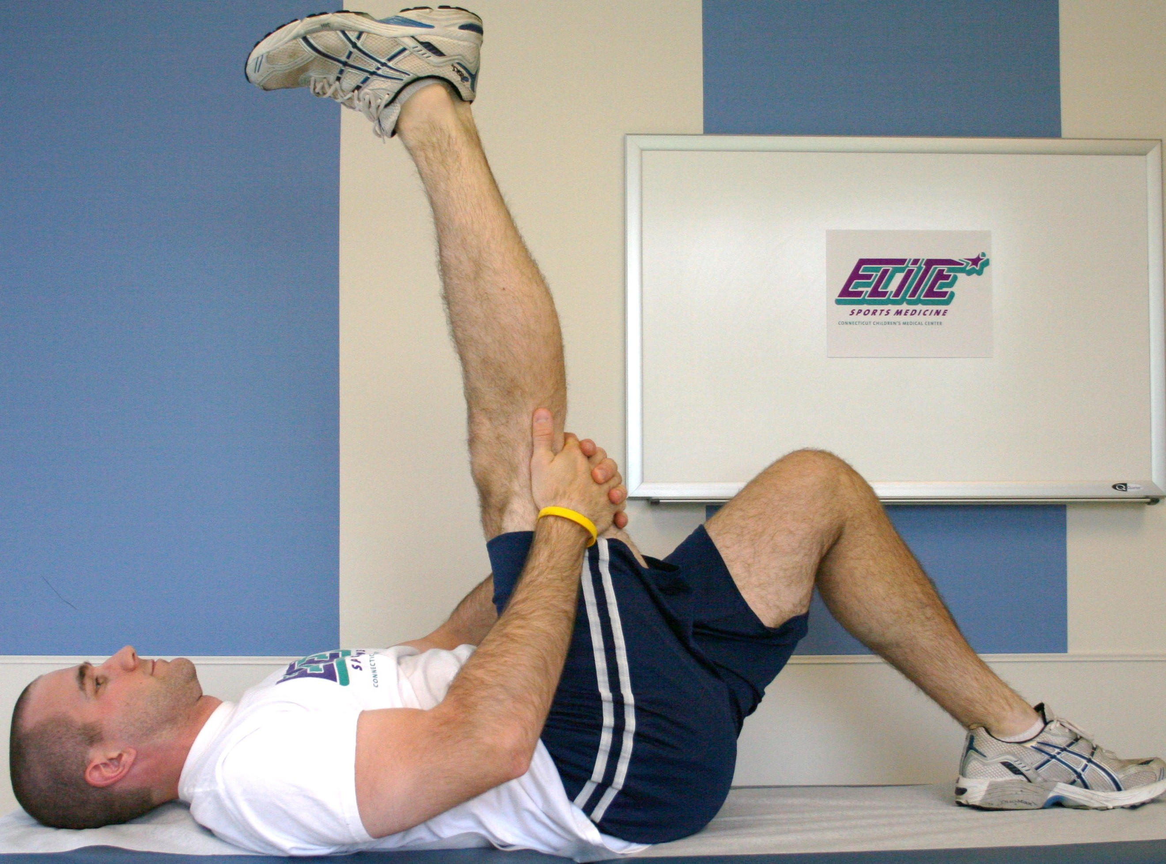

Hamstring and Lower Leg Stretch:

Lying on your back with your knees bent, grasp one leg behind your knee and gently bring it towards your chest, then gently straighten your leg until you feel tension in the muscles. Pause for 20-30 seconds. Lower your leg and repeat with the other leg. Do this 4-6 times per day.

PRISM Sports Medicine

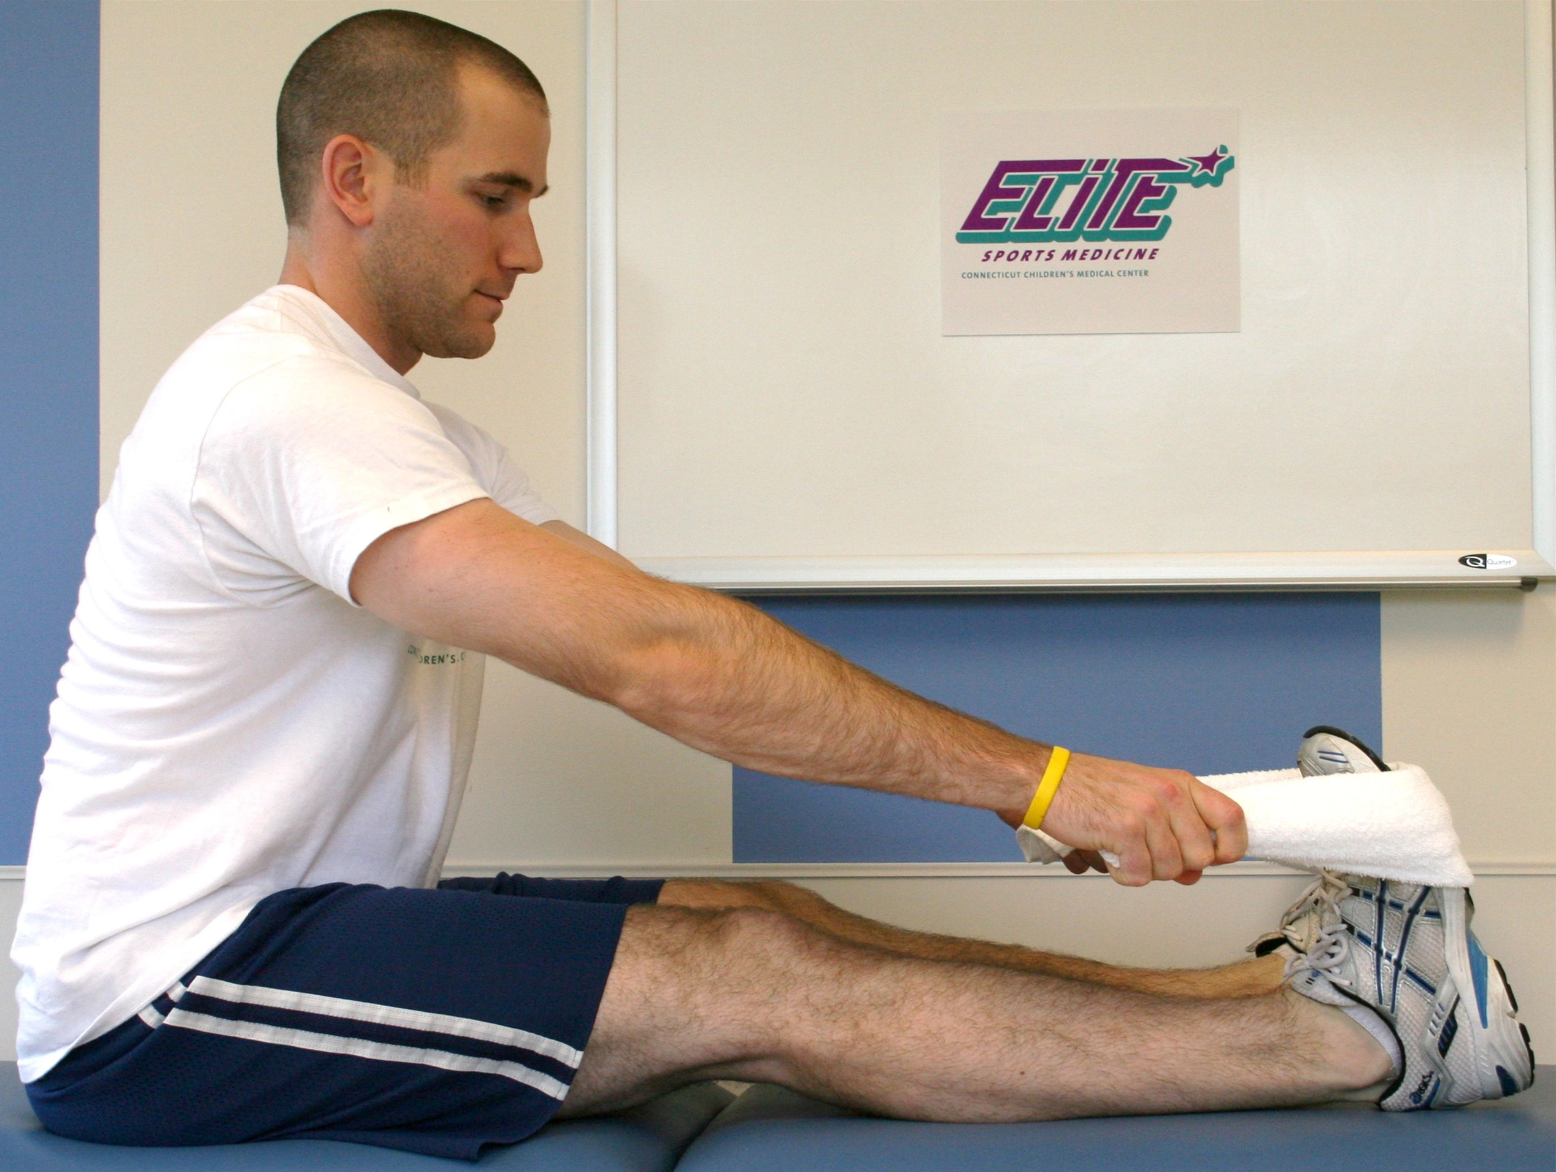

Calf Stretch:

Using a towel or a belt, gently stretch you calf muscles

as pictured. Keep your knee straight. Hold the stretch

for 20-30 seconds. Do this 4-6 times per day.

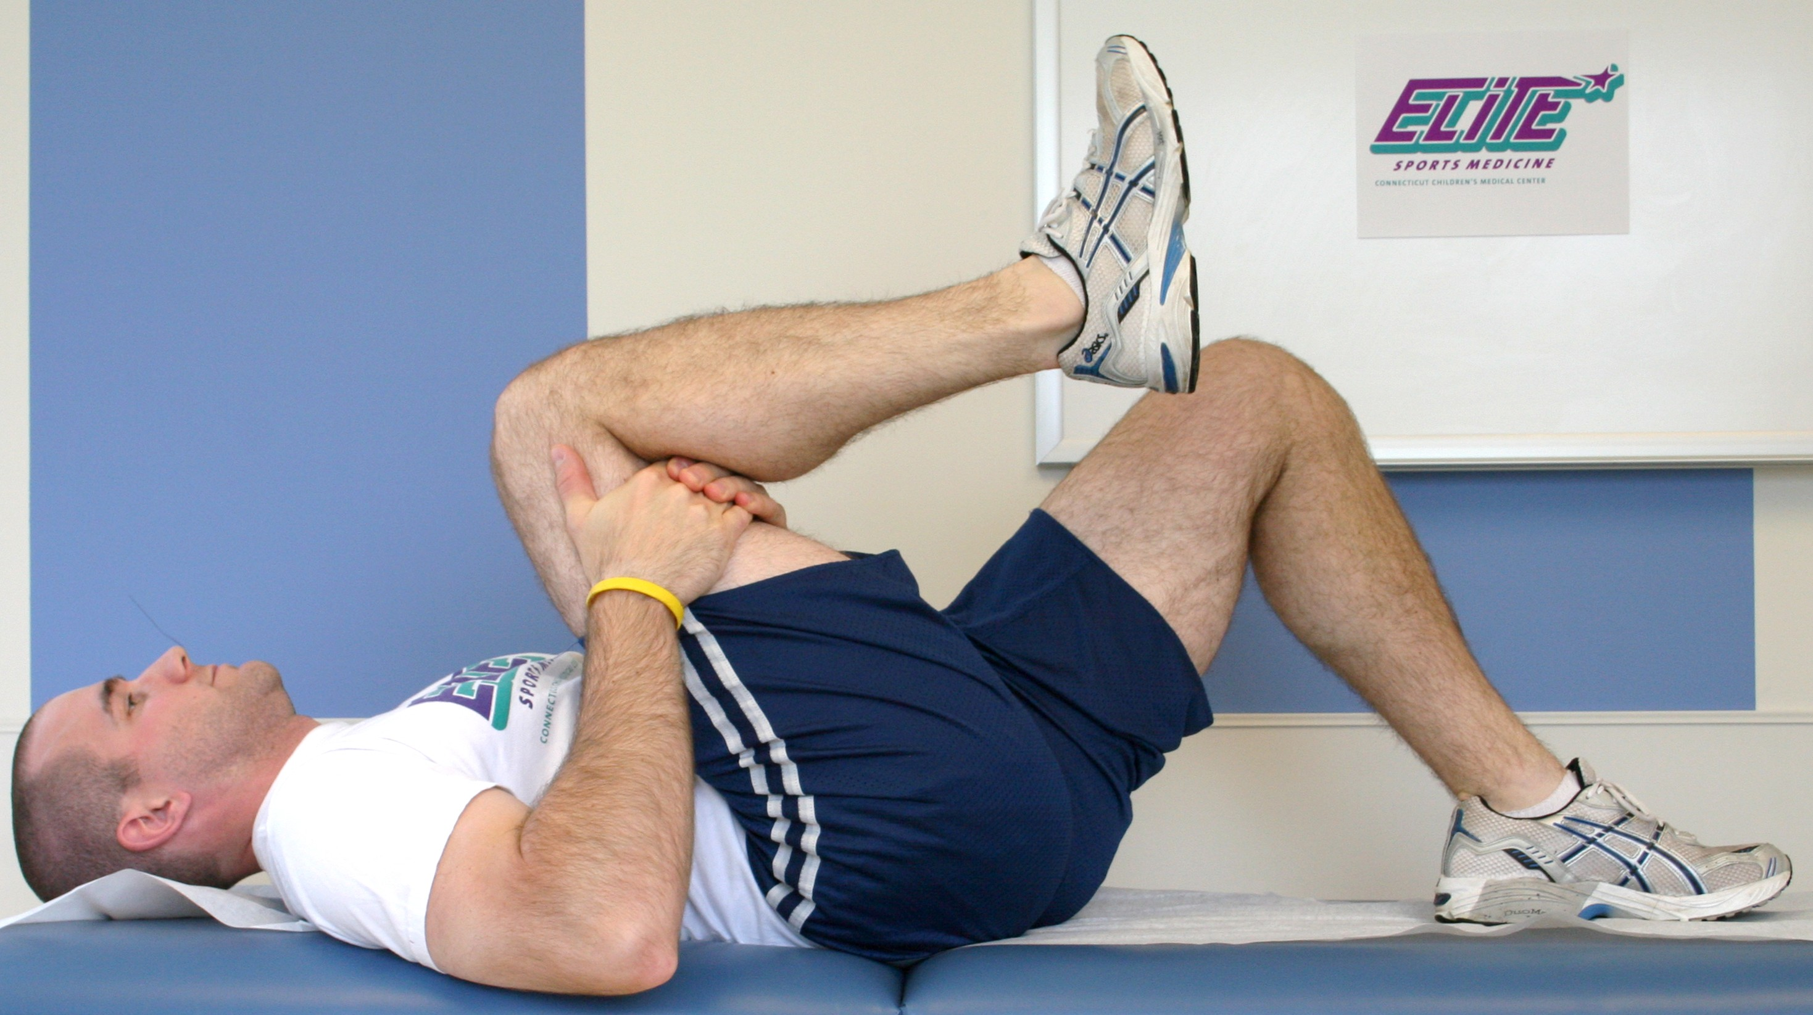

Low Back and Posterior Hip Stretch:

Lying on your back with your knees bent, grasp one leg behind your knee and gently bring it towards your chest. Pause for 20-30 seconds. Lower your leg and repeat with the other leg. Do this 4-6 times per day.

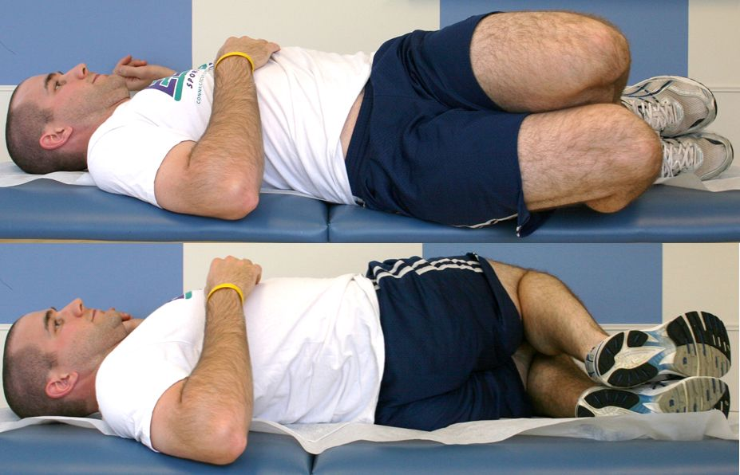

Trunk Rotation Stretch:

Lying on your back with your knees bent, gently roll your hips and knees to one side. Pause for 20-30 seconds then gently roll to the other side and pause for 20-30 seconds. Do this 4-6 times per day.