**Knee Range of Motion Exercises**

***Directions: All exercises should be completed in the following method; three (3) set of thirty (30) seconds, unless otherwise stated. Knee range of motion should be completed 3-4 times per day and should be done to both sides. Greatest gains will be made when the muscles are warm.***

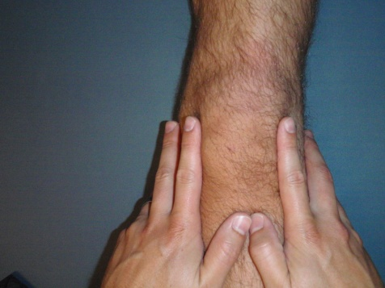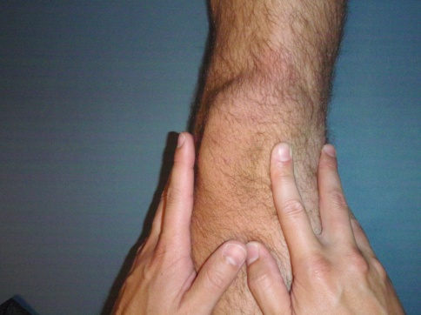

**Patella (Knee Cap) Mobilizations –**

With your index fingers on the inside and outside borders of you knee cap, press your knee cap in a direction directly towards your other knee until a stretch or resistance is felt. Hold this position for approximately 5 seconds and repeat 30 times.

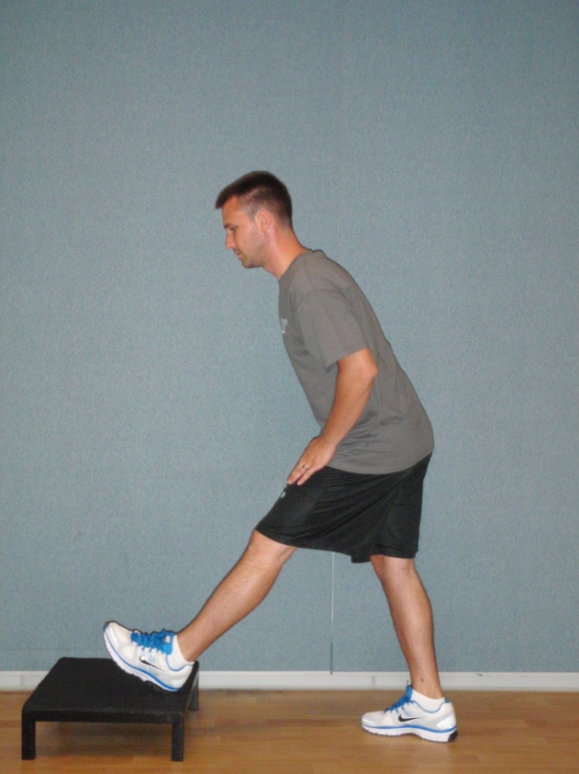

**Hamstring Stretch –**

Prop your heel on a chair, step, or stair. With your back completely straight, bend at the waist toward your feet until a stretch is felt in the back of your upper leg.

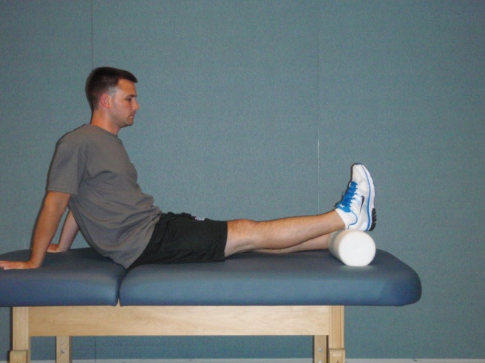

**Knee Extension with Bolster –**

While sitting with your legs straight out in front of you, prop your heels onto something (pillow, books, coffee table) so that nothing is touching the back of your knee. Relax in this position for approximately 5 minutes to help you gain full extension.

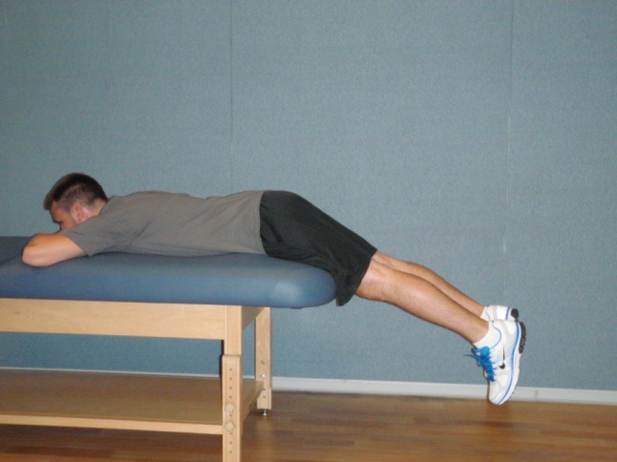

**Prone Hangs –**

While lying on your stomach with your legs hanging off of a table or bed from just above the knee, relax in this position for approximately 5 minutes to help you gain full extension.

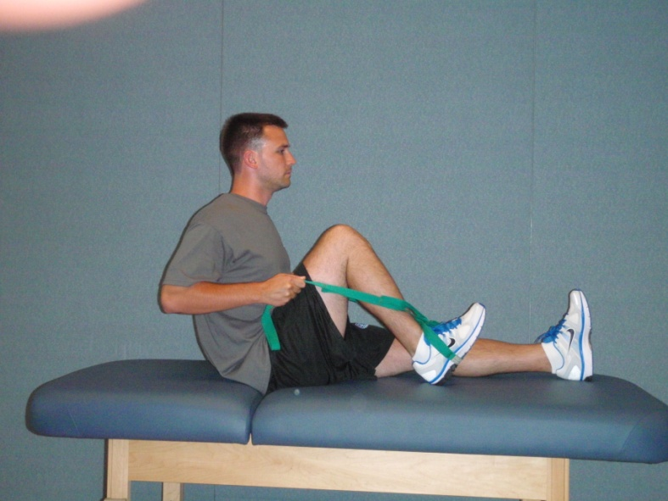

**Wall Slides –**

While laying on a table or bed, prop your heel against the wall with your leg straight. Allow gravity to help you slide your heel down the wall toward your bottom until a gentle stretch or pressure is felt in the front of your knee or just above your knee. Hold this position for approximately 5 seconds and repeat 20 times.

**Heel Slides –**

While sitting on a table or bed, wrap a towel around the bottom of your foot. While holding onto the towel, pull your heel toward your bottom until you feel a gentle stretch or pressure in the front of your knee or just above your knee. Hold this position for approximately 5 seconds and repeat 20 times.

