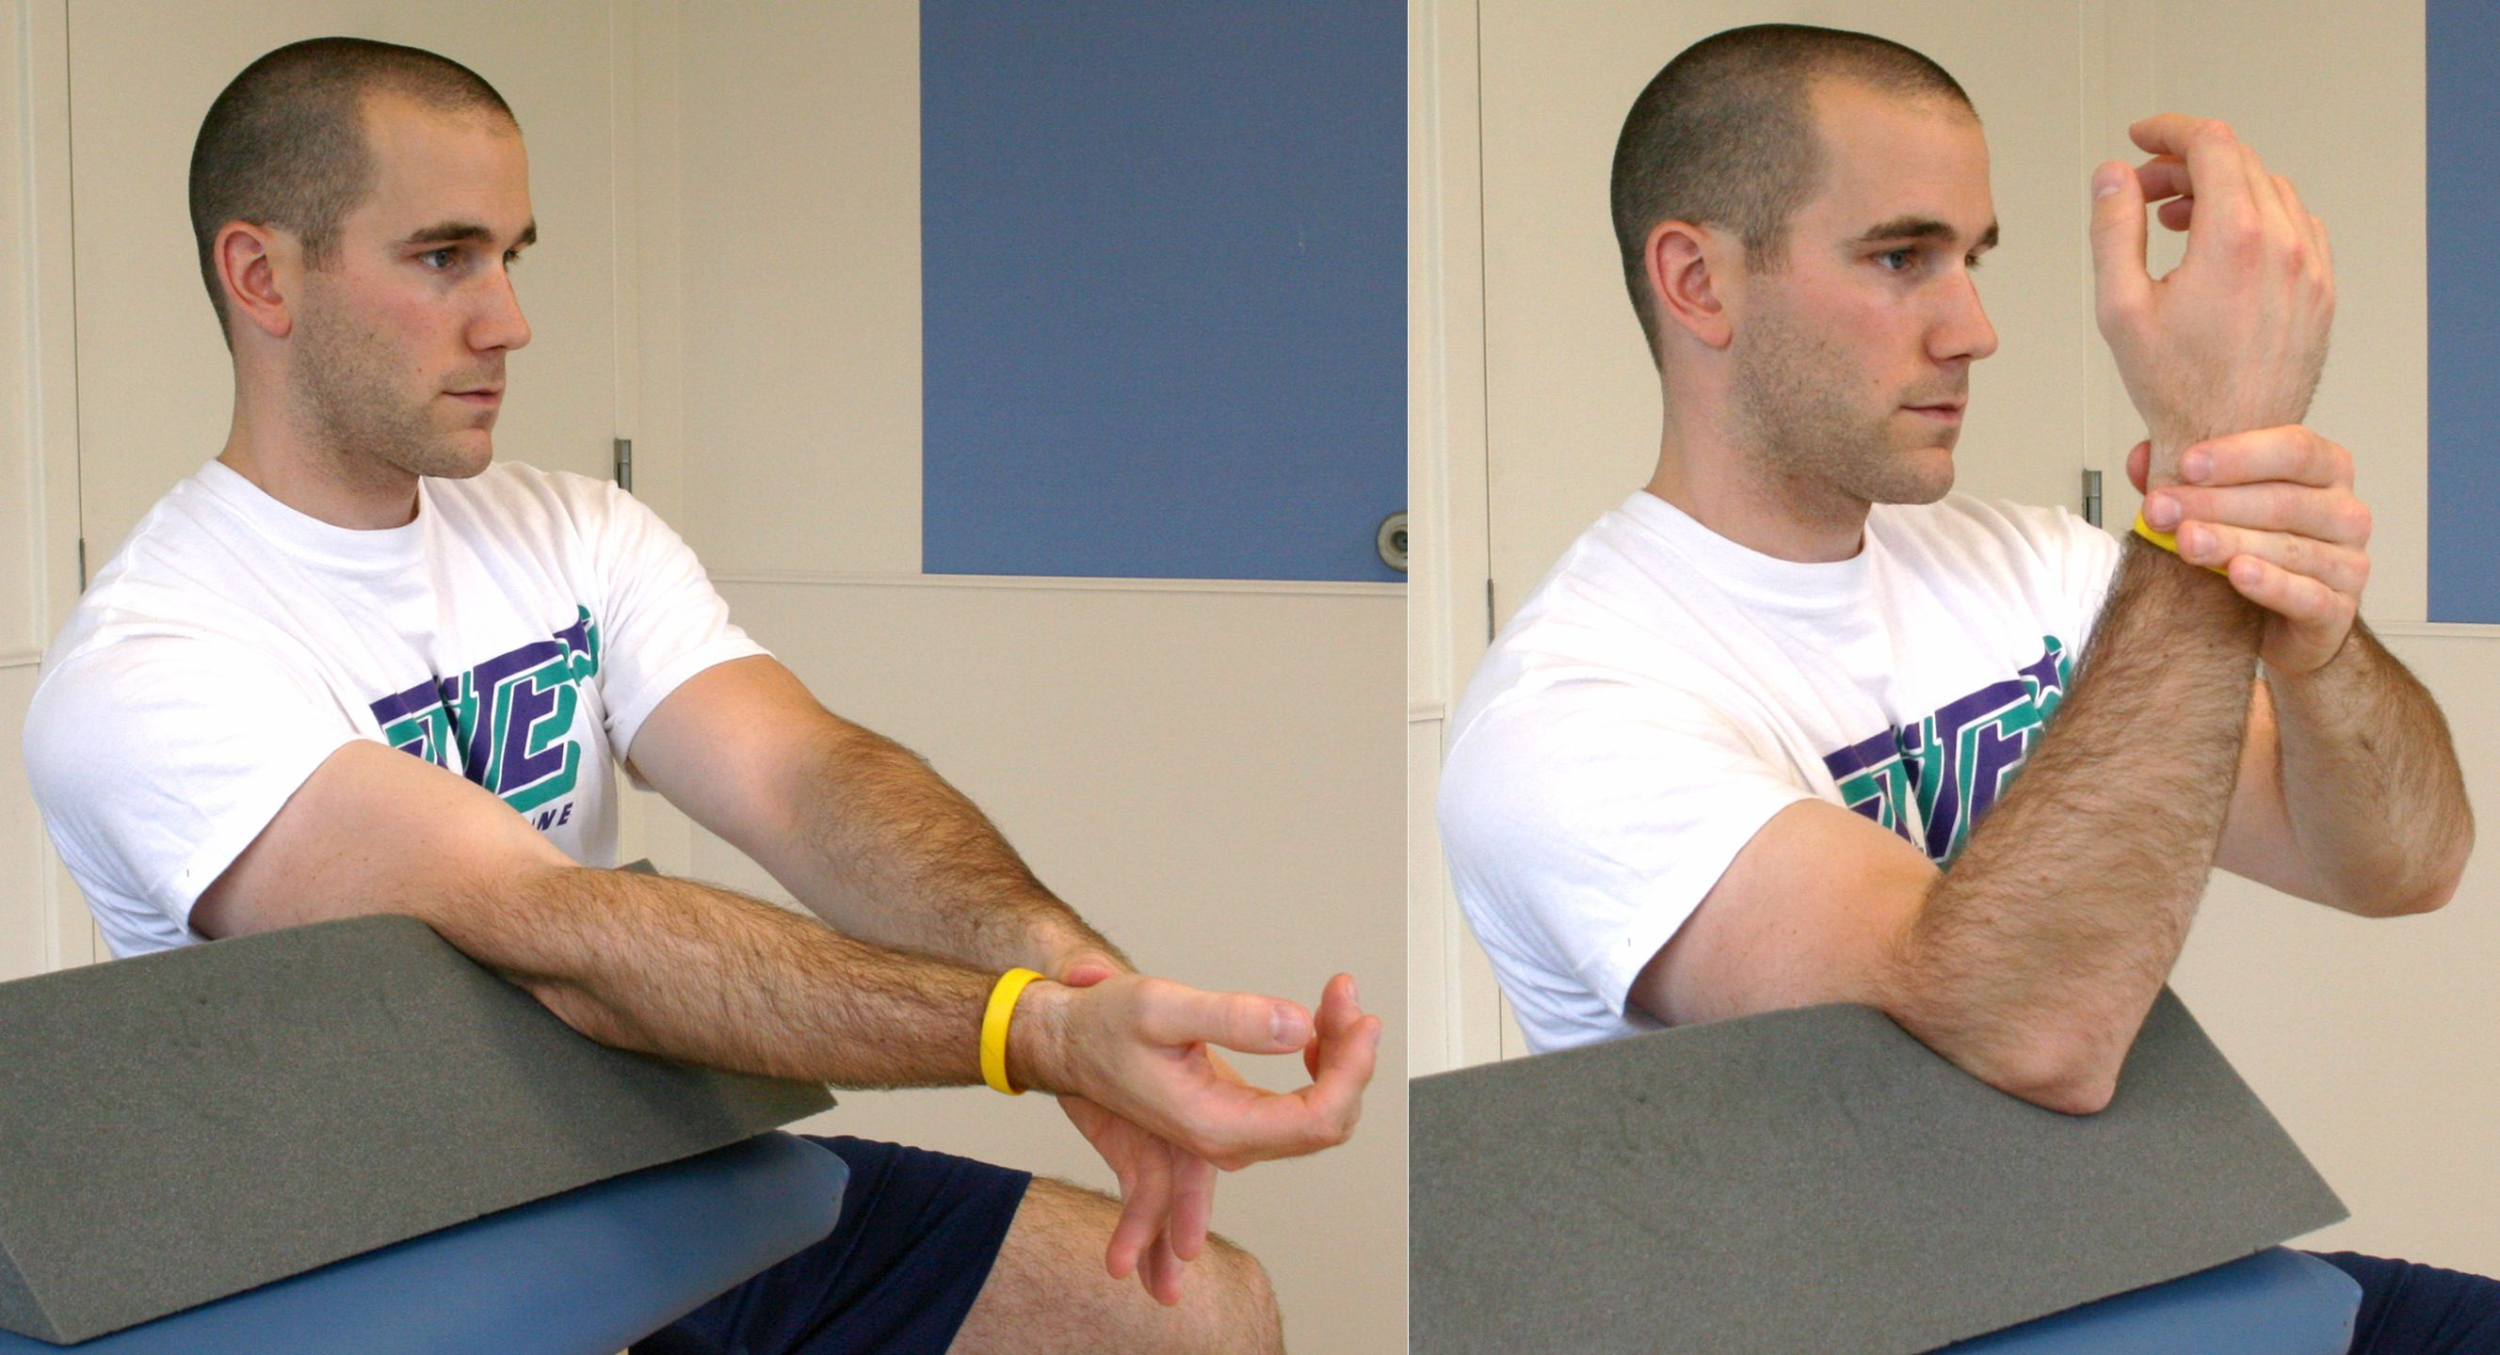

Passive Elbow Flexion:

Use your “good” hand to bend the elbow of the arm that had surgery. Also using your “good” hand, slowly lower the arm so it is straight. Repeat 15-30 times. Do this 4-6 times per day.

Ball Squeezes:

Place a soft rubber ball into your hand while you are wearing your sling. Gently squeeze the ball and hold the contraction for 3-5 seconds, then slowly relax. Repeat 30 times. Do this 6-8 times per day. (not pictured)

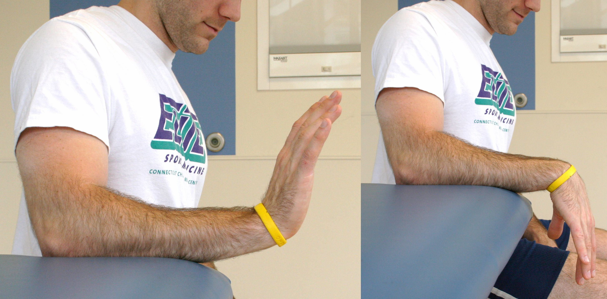

Active Wrist Extension/Flexion:

While wearing the sling, bend your wrist up and down. You may also bend your wrist from side to side and turn your hand from palm facing up to palm facing down (not shown in picture). Repeat 30 times. Do this 4-6 times per day.