***Lower Extremity Strengthening and Plyometric Exercises***

***Directions: All exercises should be completed in the following method; strengthening exercises, three (3) set of fifteen (15) reps, plyometric exercises, three (3) set of twelve (12) reps. Lower extremity exercises should be completed 1-2 times per day and should be done to both sides. Greatest gains will be made when the muscles are warm.***

**Standing Clam Shells –** Place band (optional) just above both knees. Drop your hips and bend your knees into a proper squat position. Make sure to keep your back straight and your knees behind your toes. While keeping both feet firmly on the ground, let one knee move towards other knee. Use your hip muscles to pull your knee out against the band.

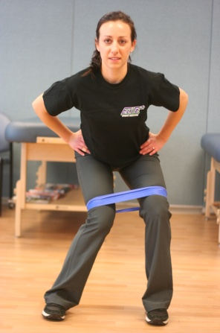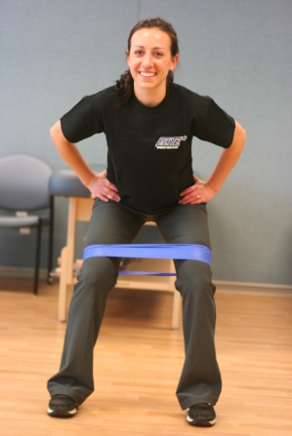

**Squat with Hip Abduction –** Stand with your feet under your hips. Drop your hips and you’re your knees into a proper squat position. Make sure to keep your back straight and your knees behind your toes. Do not let your knees come together. Rise up to standing and slowly lift one leg out to the side. Be sure to maintain your balance on the standing leg. Slowly lower your leg back to the starting position and repeat squat.

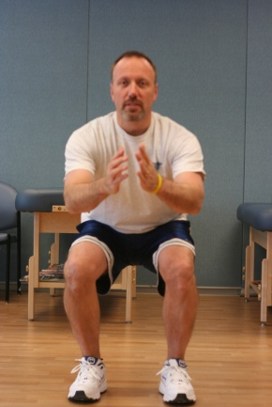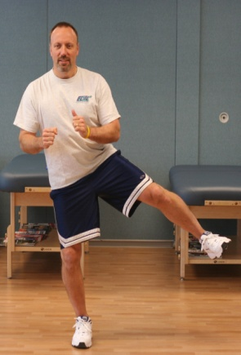

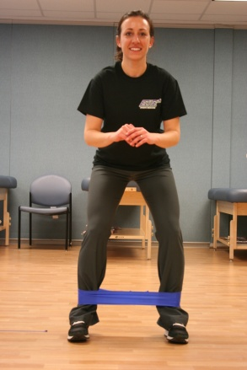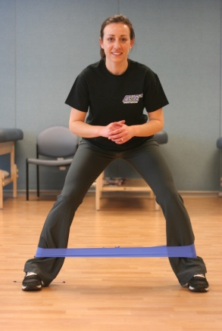

**Lateral Band Walks –** Place band (optional) around your ankles. Start in slight squat position with your feet under your hips and maintain throughout the exercise. Take a large step to the side with one leg then slowly bring the other leg back to the starting position. Continue in one direction then switch directions.

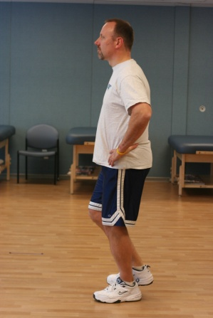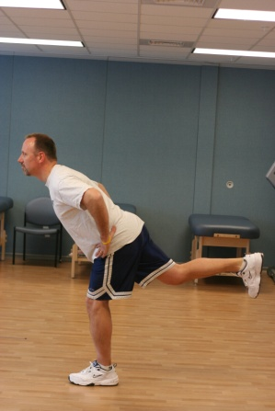

**Single Leg RDL –**

Stand on one leg with your hands on your hips and your knee slightly bent. Bend forward at the waist keeping your back straight and your hips square to floor. Slowly raise your other leg while squeezing your buttocks. Return to starting position and repeat.

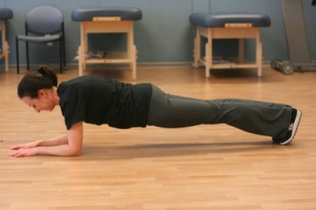

**Planks –**

**Forward –** Lie on your stomach with your toes and forearms on the floor. Left your hips off of the floor while keeping your back straight. Hold for 30 seconds (working up to 1 minute holds).

**Side –** Lie on your side with your elbow on the floor and your feet stacked on one another. Lift your hips off of the floor while keeping your back straight and your hips and shoulder pointing up to the ceiling. Hold for 30 seconds (working up to 1 minute holds).

**Reverse –** Lie on your back with your heels and forearms on the floor. Left your hips off of the floor while keeping your back straight. Hold for 30 seconds (working up to 1 minute holds).

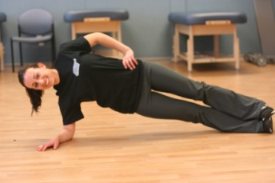

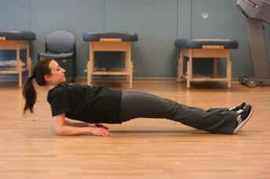

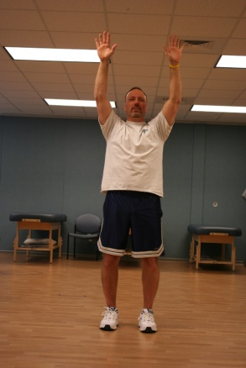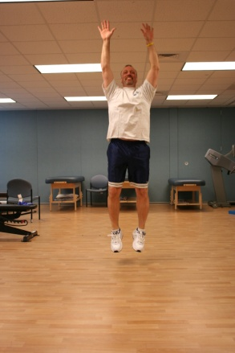

**Ankle Hops –**

Start standing with your feet under your hips and your knees slightly bent. Reach your arms in the air as you jump up quickly. Land on your toes with a good bend at the knees and quickly repeat.

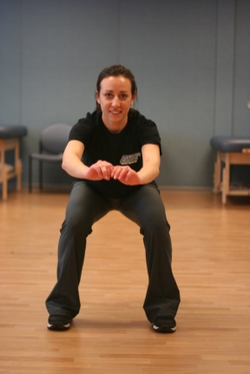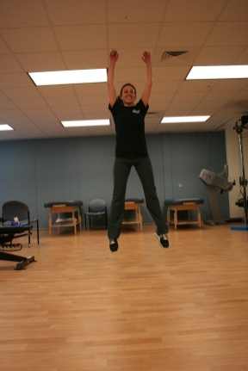

**Squat Jumps –**

Start in a proper squat position and jump up as high as possible reaching your arms in the air. Land softly in a squat position and immediately repeat the jump. Maintain proper knee mechanics throughout the entire exercise.

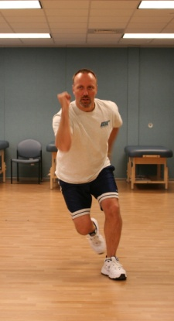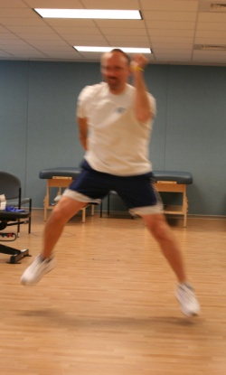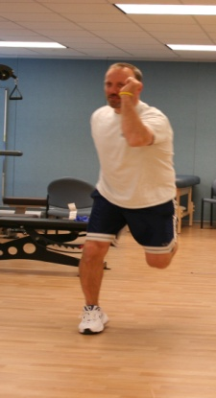

**Speed Skater Jumps –**

Start standing on one leg with your hips and knee slightly bent. With your opposite arm forward and same side arm back, push off your leg landing onto your opposite leg. Alternate arms in running form. Repeat continuously.

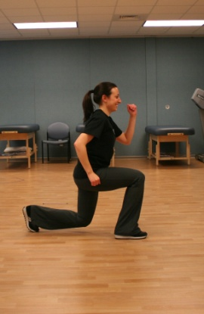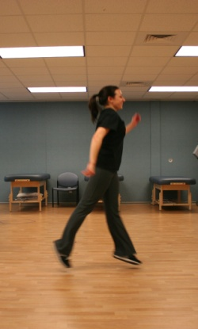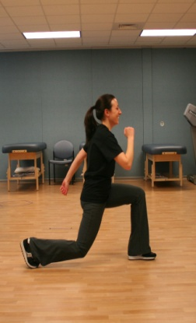

**Split Cycle Squat Jump –**

Start in a lunge position with appropriate arm position and with your trunk upright. Push up through your legs and switch your legs while in the air so as to land in a lunge position with your opposite leg in front. Use your arms in running form. Repeat continuously.