**Lower Extremity Stretching**

***Directions: All exercises should be completed in the following method; three (3) set of thirty (30) seconds. Lower extremity stretching should be completed 3-4 times per day and should be done to both sides. Greatest gains will be made when the muscles are warm.***

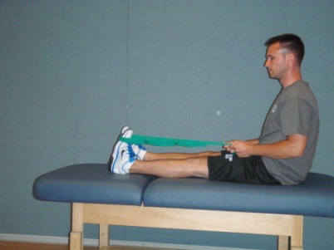 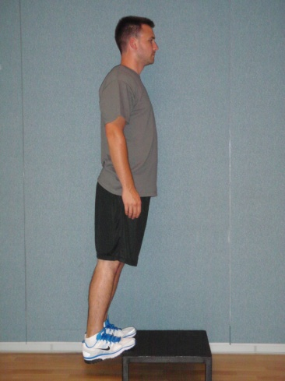

**Gastrocnemius (Calf) Stretch –**

**Seated –** Wrap a towel around the bottom of your feet at the area of the toes. With your knees completely straight, pull your toes toward your head.

**Standing –** Standing on a step with your knees completely straight, allow your heels to sink toward the ground.

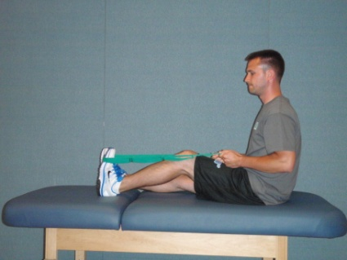 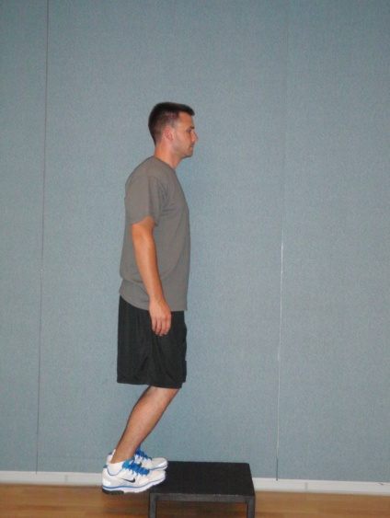

**Soleus (Calf) Stretch –**

**Seated –** Wrap a towel around the bottom of your feet at the area of the toes. With a slight bend in your knees, pull your toes toward your head.

**Standing –** Standing on a step with a slight bend in your knees, allow your heels to sink toward the ground.

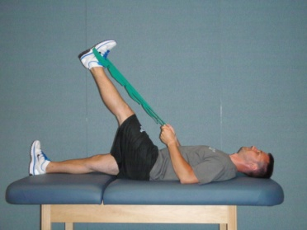 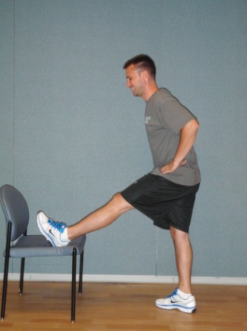

**Hamstring Stretch –**

**Supine –** With your knee completely straight, wrap a towel around your foot and lift your leg up in the air.

**Standing –** Prop your heel on a chair about knee height. With your back completely straight, bend at the waist toward your feet.

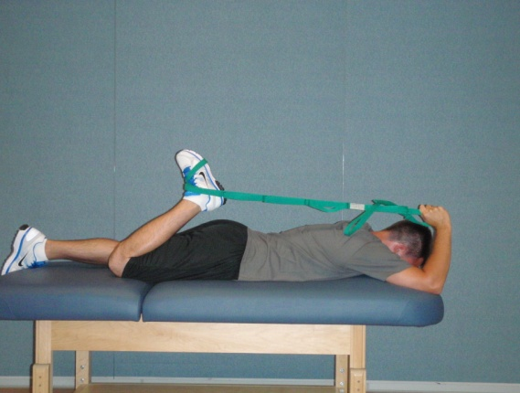

**Quad Stretch –**

**Prone –** Lying on your stomach, wrap a towel around your foot and pull your heel toward your bottom.

**Standing –** Prop your foot on a chair about waist height so that your knee is bent to approximately 90 degrees. While holding onto something for balance, squat slightly with the leg you are balancing on.

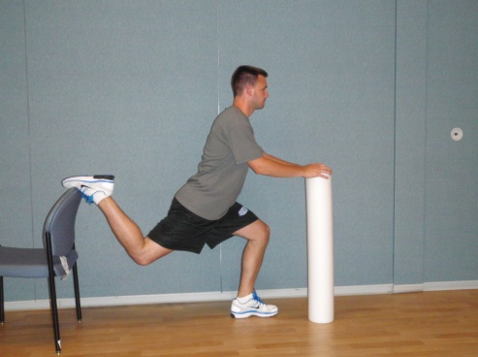

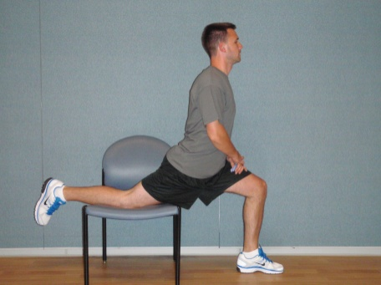

**Hip Flexor Stretch –**

**Standing –** Prop you lower leg and knee onto a chair until you hip is slightly extended. While holding onto something for balance, squat slightly with the leg you are balancing on.

**Kneeling –** While kneeling on the ground or on a mat, get into a lunge position. Place your hands on your hips and rock slightly forward at your hips.

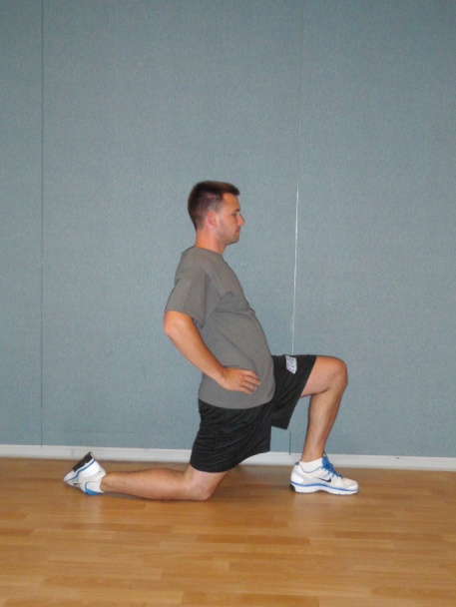

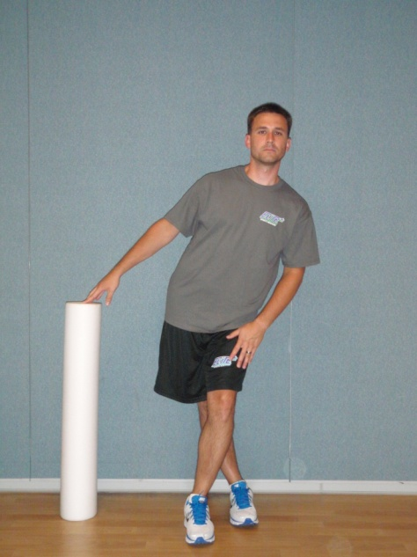

**Iliotibial Band (ITB)/Tensor Fasciae Latae (TFL) Stretch –**

With one leg behind the other and holding onto something for balance, gently push the hip of the leg in back toward whatever you are using to balance with. The stretch should be felt on the outside of the hip on the leg in back.

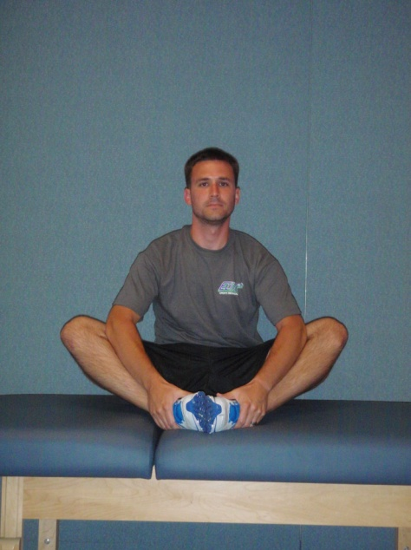

**Piriformis Stretch –**

While lying on your back, cross one leg over the other so that your ankle is placed on the opposite knee. Grab behind your knee on the side that is not crossed and pull your knee toward your chest. You should feel this stretch in your bottom on the side that is crossed over.

**Butterfly Stretch –**

While seated, place the bottoms of your feet together and with your elbows press your knees away from each other.

