Assisted Knee Flexion:

While seated, Use your “good” foot to gently guide you has you bend and straighten your operative knee. Only bend as much as is comfortable for you. This may be done periodically during the day.

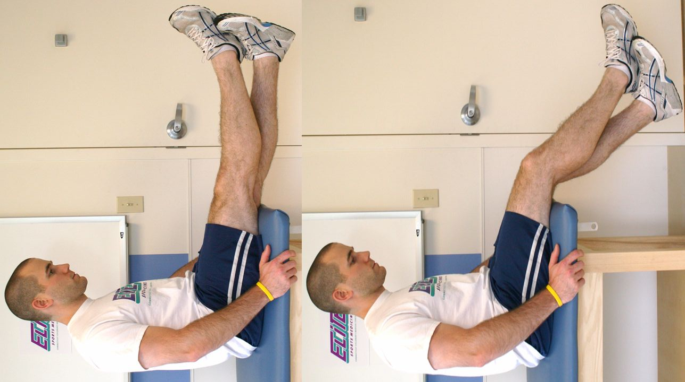

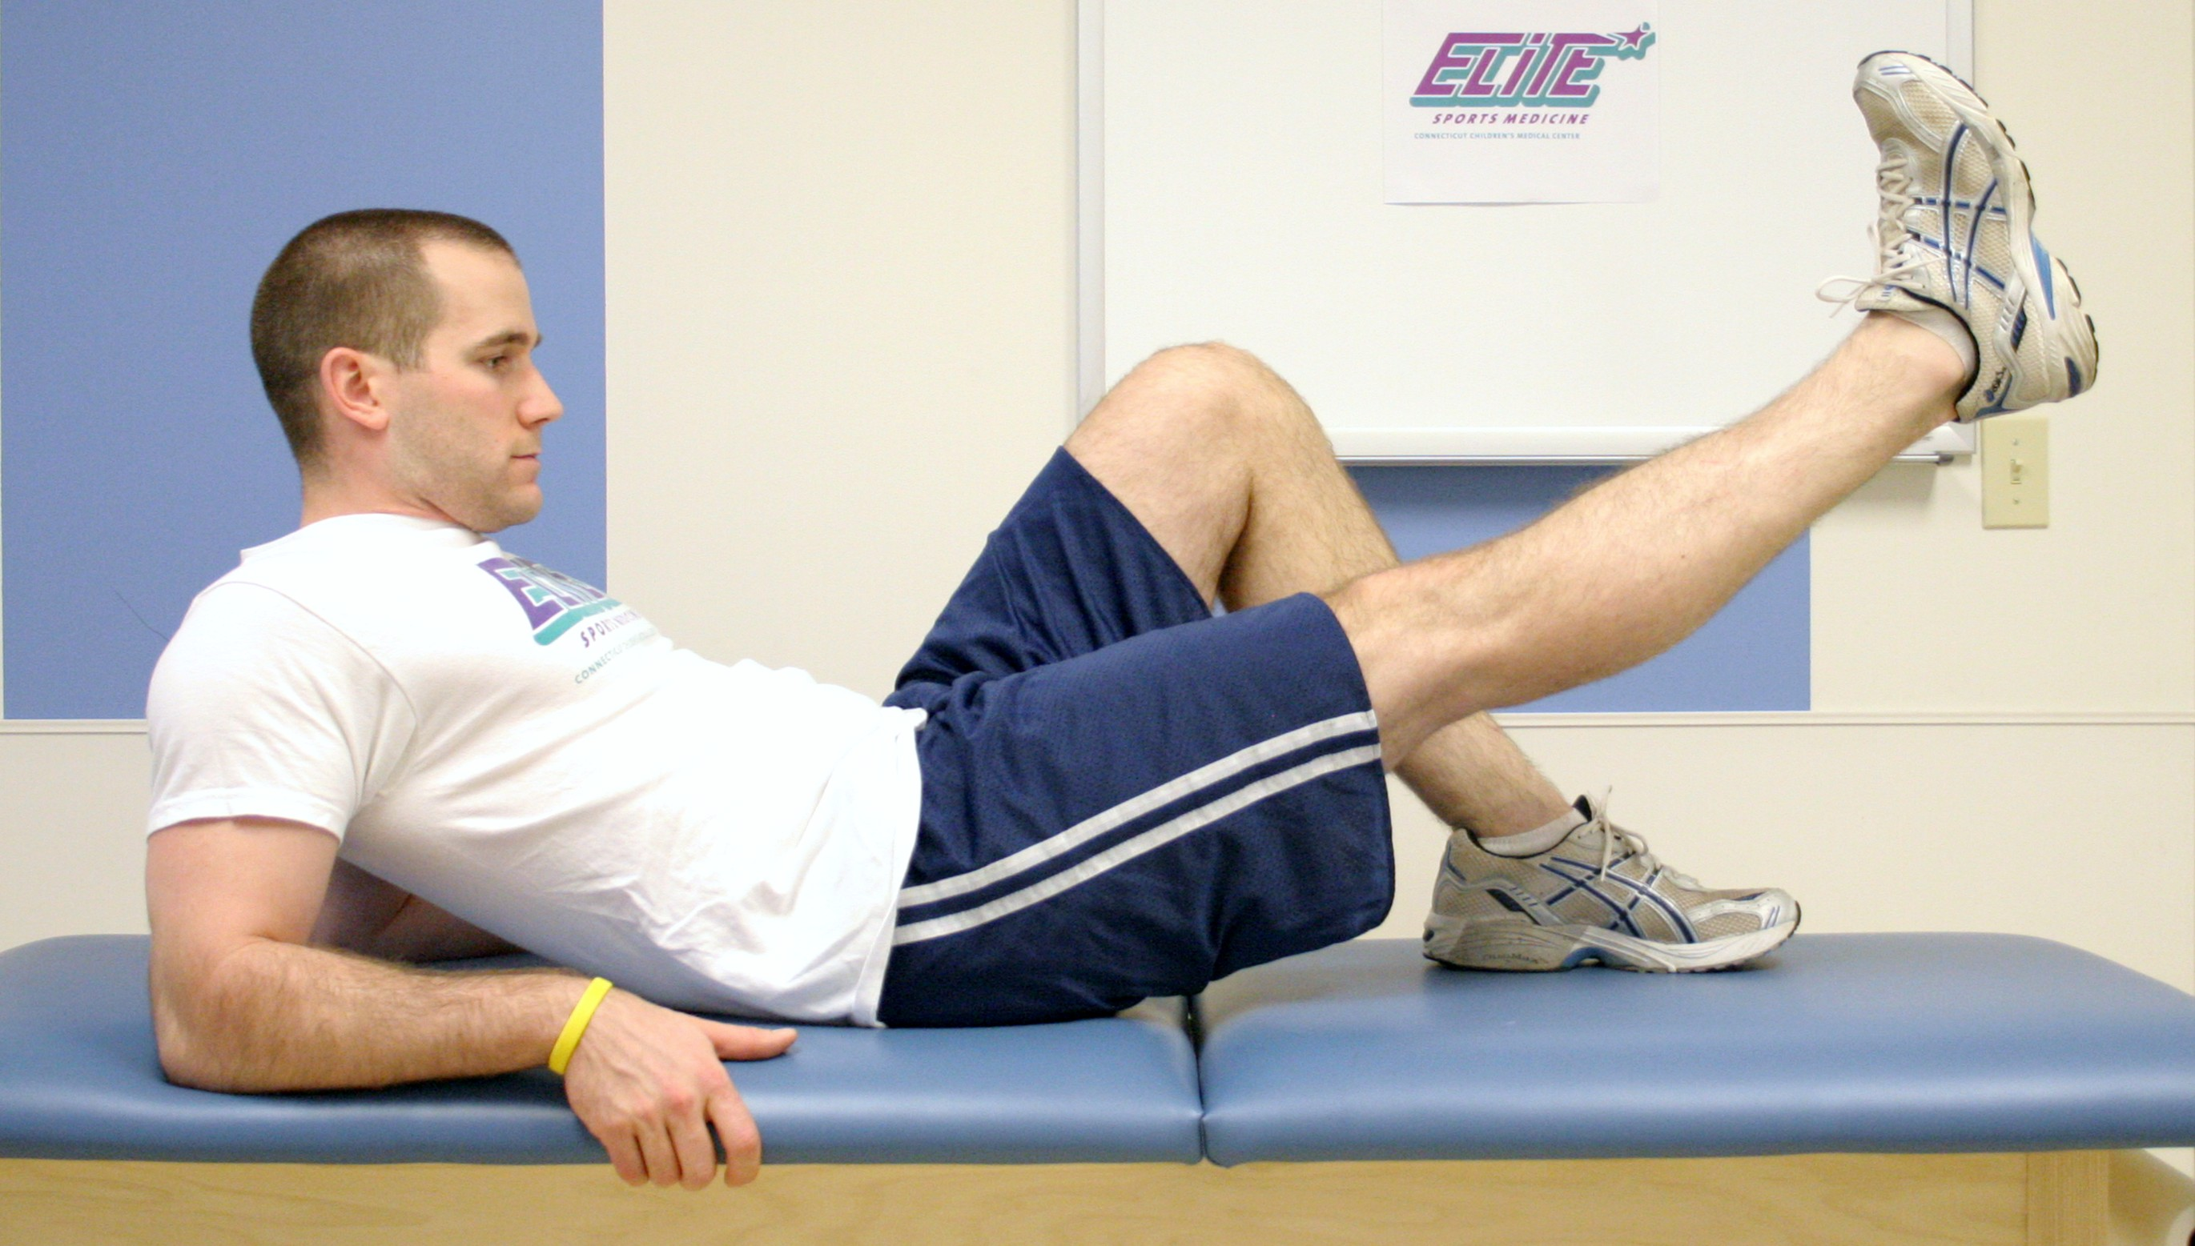

Straight Leg Raise, Flexion:

Squeeze thigh muscles tightly, then lift leg from the surface as shown in the picture. Raise and lower your leg slowly. Repeat 15-30 times. Do this 4-6 times per day.

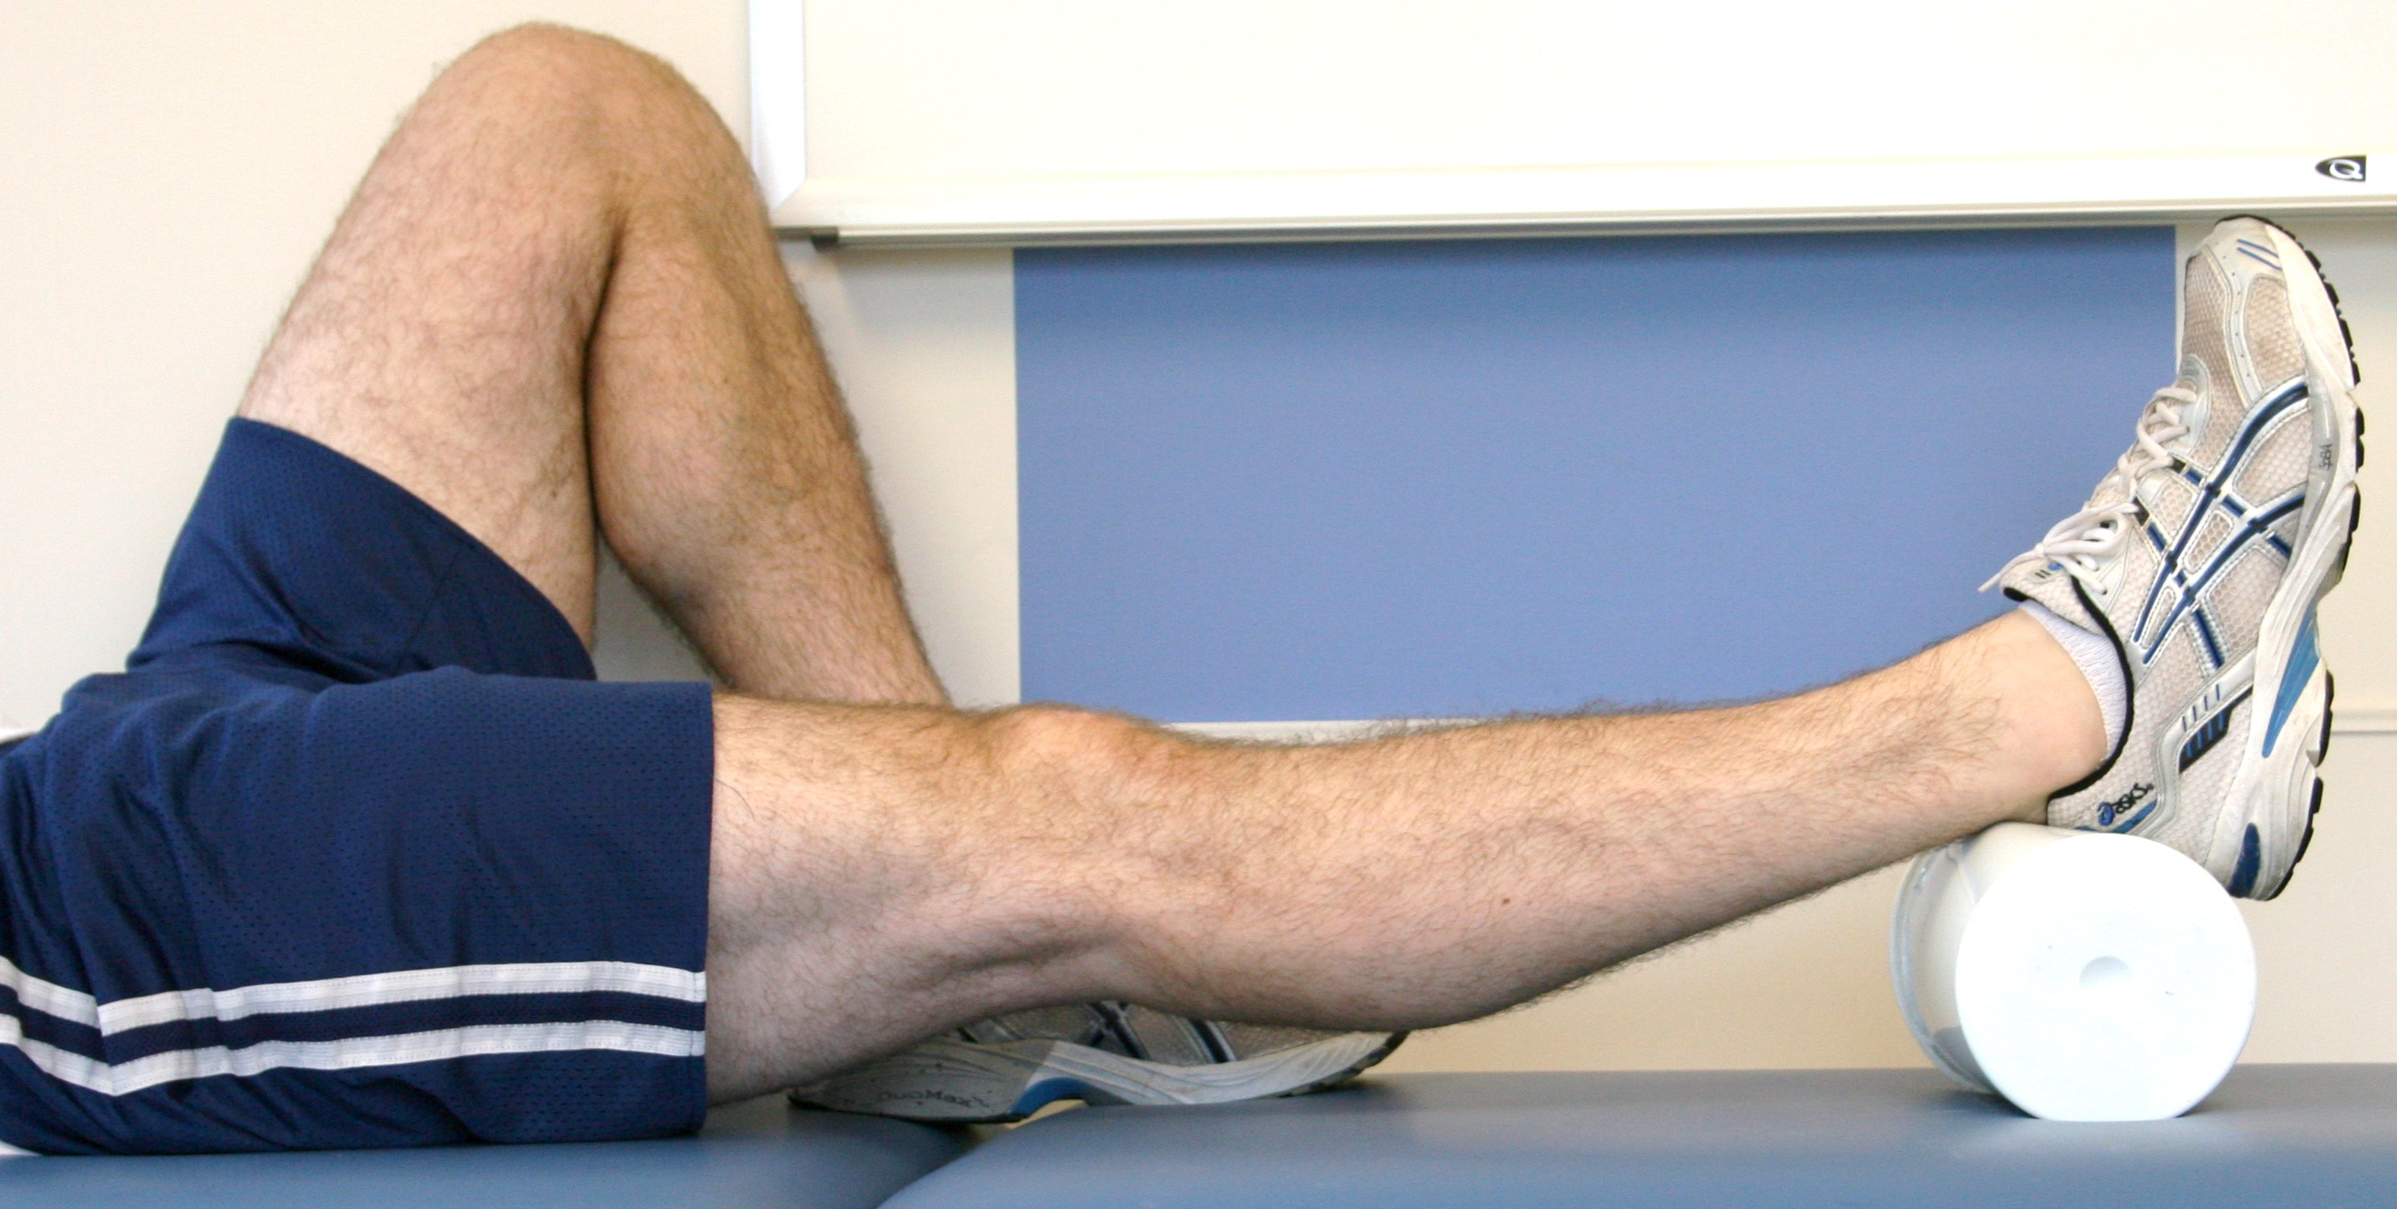

Heel-Leg Prop:

Elevate your leg by placing a cushion underneath your lower leg or heel as shown. While the leg is elevated, you may also bend your ankle so your foot moves up and down or in circles (not pictured). Do this 4-8 times per day for 15-20 minutes. You may also sleep with your leg elevated.

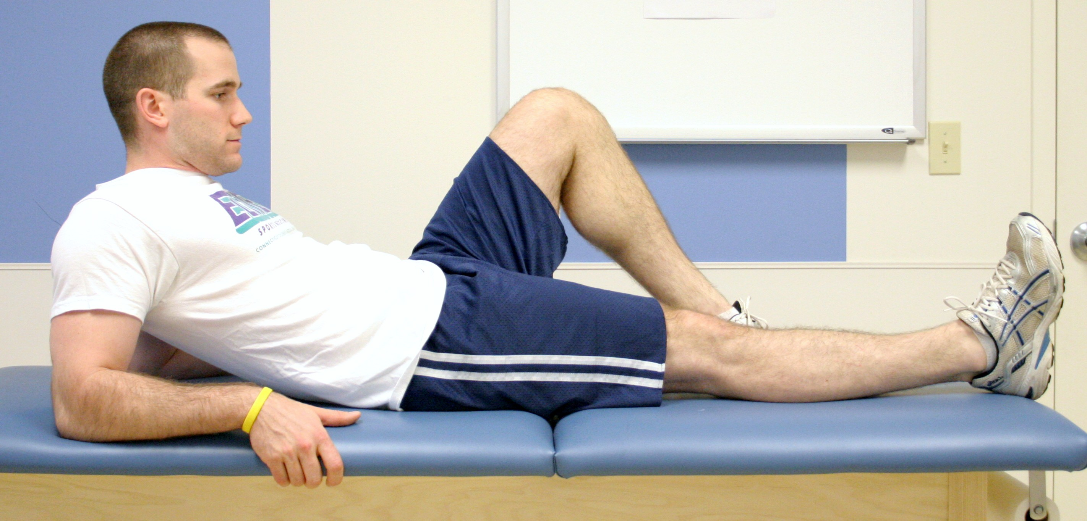

Quad Set:

Squeeze thigh muscles tightly, as if pressing the back of your knee into the surface you are lying on. Hold contraction for 10 seconds, repeat 30 times. Do this 4-6 times per day.

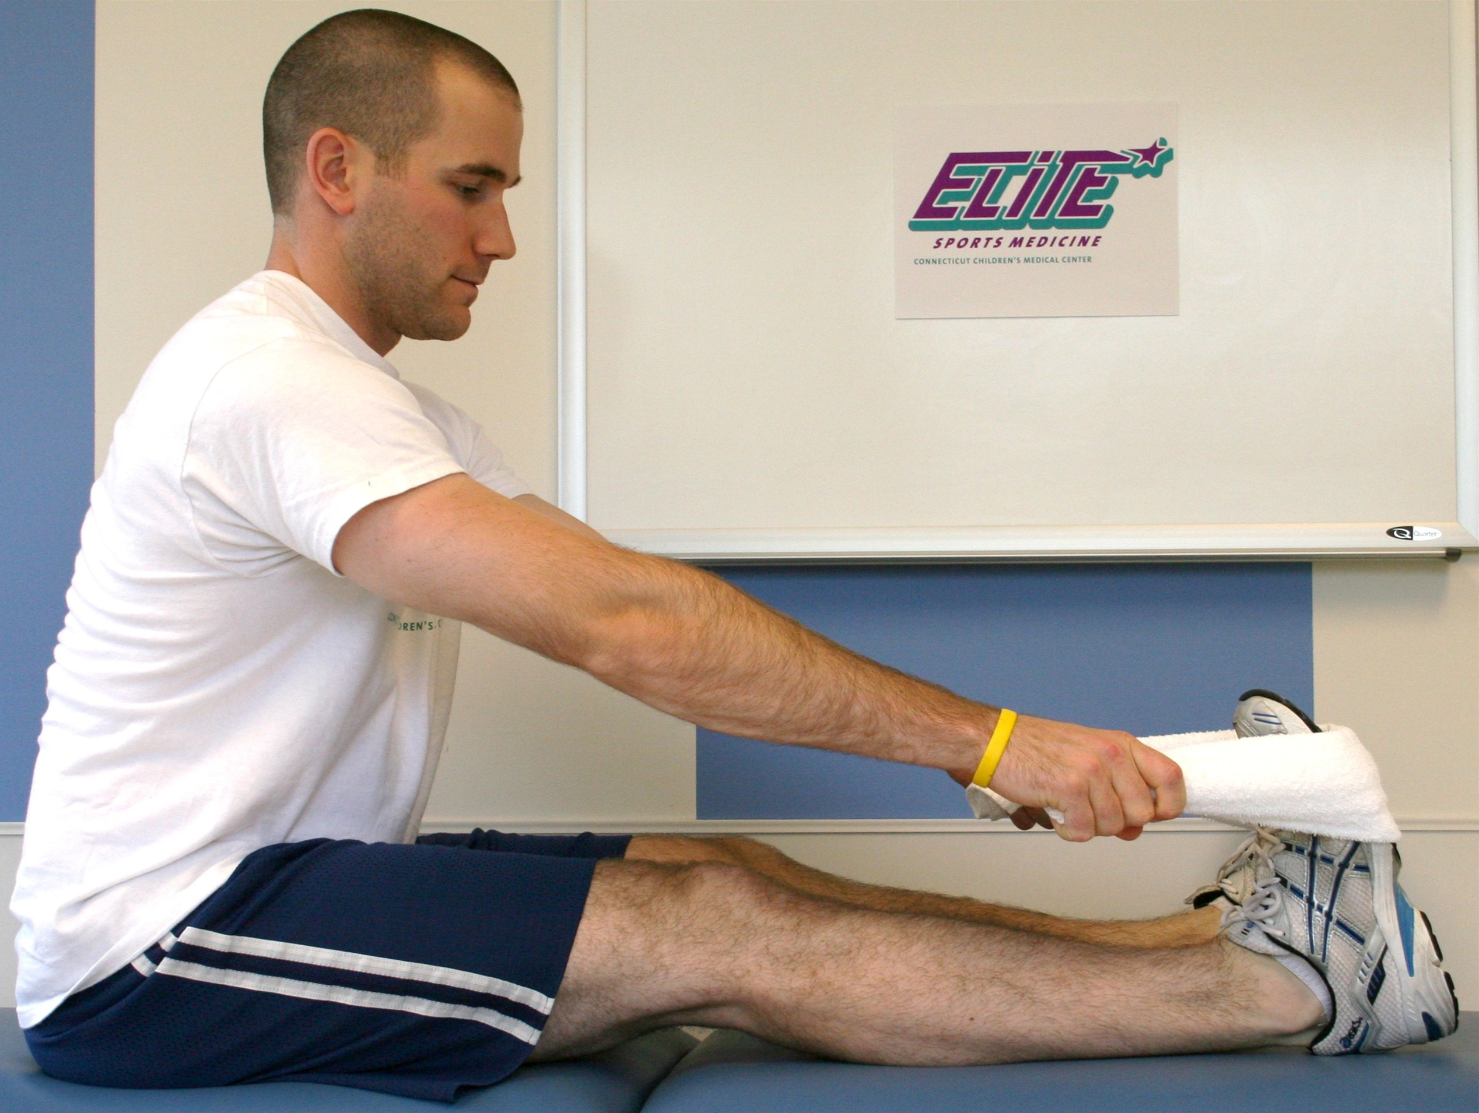

Calf Stretch:

Using a towel or a belt, gently stretch you calf muscles

as pictured. Keep your knee straight. Hold the stretch

for 20-30 seconds. Do this 4-6 times per day.

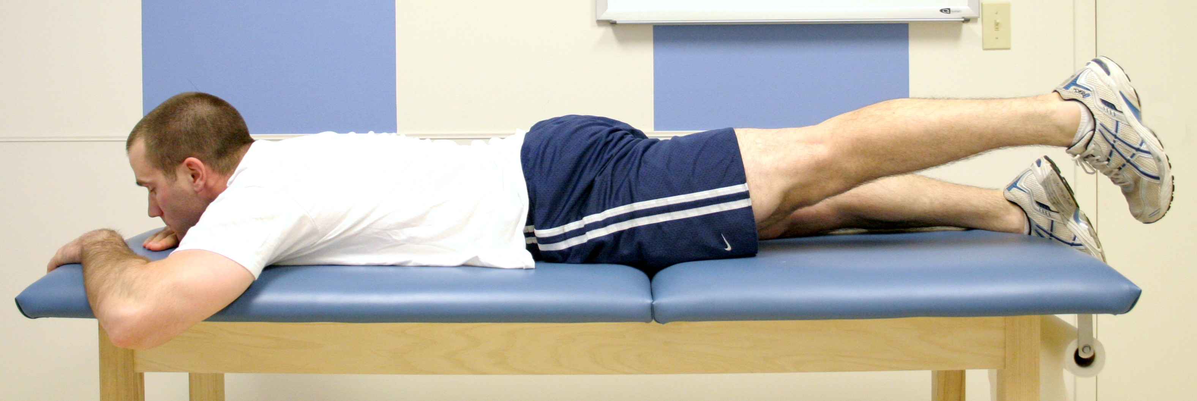

Straight Leg Raise, Extension:

Squeeze thigh muscles tightly, then lift leg from the surface as shown. Raise and lower your leg slowly. Repeat 15-30 times. Do this 4-6 times per day.