***Peri-scapular Strengthening Exercises***

***Directions: All exercises should be completed in the following method; three (3) set of ten (10) repetitions unless otherwise noted. Shoulder strengthening exercises should be completed 3-4 times per week and should be done to both sides. Greatest gains will be made when the muscles are warm.***

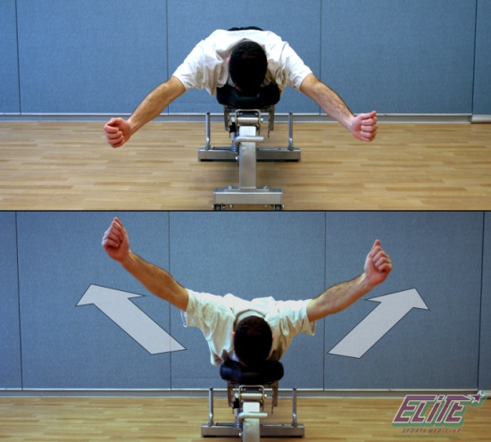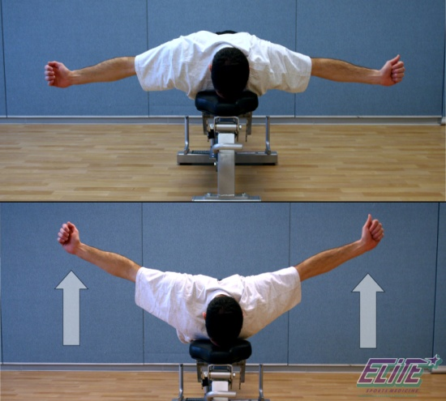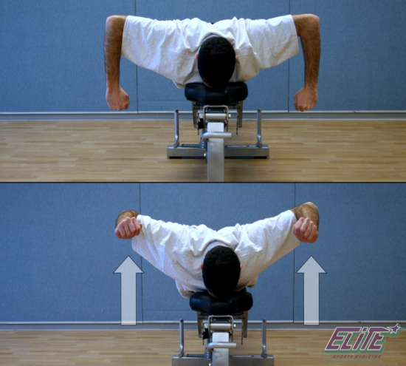

**T’s, W’s, Y’s –** While lying on your stomach, squeeze shoulder blades together and complete the following

**T’s – (*Pictured Top Left)*** point thumbs toward the ceiling with arm straight out to sides and raise arms up

**W’s – (*Pictured Middle)*** bend elbows to 90°, point back of hand to ceiling and raise arms up to shoulder height

**Y’s – (*Pictured Right)*** point thumbs to ceiling with arms out in front at 45° from head and raise arms up.

**Prone I’s –**

Lie on your stomach with your arms down by your sides. Squeeze your shoulder blades together and slowly raise your arms off the floor. Rise up as high as you can while keeping the front of your chest in contact with the floor. Hold the position for 5 seconds then lower your arms to the floor.

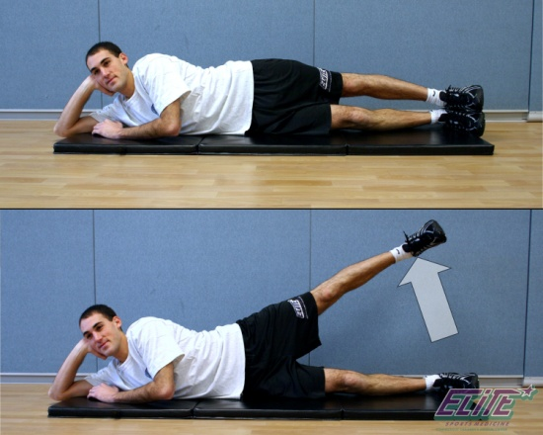

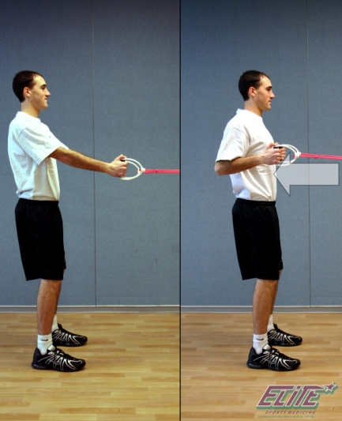

**Rows –**

Squeeze your shoulder blades together. Keep your elbows bent and close to your side. Pull your elbows back behind you and maintain your squeezed shoulder blades. Slowly return to the beginning position.

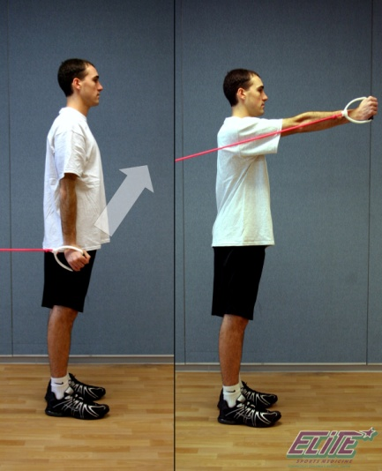

**Shoulder Flexion –**

Squeeze your shoulder blades together. Keep your elbow straight and lift your arm in front of you to the height of your shoulder. Slowly return your arm to your side, not allowing the tubing to pull your arm back quickly.

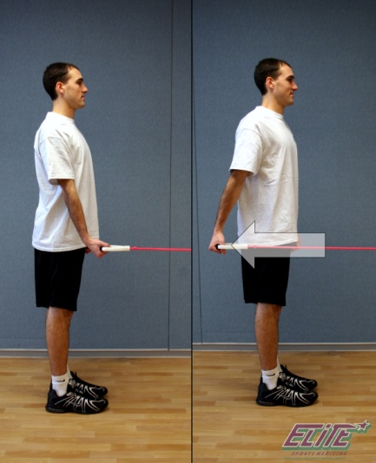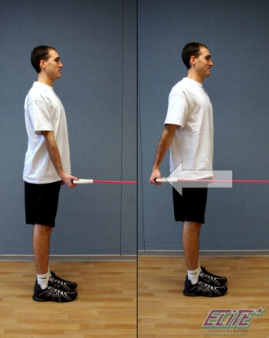

**Shoulder Extension –**

Squeeze your shoulder blades together. Keep your elbow straight and slowly pull you hand back behind yourself. Slowly allow your hand to return back to the beginning position.





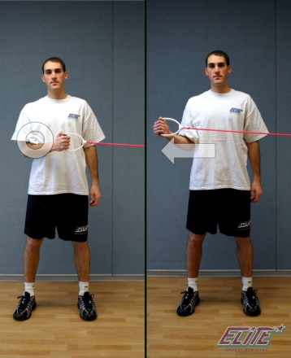



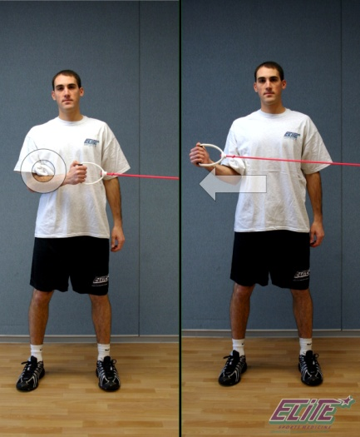

**External Rotation –**

Place a towel between your elbow and side. Squeeze your shoulder blades together. Slowly rotate your hand away from your body. Then slowly allow your hand to come back to the beginning position.

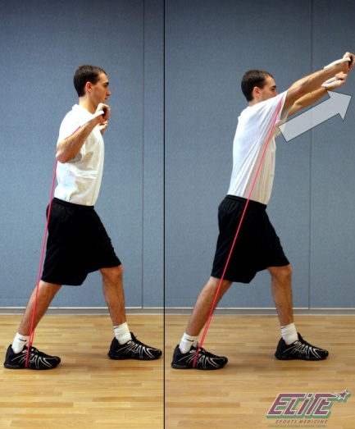

**Punches –**

Start with elbows bent and hands up by your collarbones. Slowly straighten out both elbows as if you are punching out in front of your face. Slowly allow your hands to come back to the beginning position.