***Stretching and Strengthening for the***

***Overhead Athlete***

***Directions: All exercises should be completed in the following method; stretching 3-5 sets of 30 seconds, and strengthening 3-6 sets of 10-20 reps. unless otherwise noted. Greatest gains will be made when the muscles are warm.***

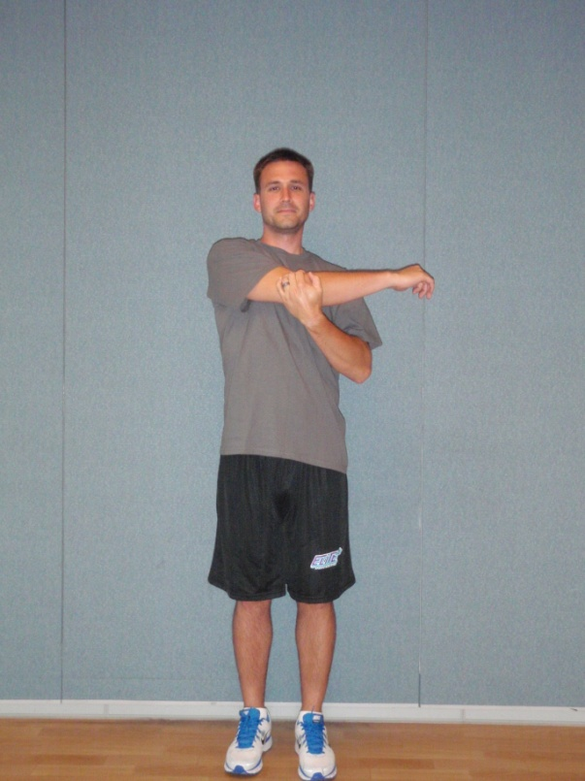

**Horizontal Cross Arm (Adduction) Stretch –**

While standing or seated, move one arm straight across your body to the opposite shoulder. With the other hand, gently apply over pressure just above the elbow of the arm being stretched in a direction moving your arm closer to your body until a stretch is felt in your shoulder.

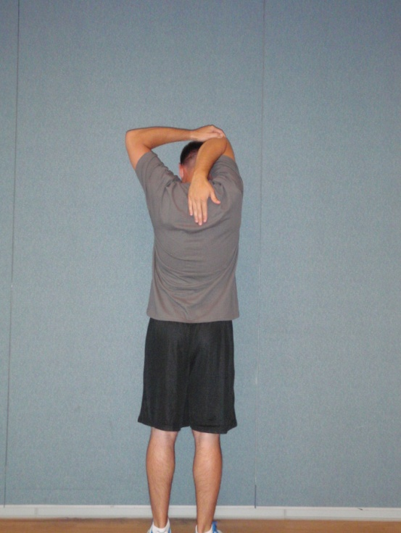

**Triceps Stretch –**

While standing or seated, reach behind your head as if to scratch the middle of your upper back. With the other hand, gently apply over pressure to the elbow of the arm being stretched in a downward direction until a stretch is felt in the back of your upper arm.

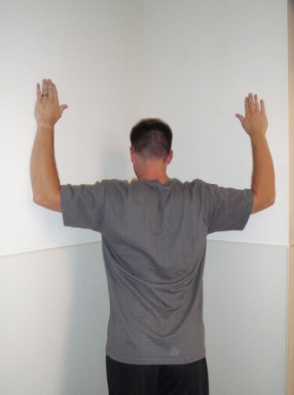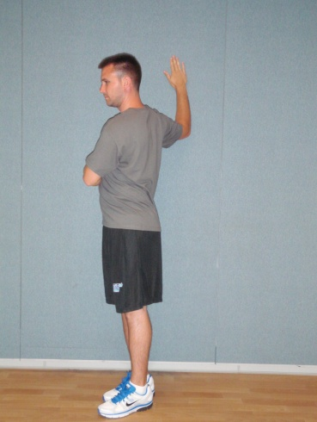

**Corner Stretch –**

**Double Arm –** While standing in a 90° corner or in a doorway, place your arms in a 90°/90° position. Using the weight of your body, lean into the corner until a stretch is felt in the front of your chest.

**Single Arm –** While standing near a wall or in a doorway and your shoulder in a 90°/90° position, place your elbow and forearm against the wall and rotate your body away until a stretch is felt in the front of your chest.

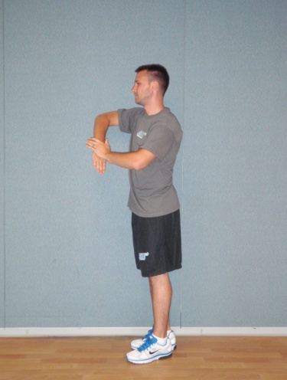

**Sleeper Stretch –**

**Standing –** While standing with your upper arm and elbow against a wall, place your arm straight out in front of you and bend your elbow 90°. With the opposite hand, hold the back of your wrist and gently press your wrist towards the wall until a stretch is felt in the back of your shoulder.

**Side Lying –** While lying on your side, place your arm straight out in front of you and bend your elbow 90°. With the opposite hand, hold the back of your wrist and gently press your wrist towards the table until a stretch is felt in the back of your shoulder.

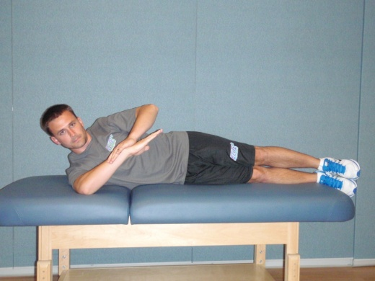

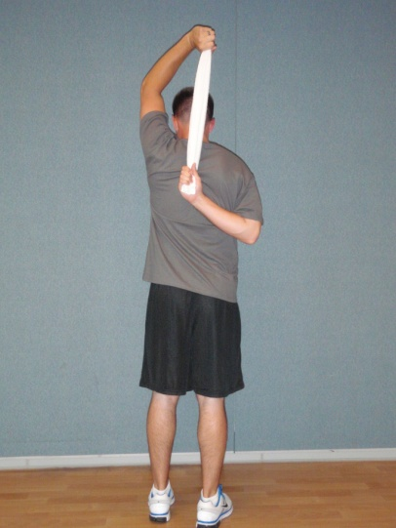

**Towel Stretch –**

While standing or seated, place the back of one hand on your low back. Grasp a towel with both hand behind your back and head. With the arm above your head, gently pull the other arm up your back until a stretch is felt in your shoulder.



**T’s, W’s, Y’s –** While lying on your stomach, squeeze shoulder blades together and complete the following

**T’s – (*Pictured Top Left)*** point thumbs toward the ceiling with arm straight out to sides and raise arms up

**W’s – (*Pictured Middle)*** bend elbows to 90°, point back of hand to ceiling and raise arms up to shoulder height

**Y’s – (*Pictured Right)*** point thumbs to ceiling with arms out in front at 45° from head and raise arms up.

 

**L’s with Rotation –**

With your arms straight out to the side and with your elbows bent to 90°, rotate your hands up toward the ceiling while pinching your shoulder blades together.

**90° - 90° External Rotation –**

With your arm straight out to your side and with your elbow bent to 90°, pinch your shoulder blade down and back and rotate your hand upward while maintaining the proper shoulder alignment.

**90° - 90° Internal Rotation –**

With your arm straight out to your side and with your elbow bent to 90°, pinch your shoulder blade down and back and rotate your hand toward the floor while maintaining the proper shoulder alignment.



**Reverse Throw –**

While holding elastic tubing with your dominant hand above and behind your head with your palm up, bring your arm down across your body while rotating your palm down. Slowly return to the start position.

**Wind Up –**

While holding elastic tubing with your dominant hand down across your body and your thumb pointing toward your back, pull your arm up and out while rotating your palm forward. Slowly return to the start position.





**Side Lying External Rotation –**

While keeping your elbow pinched by your side and your elbow bent to 90°, slowly rotate your forearm toward the ceiling. Slowly return to the starting position.



**Push Up Plus –**

While on your hands and knees with your upper back relaxed, push your chest away from the floor as to round your shoulders. Slowly return to start position while keeping your elbows straight.



**Shoulder Punches –**

With your hands at approximately shoulder level, slowly straighten your elbows as if you were punching in front of your face at a 45° angle towards the ceiling. Slowly return to the starting position.