Hand Exercise:

Gently open and close your hand, as if gently making a fist, then opening your closed fist. Repeat 30 times. Do this 6-8 times per day. (not pictured)

Hand Elevation:

In a seated position with your elbow immobilized at 90 degrees, use pillows to elevate your arm. Keep your hand elevated for 15-20 minutes. Do this 4-6 times per day.

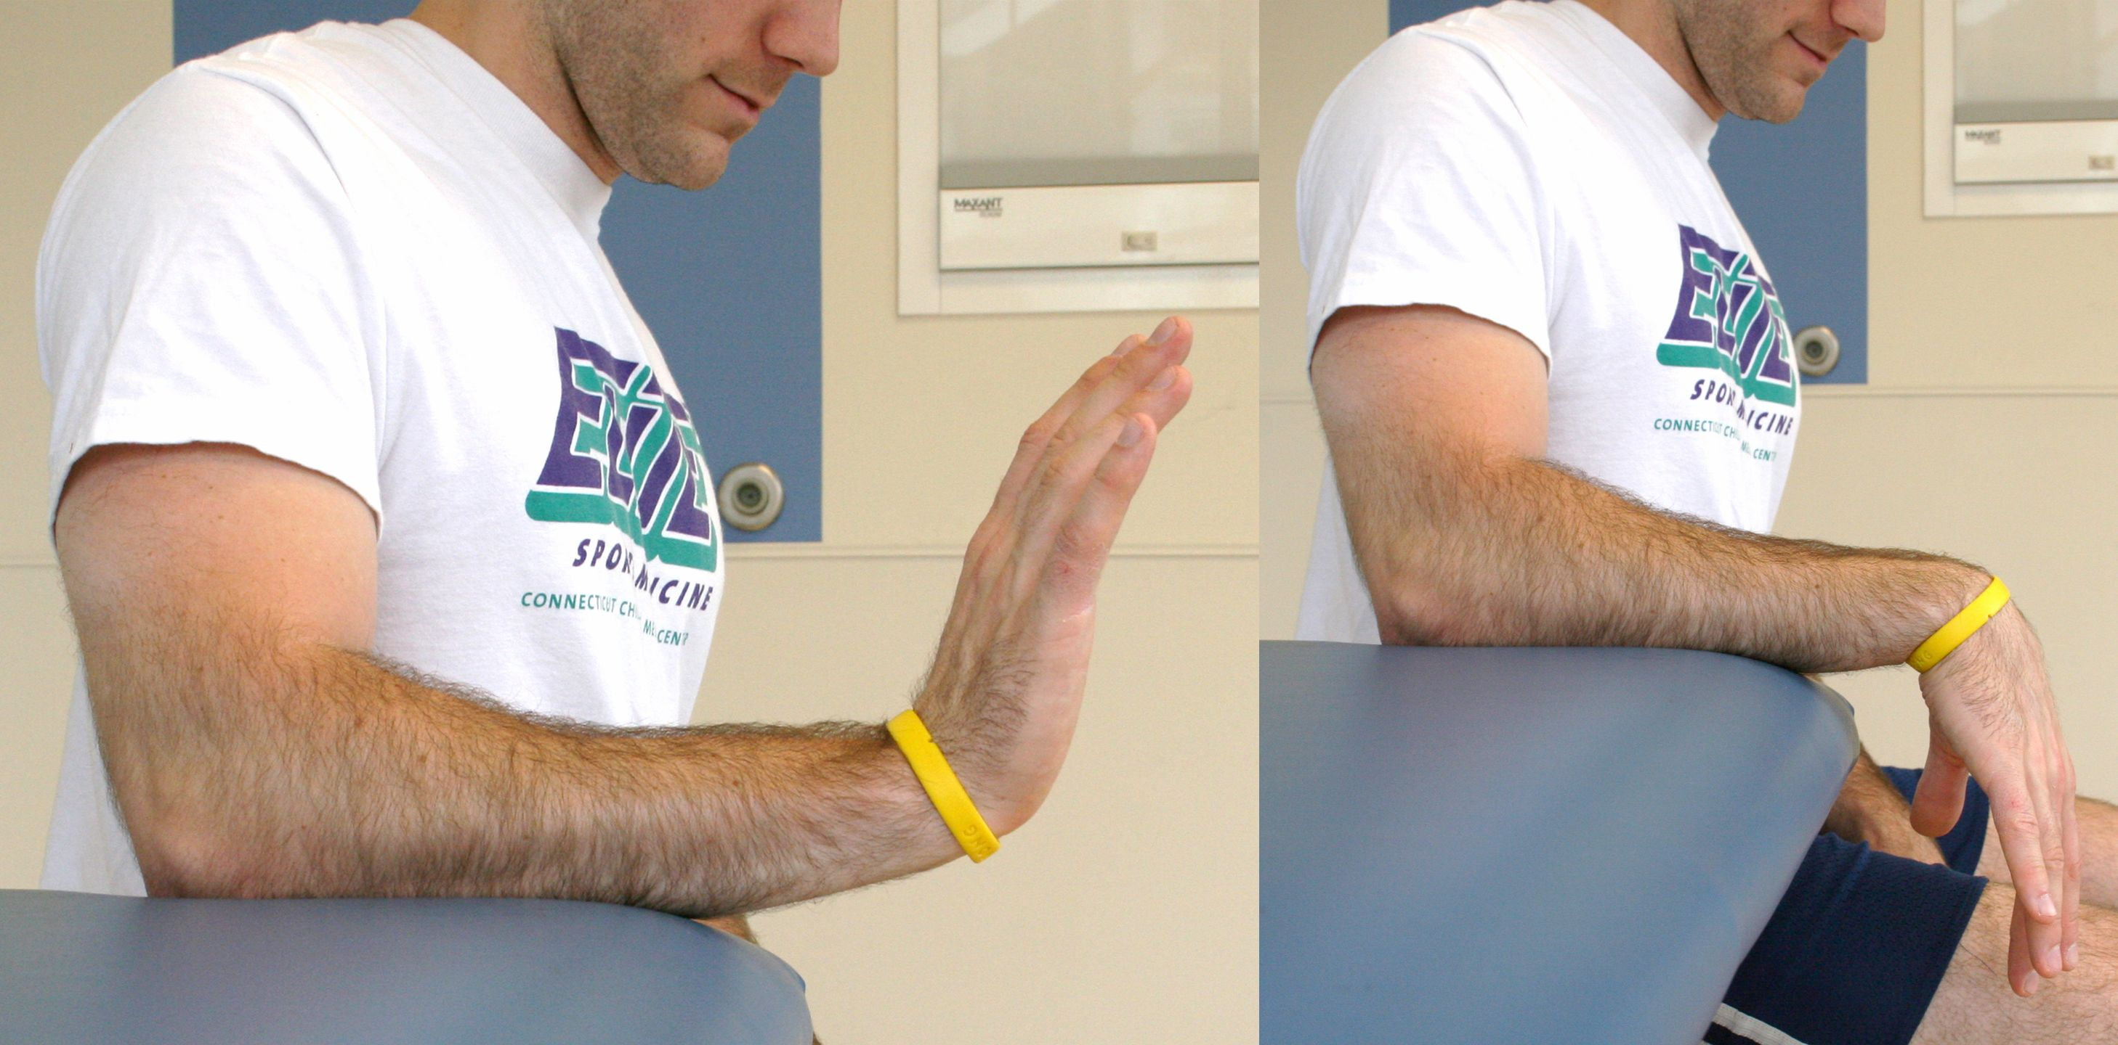

Active Wrist Extension/Flexion:

While keeping your elbow immobilized at 90 degrees, bend your wrist up and down. You may also bend your wrist from side to side (not shown in picture). Repeat 30 times. Do this 4-6 times per day.

Shoulder Flexion:

While seated or standing, keep your elbow immobilized at 90 degrees and raise your arm forward from the shoulder. Repeat 15-20 times. Do this 4-6 times per day.

Shoulder Abduction:

While seated or standing, keep your elbow immobilized at 90 degrees and raise your arm sideways, away from the side of your body. Move only from the shoulder. Repeat 15-20 times. Do this 4-6 times per day.