PRIDES May/Summer Newsletter
1 message
Lisa Safago <safago.lisa@gmail.com>

SCW PRIDES <scwprides@gmail.com> Thu, Apr 27, 2023 at 5:14 PM Reply-To: scwprides@gmail.com
To: safago.lisa@gmail.com

May/Summer 2023 Newsletter
See you in the fall snowbirds, safe travels.

See you on the streets sweatbirds, wear sunscreen!

A Note from the President

PRIDES,

Hope you all are ready for some warmer weather!

To all the Snowbirds, we hope everyone has a happy, safe, and healthy summer. Enjoy your summer home and surroundings. Please, on June 17 think of all our full-time members
enjoying TWO donuts at the June Payday meeting! You all are welcome to fly back and enjoy, but you must work Saturday morning.
What a great community we live in. We have collected significant donations for many SCW

Clubs and organizations. Thanks to: Tennis Club, Catholic Daughters, ARC, Lions Club, Pickleball Club, Zymurgy Club and to all the residents sending individual donations.
Our current focus will be growing our numbers. We hope to visit many of the local organizations seeking volunteers. We receive so many “thank-you’s” and donations, now we just need to ask for one more item and that is “join us”. I believe if we ask, we will receive.
Look for new faces when you all get back in the fall. Then we will do it again after you all return.
Be safe and healthy, Gary

From the Horticulture Team
Irrigation Best Practices by Bruce Kilbride

It is almost time to change your home irrigation system to summer watering. With different styles of irrigation systems and a variety of plants, it’s impossible to have a simple answer on irrigation timing.

Here are the “Best Practices” for desert irrigation, water infrequently and water deeply. If you are watering 10 minutes a day this is not infrequent or deep.
If your landscaping has drip emitters measured in 1-2 gallons of water PER HOUR you can water shrubs 3-4 hours a day, two days per week in the summer and one day a week in the winter.

Trees need more water than shrubs, so you need additional emitters and/or more time. Trees need only one day per week in the summer and one day every two weeks in the winter.

Citrus trees need more water in the summer than landscaping trees. Water citrus 3 to 4 days per week in the summer, and 2 days per week in the winter. Citrus trees may exhibit “leaf curl” on many leaves if they are not getting sufficient water. (Leaf curl may also be caused by tiny

insects called thrips. Thrips create “cosmetic” damage but do not create concern for the health of the citrus tree).
Irrigation systems with PVC bubblers are measured in gallons of water PER MINUTE so you
cannot water for hours as you will flood your yard. A solution for bubblers is to water for 15-20 minutes then delay 60 minutes and water again for 15-20 minutes. The first watering soaks the soil and the second watering soaks through and then waters more deeply. Most home irrigation timers can water multiple times per day.

Remember, water infrequently and water deeply. You will need to apply these best practices to your specific landscape situation.

Summer Calendar

May | June | July | August
6 - work  13 - work | 3 - work  10 - work | 1- No work, Happy | 5 - work  12 - work

20 - work and Pay Day
27 - No work

Happy Memorial Day!

17 - work and Pay Day
24 - work
Fourth of July!

15 - work and Pay Day
21 - work

19 - work and Pay Day
26 - No Work

Happy Labor Day!

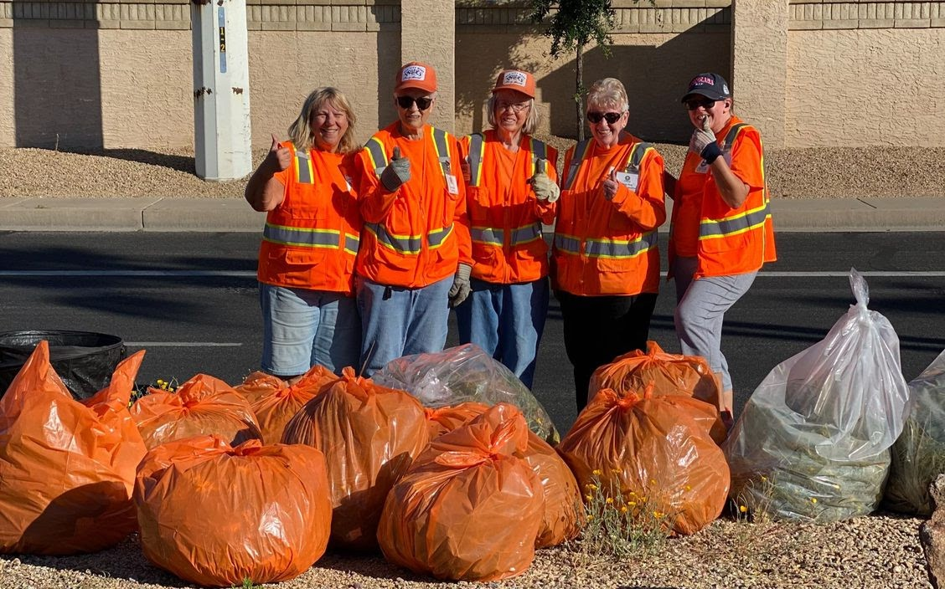

Section 8, left to right; Marybeth Dougherty, Sara Dunn, Lynn Krabbe, Diane Rice Monitor, Hollie McCurdy

Summer Anniversaries in May, June, July, and August Congratulations to All!

May
Name - Years Kathryn Bell - 1 Steve Benza - 8
Sharon Chesney - 6 Ralph Johnson - 11 Bill King - 3
Laura King - 3 Gary Konop - 5
Ralph Kwapiszeski - 9

June
Name - Years Donna Barr - 3 Jan Benjamin - 4
Kevin Benjamin - 4

Nancy Billinghurst - 5 Leonard Clark - 3 Sara Dunn - 5
Kelly Hybl - 4

Dale Johnson - 2

John Lowe - 3 Jim McLeod - 2 Jim Pruitt - 3
Doug Randall - 13
Shirley Hohnson - 2 Suzanne Jones - 11 Tommy Jones - 11 Austin McGeary - 5 Elaine Miller - 13 Diane Rice - 8
Larry Tannenbaum - 2 Leanne Tawoda - 1

July
Name - Years Maggie Barrett - 18 Richard Barrett - 18 Joe DeGumbia - 7 Char Kunze - 18 Sharon Odya - 4 John Quinn - 1
Jim Rowe - 6

August
Name - Years Virginia Brokish - 26 Shelly Hooper - 2
Karyn Odella - 1 Maryalyce Skree - 11

Attention Monitors:
Keeping your team members safe!

Working in a median with cones on one side only: you may work on the island but not close to the exposed edge. Work on the side of the median that has a lane blocked for you.

Working in a median with no cones: this is not allowed.

Cars and bicyclists traveling in the blocked lane: remind them the lane is blocked to ALL traffic including cyclists. This is for the safety of everyone.

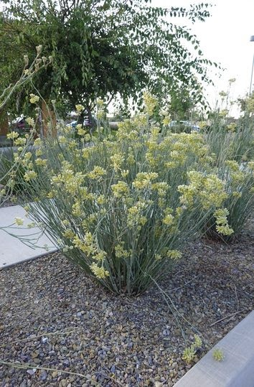

Plant of the Month
Asclepias subulata, Desert Milkweed

Desert Milkweed is found in nature in sandy washes in the arid regions of lower elevations below 3000 feet including the upper reaches of the Sonoran Desert, eastern California, southern Nevada and into Baja California.

It is a great seasonal accent plant (mostly line and texture) for dry landscapes. It is erect, stiff, open, airy, and informal. It is a herbaceous perennial, generally basally clumping and erect. A moderate grower from 2 to 5 feet in height. If it's irrigated regularly, then it will respond with increased vigor and size and become “leggy.”

It is green to gray green stems are entirely leafless except for new growth; medium fine texture. It has small creamy yellow flowers forming flat-topped umbels during spring through fall.
It is very heat tolerant, is cold tolerant to 18 degrees F, and loves full sun.

Desert milkweed prefers sandy, well-drained soils, but will grow well in pretty much any Phoenix soil type. It requires little to no watering. It requires no pruning but it can be cut back back severely to rejuvenate every 3 to 5 years.

Desert milkweed is currently quite popular as a desert accent plant. This interesting plant attracts butterflies, and in particular is a forage source for the monarch and striated queen butterflies.

Check out these informational reference articles for more information:

https://www.public.asu.edu/~camartin/plants/Plant%20html% 20files/asclepiassubulata.html

https://azmnmcp.org/f/magnificent-monarchs-and-marvelous-milkweeds

https://wateruseitwisely.com/blog/plant-of-the-month-desert-milkweed-asclepias- subulata/?gclid=CjwKCAjw0N6hBhAUEiwAXab-TTUWSkOfB5NHMkZP- PXet8OyGbiUqrMwyfIEqO8RrcpyXvh4tSNN_BoCsTIQAvD_BwE

https://ag.arizona.edu/maricopa/garden/html/pubs/1203/milkweed.html

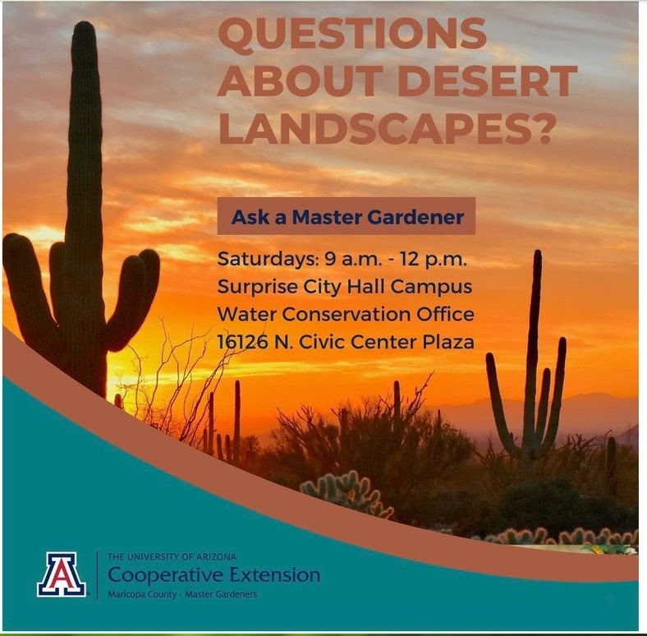

“Retail Nurseries and Garden Centers List”

is now available on our Website Check it out under Landscaping Resources
or click here:

Retail Nurseries and Garden Centers List

Have a fun and safe summer.
Keep posted on PRIDES news by visiting our website:

PRIDES Website

PRIDES Board Members
Gary Schrorer, President Tom Jones, Vice President Lisa Safago, Secretary
Ron Rada, Treasurer

Kathy Estes, Associate Treasurer of Revenue Judy Holmen, Associate Treasurer of Disbursements Lowell Janssen, Associate Treasurer of Disbursements
Linda Mandowski, Associate Treasurer of Revenue Maryalyce Skree, Director

Proud Residents Involved Doing Environmental Services PRIDES is a Non-Profit, 501 (3) (c) Organization

This email was sent to safago.lisa@gmail.com
why did I get this? unsubscribe from this list update subscription preferences
PRIDES of Sun City West · 14630 W R H Johnson Blvd · Sun City West, AZ 85375-1807 · USA

