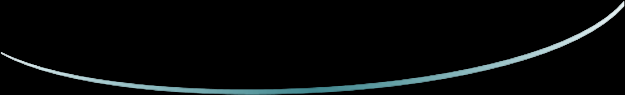
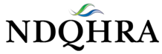
Cell Phone:

Thank you for your continued support of NDQHRA!

North Dakota Quarter Horse Racing Association
Leon A. Glasser, President
www.thendqhra.org

2026 NDQHRA Membership Form
Dues = $50.00
(Membership Expires: December 31, 2026)
Name(s) or Farm/Ranch:
*Please list the name you wish placed on your membership card and used in the newsletter.
Contact if a business is listed above:
Mailing Address:
City: State: Zip:
Home Phone:
Email:
Website:
Most communications are sent out using email including payment receipts. If you do not have an email address, please make sure we have the current mailing address.
As a Member you receive:
- Eligibility to enter special races.
- Awards.
- Invitation to the Annual Horsemen Awards Banquet.
- Voting Privileges at General Meetings
- Newsletters
- Payment Schedules
- AQHA Affiliated

To participate in the Northern Plains races all owners must be a NDQHRA members. Names must match all those required by AQHA for valid entries. Regarding the North Dakota Certified Bred Races, if you are a current NDQHRA member, prior to the races, you are eligible to receive awards at the race track and at year end.
Please mail your membership form and payment to: NDQHRA, PO Box 188, Mapleton, ND, 58059. Visit our website at: www.thendqhra.org

