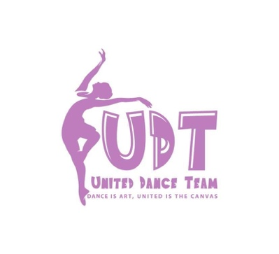
2022 Registration

Name of Dancer__________________________ Date of Birth _______________________

Address__________________________________ Shirt Size_____________________

City __________________ State ______ Zip code ______________

Primary Phone Number ____________________________ Cell Landline Business (Circle One)

Email Address__________________________________________________

Parent Name_____________________________________ Cell Phone Number ________________________

Release for Social Media photos and videos: Yes / No

Emergency Contact Information

Name _______________________________ Phone Number __________________________

Medical

Allergies if any ______________________________________________________________________

I, ____________________________ parent of ________________________________hereby agree and understand that tuition is due on the 10th of every month in the amount of $20. Families of multiple children will be charged the initial $20 and $5 for each additional child. The cost of the lessons remain the same whether your dancer attends practices or not. Two uniform shirts a year will be included in tuition costs. If you are unable to pay for tuition, arrangements can be made prior to the 10th of the month by contacting Amanda C.

Dancers are expected to follow and understand the following rules while participating with United Dance Team, UDT:
Performances you must wear uniform consisting of long pant length black leggings, black socks, black shoes (may vary, specific shoe will be discussed prior to performances), Uniform shirt that will be provided twice a year, and a bow or hat. Uniform shirts are to be worn for performances only; do not wear them outside of dance. NO jeans, denim, short shorts (must be finger length long) are to be worn during any United Dance Team event including practices. Parent is responsible for providing uniform unless otherwise announced
If you are late without notification to a performance, your child may NOT perform. No call/ No show performances will result in suspension from practice and participation for up to one week. You must give 24 hour notice to United Dance Team and/or leaders prior to performances.
Dance practices are for the dancers only. Please keep non-dance family members or friends away from the dance area during this time. Positive encouragement is always welcomed but we ask for all other comments and interjections be refrained until after practice is over. Parents may approach dancers after practice but not during instructional time.
Practices will vary depending on performance schedules. Please note your child must attend every practice in order to participate in the performance for that week. IF your child misses more than one practice during a performance week, she/he will not be allowed to perform at the event.
By signing this agreement, I understand that United Dance Team (UDT) will be performing at various locations. I hereby release, indemnify, and hold harmless United Dance Team, Board of Directors, Management, and/or Shahira McGinty from any and all claims, causes of actions, and liability arising from or in any way connected with the organized dance team when participating with any event until notified otherwise.

___________________________________________ ______________________________
Parent Signature Date

