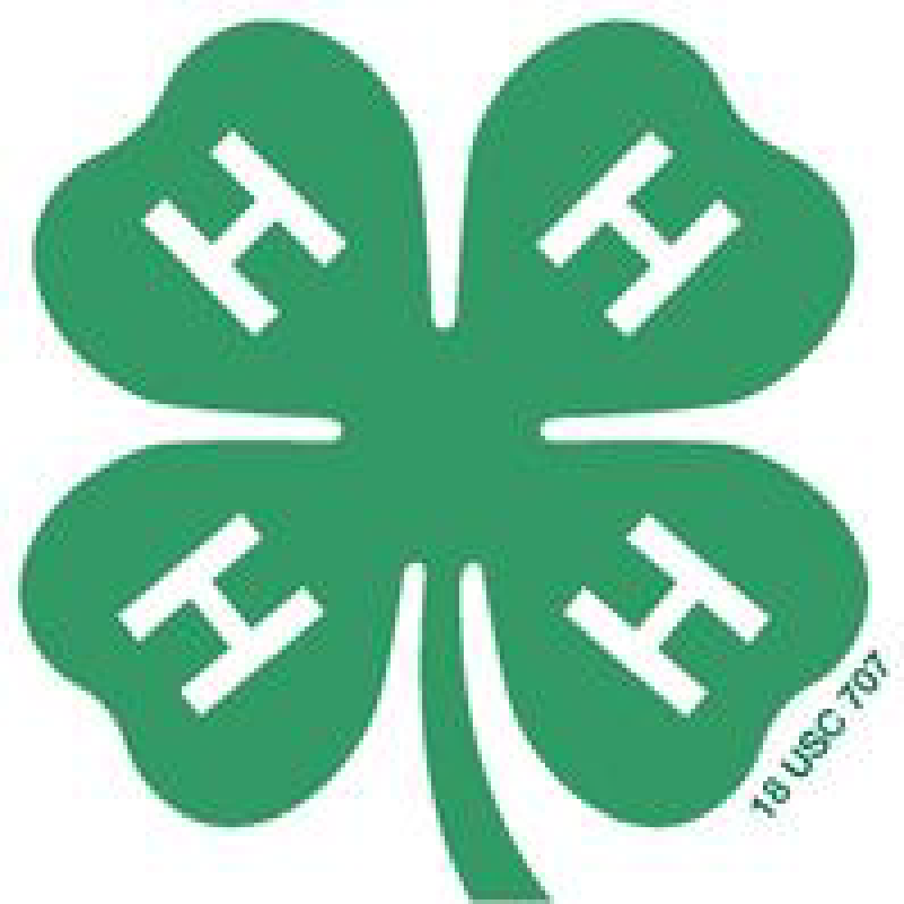

We would like to welcome everyone for our 2024 year!!! We want to say a special welcome to any new members we have joining us! Please remember communication is key. We operate using e-mails; please make sure we have a current one on file. We send out a weekly email every Friday with information on upcoming meetings and important information from previous meetings.
2023 started out great, with officer elections and some educational and informative speakers. Our inaugural Cook Out and Auction was an amazing success in March. The 2023 fair was hot, but we still got to see the kids succeed in everything they practiced throughout the year at the meetings. We are looking forward to a great 2024, with our Monday night meetings again and bringing horses starting in April.
Our club continues to grow every year, so we need everyone’s help throughout the year! Your club leaders are very proud of each member and every family that participates in our club. It’s hard to THANK YOU enough for all that you continue to do to help make our club the best it can be for our youth!!!
We want to be able to welcome everyone who wants to come and have a fun-filled evening as we have for many years now.
Looking Forward to Educational, Life Rewarding, Fun in 2024!!!!!

Club website: www.ccbarnbums.com
We also have a Facebook & Instagram page!

