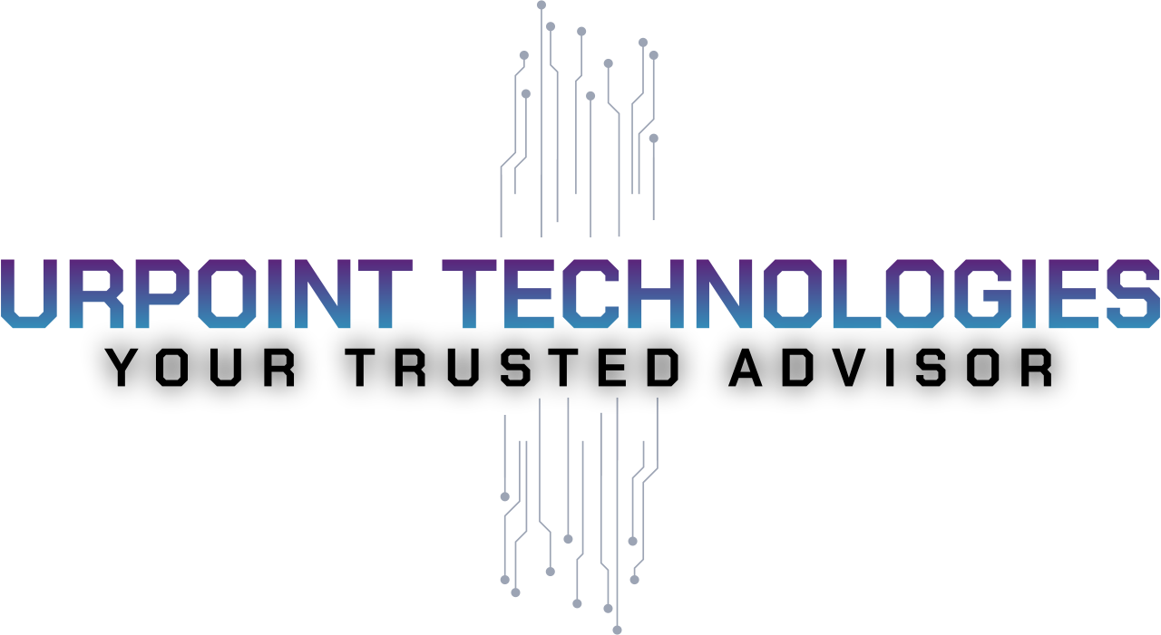

SMB Cybersecurity Checklist & Readiness Guide

Understand Your Cybersecurity Posture in Minutes — And Learn Why Choosing the Right Partner Matters.

Cyberattacks don’t just target the big players — small and mid-sized businesses (SMBs) are often the easiest wins for hackers. This checklist is designed to give you a fast, clear picture of where your business stands today. It’s not about doing everything yourself — it’s about knowing your risk level so UrPoint can connect you with the right vendors and solutions.

1) Access & Identity
- ☐ Strong passwords or passphrases (12+ characters).
- ☐ Multi-Factor Authentication (MFA) enabled on critical systems.
- ☐ Inactive accounts removed or reviewed quarterly.
2) Devices & Apps
- ☐ All laptops/phones have up-to-date antivirus or endpoint protection.
- ☐ Automatic updates/patches turned on for all software.
- ☐ Lost/stolen device protection in place (remote wipe).
3) Email & Phishing
- ☐ Spam filtering and phishing protection enabled.
- ☐ Employees trained regularly to spot phishing attempts.
- ☐ Your business email domain is protected with SPF, DKIM, and DMARC.
4) Data Protection & Backups
- ☐ Automated backups (including cloud apps like Microsoft 365/Google).
- ☐ Backups include at least one secure/offline copy.
- ☐ You’ve tested a restore in the last 6 months.
5) Network & Remote Access
- ☐ Firewall and secure Wi-Fi (WPA2 minimum, WPA3 preferred).
- ☐ Guest Wi-Fi separated from business Wi-Fi.
- ☐ Remote access secured with VPN or similar solution.
6) Monitoring & Response
- ☐ Systems are monitored 24/7 internally or by a provider.
- ☐ Incident response plan exists with roles and steps documented.
- ☐ Logs are collected and reviewed regularly.

7) Governance & Compliance
- ☐ Cybersecurity policies exist (acceptable use, remote work, etc.).
- ☐ Vendor risks are reviewed (partners, contractors, cloud apps).
- ☐ Industry compliance needs reviewed (PCI DSS, HIPAA, etc. if relevant)

Cybersecurity Readiness Scorecard
Go through the checklist and mark each item Yes or No. Then count your Yes answers:
- 17–20 Yes → Ahead of the curve. UrPoint can validate your setup and strengthen your defenses.
- 12–16 Yes → Some gaps exist. Attackers love to target these. We’ll match you with the right vendors to fix them.
- 0–11 Yes → High risk. A single attack could shut you down. UrPoint will guide you toward the right solutions immediately.
SMB Cybersecurity Action Plan
1. Check Your Score
Use the checklist and mark your Yes answers.
2. Review the Gaps
Look at the 'No' answers — these are where attackers will target you first.
3. Prioritize the Big Risks
Not everything is equal. Focus first on:
- Strong authentication (MFA, access controls)
- Backups and recovery testing
- Device protection and patching
- Email/phishing defenses
4. Talk with an Expert
Don’t waste time guessing which products or tools are right. That’s where UrPoint steps in. We’ll review your score with you and recommend the right vendors at the right price.
5. Stay Protected
Cybersecurity isn’t a one-time task. We’ll help ensure your setup is monitored, updated, and reviewed regularly.

Next Step: Don’t guess which products or tools you need.
UrPoint specializes in helping SMBs choose the right cybersecurity vendors at the right price. We’ll sit down with you, review your score, and build a roadmap to real protection — without wasting money or time.
📩 Contact us: www.urpointtech.com

