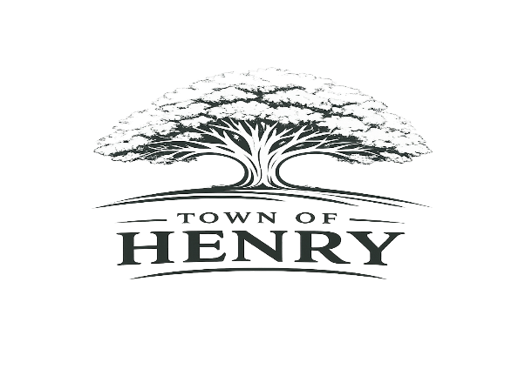
Agenda
Monday August 3, 2026
5:30 PM
Henry, SD Town Hall

- Call meeting to order
- Adopt Agenda
- Pledge of Allegiance
- Public Input
**A time for public members of the community to express comments or concerns to the Board of Trustees on any item not included on the agenda. Comments are limited to 3 minutes. Action will not be taken at the meeting on any issue not included on the agenda.
- Approve July meeting minutes
- Approve August claims
- Old Business
  - Cottonwood Tree Removal update
- New Business
  - Board
    - Insurance
  - Zoning
    - Ryan Lindner
  - Water/Wastewater
    - Opening bids
  - Maintenance
    - Light fixture bids for Town Hall and Community Center
  - Finance/Community Report
    - Rental Contracts
    - Vacation August 24 through August 31
    - Automatic budget Supplement to Streets- $13170.98
    - Automatic Budget Supplement to Parks- $8622.12
    - Automatic Budget Supplement to Fire Department- $410.40
- Next regular meeting scheduled to be held at the Town Hall Thursday, September 3, 2026, at 5:30 PM
- Adjourn meeting

