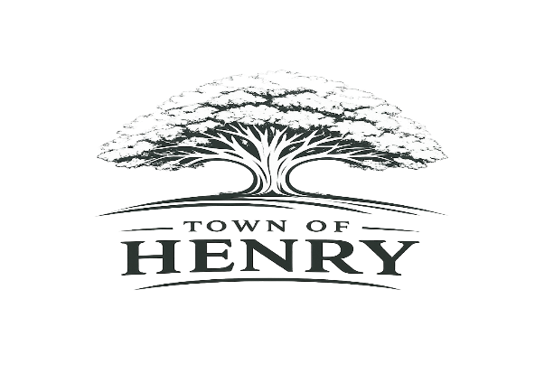
Agenda
Monday, October 5, 2026
5:30 PM
Henry, SD Town Hall

- Call meeting to order
- Adopt Agenda
- Pledge of Allegiance
- Public Input
**A time for public members of the community to express comments or concerns to the Board of Trustees on any item not included on the agenda. Comments are limited to 3 minutes. Action will not be taken at the meeting on any issue not included on the agenda.
- Approve September meeting minutes
- Approve October claims
- Old Business
    - Fire Department
    - Insurance- Tabled in August
    - 2nd Reading of Ordinance 290- 2027 Budget
    - Pickleball Courts
- New Business
  - Water/Wastewater
    - Tools
    - Pay Request #2 and ledger
    - Helm’s Invoice
    - Halme Invoice
    - Sewer Pond Application
  - Streets
  - Zoning
    - Chance Walford
  - Maintenance

  - Finance/Community Report
    - FMLA Policy
    - Quarterly Financial Report
  - Executive Session- SDCL 1-25-2.1
- Next regular meeting scheduled to be held at the Town Hall Monday, November 2, 2026, at 5:30 PM
- Adjourn meeting

