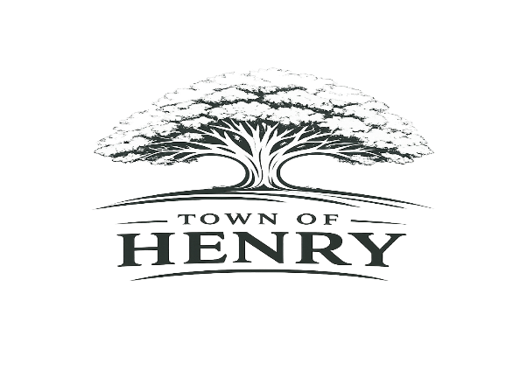
Agenda
Tuesday, September 7, 2026
5:30 PM
Henry, SD Town Hall

- Call meeting to order
- Adopt Agenda
- Pledge of Allegiance
- Public Input
**A time for public members of the community to express comments or concerns to the Board of Trustees on any item not included on the agenda. Comments are limited to 3 minutes. Action will not be taken at the meeting on any issue not included on the agenda.
- Approve August meeting minutes
- Approve September claims
- Old Business
  - Board
    - Insurance- Tabled in August Meeting
    - Boyd Alley Way
    - Fire Department
- New Business
  - Water/Wastewater
    - Sewer System Inspection Books
    - Payment Request #1
    - Helm’s Invoices
    - Record number 4895
    - Old City Water System
  - Streets
    - Street Signs
  - Maintenance
    - Future Equipment
  - Finance/Community Report
    - First Reading of Ordinance 290- 2027 Budget
    - Community Center Cleaning
    - Fire Department/Community Center Siding Repair
    - Special Assessments
- Next regular meeting scheduled to be held at the Town Hall Monday, October 5, 2026, at 5:30 PM
- Adjourn meeting

