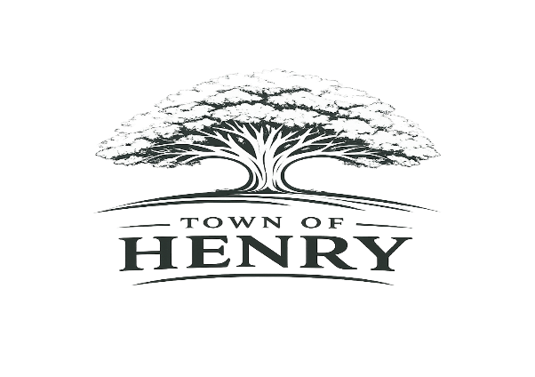
Agenda
Tuesday, April 7, 2026
5:30 PM
Henry, SD Town Hall

- Call meeting to order
- Adopt Agenda
- Pledge of Allegiance
- Public Input
**A time for public members of the community to express comments or concerns to the Board of Trustees on any item not included on the agenda. Comments are limited to 3 minutes. Action will not be taken at the meeting on any issue not included on the agenda.
- Approve meeting minutes
- Approve March claims
- Old Business
  - Henry Community Family Day- Garbage Cans, Portable Toilets
- New Business
  - Lukas Weyh- main street property, concrete property and storage units
  - Johnson Property/Water Project Phase 2 & 3
  - New addition road repair
  - 1st Street Blading by County Highway Department
- Finance/Community Report
  - Annual Clean-Up
  - Payroll
  - Annual Report
  - Quarterly Budget Report
  - Code Enforcement Training
  - Record #4895
- Water Infrastructure
  - Certificate of Completion- Phase 1
  - Sewer Drain by Old Steakhouse
- Maintenance
  - Street Sweeping Quote
  - Helm’s Invoices
- Next regular meeting scheduled to be held at the Town Hall Monday, May 4, 2026 at 5:30 PM
- Adjourn meeting

