TOWN BOARD FILE

Ordinance 289

AN ORDINANCE ENTITLED, an ordinance amending Ordinance 246 (adopted November 3, 2014), An Ordinance Amending Ordinance Number 162 An Ordinance Establishing Zoning Regulations for the Town of Henry, South Dakota, and Providing for the Administration, Enforcement, and Amendment Thereof, in Accordance with the Provisions of Chapters 11-4 and 11-6, 1967 SDCL, and Amendments Thereof, and for the Repeal of All Ordinance in Conflict Herewith, as amended.

Be it ordained by the Town Board of the Town of Henry, South Dakota that Section 2.05.03 [R1] Permitted Accessory Uses, of the Zoning Ordinance of the Town of Henry adopted November 3, 2014 by Ordinance 246, as amended, be amended by adding the highlighted language in bold and underline font, and removing the language in strikethrough font:

Section. 2.05.03. Permitted Accessory Uses:

The following accessory uses and structures shall be permitted in the “R1” Single Family Residential District:

- Accessory uses and structures customarily incidental to permitted uses,

- Shipping Containers. (See Chapter 4.30)

Be it further ordained by the Town Board of the Town of Henry, South Dakota that Section 2.06.03 [R2] Permitted Accessory Uses, of the Zoning Ordinance of the Town of Henry adopted November 3, 2014 by Ordinance 246, as amended, be amended by adding the highlighted language in bold and underline font, and removing the language in strikethrough font as follows:

Section 2.06.03. Permitted Accessory Uses:

- Accessory buildings and uses customarily incident thereto:

- No part of any manufactured home park shall be used for nonresidential purposes, except such uses that are required for the direct servicing and well being of park residents and for the management and maintenance of the park:

- Shipping Containers. (See Chapter 4.30)

Be it further ordained by the Town Board of the Town of Henry, South Dakota that Article IV Supplemental Regulations, of the Zoning Ordinance of the Town of Henry adopted November 3, 2014 by Ordinance 246, as amended, be amended by adding the following Chapter in highlighted language in bold and underline font:

CHAPTER 4.30. SHIPPING CONTAINERS.
Section 4.30.01 Shipping Containers allowed in Residential Districts:

- Shipping containers are considered structures that may be permitted in all residential districts as an accessory use subject to the requirements of this Chapter.

- Up to one (1) Shipping container is allowed as an accessory use in Residential Districts on an annual basis.

- A one time building permit will be required with a fee of $50.00 (Fifty dollars) to Finance Officer, 111 Main Street, Henry, South Dakota, to place in the residential district of Henry, South Dakota.

- Conditional Use permits shall be required annually, on or before January 1 of the applicable year with a fee of $150.00 (One hundred fifty dollars ) to the Finance Officer, 111 Main Street, Henry, South Dakota.

- In addition to the penalties listed in Section 1.02.02, applicant may be required to remove the shipping container for any violation of this Chapter or if annual permit is not obtained on or before July 1 of the applicable year.

Section 4.30.02 Permitting Shipping Containers in Residential Districts:

- Written consent of one hundred (100) percent of adjoining property owners shall be submitted with the initial building permit application.

- The structure shall be placed no closer to any street right-of-way line (not including alleys) than the primary structure on the lot.

- The structure shall meet all other applicable primary yard/setback requirements of the district.

- Shipping containers shall be painted White, Tan, or Color of Residence with no rust visible.

- Shipping containers shall not be used for signs or the mounting of signs.

Be it further ordained by the Town Board of the Town of Henry, South Dakota that Article V Definitions, of the Zoning Ordinance of the Town of Henry adopted November 3, 2014 by Ordinance 246, as amended, be amended by adding the following definition in highlighted language in bold and underline font:
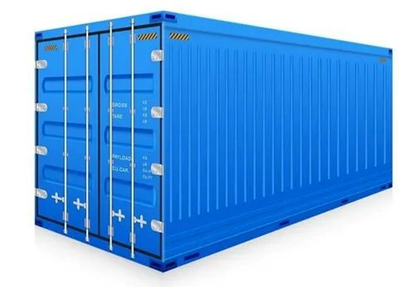

Intermodal Shipping/Shipping Container: A six-sided metal unit constructed as a general cargo container used for the transport and storage of goods and materials. Intermodal shipping/storage containers do not include railroad cars, bus bodies, semi-trailers, and similar items designed to be permanently attached to a chassis. See image at right.

__________________
Town Board President

___________________
Finance Officer

Dated this 6th day of July, 2026
Finance Officer, Henry, South Dakota

