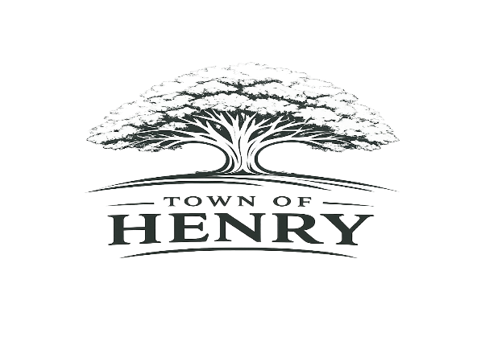
Agenda
Monday August 3, 2026
5:00 PM
Henry, SD Town Hall

- Call meeting to order
- Adopt Agenda
- New Business
  - Board
    - Workshop for Budget for 2027
- Next regular meeting scheduled to be held at the Town Hall Monday, August 3, 2026, at 5:30 PM
- Adjourn meeting

