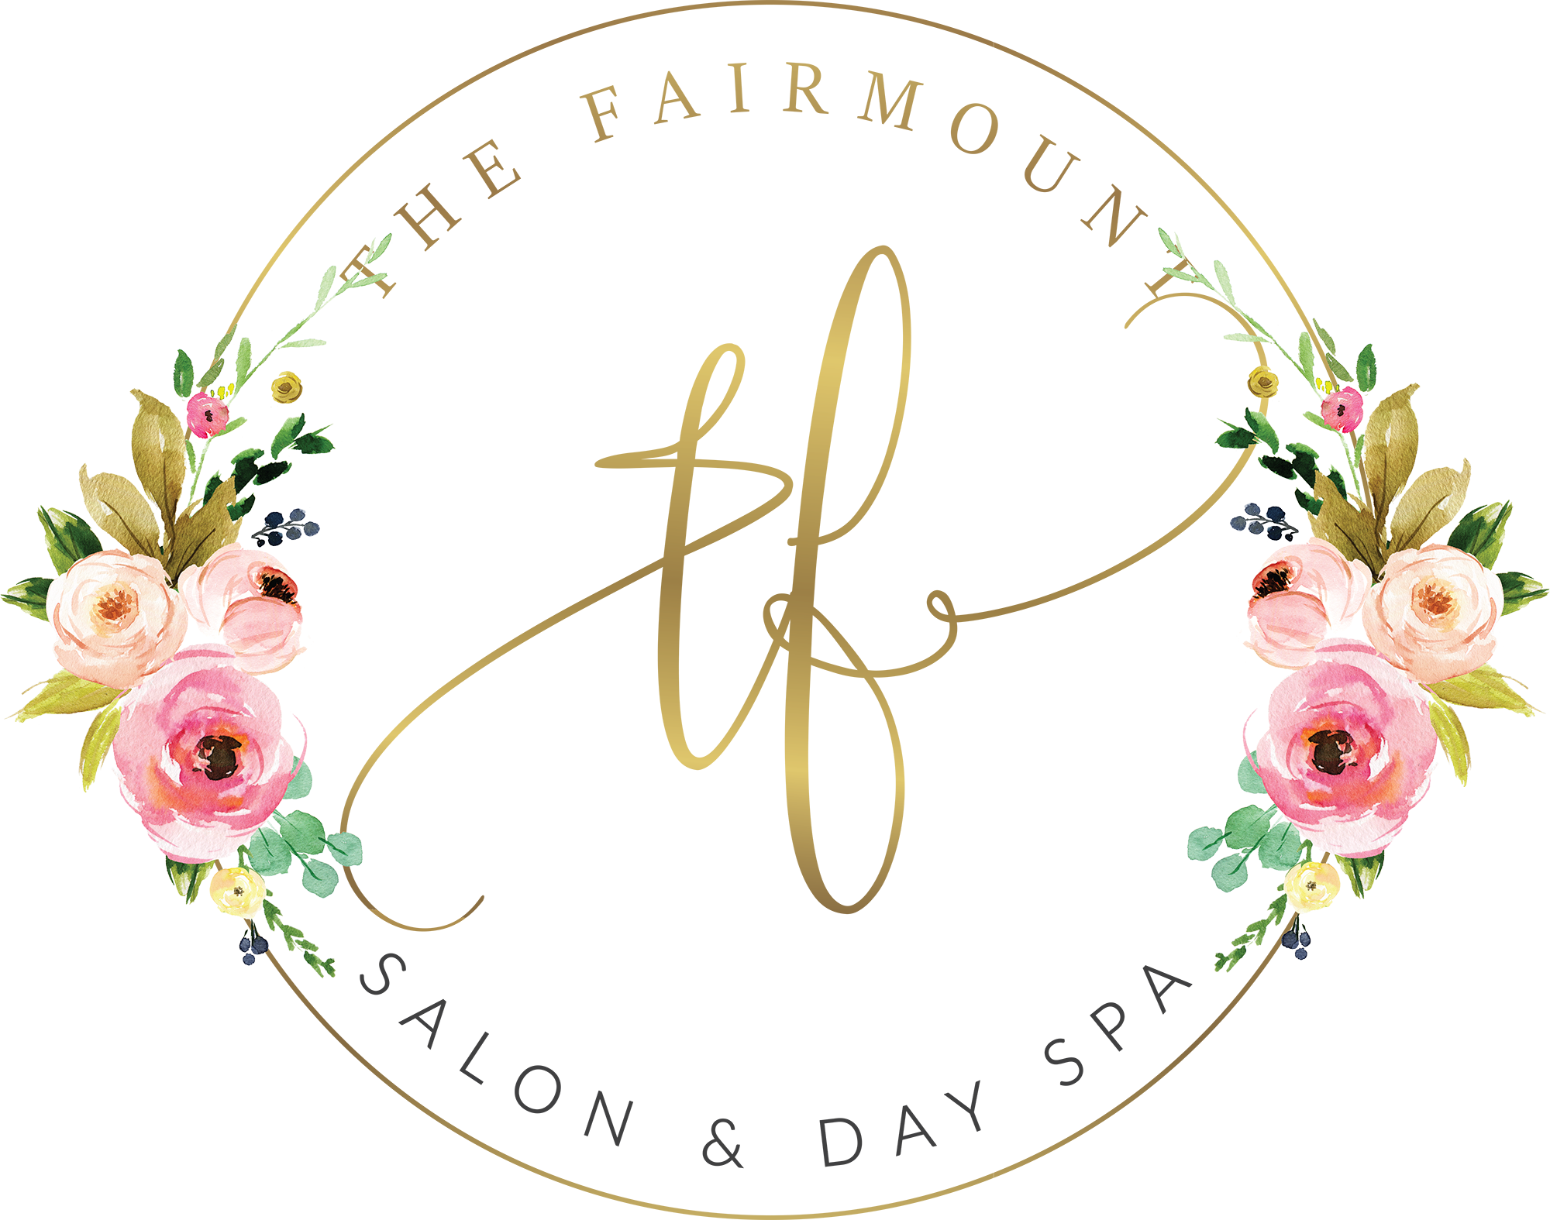
PROSPECTIVE BOOTH RENTER INTAKE FORM
Minimum Requirement: 3 Years of Professional Experience
Thank you for your interest in booth renting at The Fairmount Salon & Day Spa. This form helps us learn more about your professional background, clientele, services, and business goals.

PERSONAL INFORMATION
Full Name: ___________________________________________________________________
Phone Number: ______________________________
Email Address: ________________________________________________________
Address: ________________________________________________________________________
City / State / ZIP: _____________________________________________________________
Social Media / Professional Page: ___________________________________________

PROFESSIONAL INFORMATION
Profession / Specialty: ☐ Hair Stylist ☐ Barber ☐ Nail Technician ☐ Esthetician ☐ Other: __________________
Years Professionally Licensed: ______________________________________________
Do you have at least 3 years of professional experience? ☐ Yes ☐ No
New York State License Number: _____________________________________________
License Expiration Date: ____________________________________________________
Current Salon / Business: _________________________________________________
How long have you been at your current location? __________________________________
Reason for considering a change:
________________________________________________________________________________________________________
________________________________________________________________________________________________________

CLIENTELE & SCHEDULE
Do you currently have an established clientele? ☐ Yes ☐ No ☐ Currently rebuilding
Approximately how many clients do you personally service per week? _________________________
Estimated percentage of clientele expected to follow you: ______________________________
Days you plan to work: ☐ Mon ☐ Tue ☐ Wed ☐ Thu ☐ Fri ☐ Sat ☐ Sun
Typical hours you would like to work: __________________________________________
Rental interest: ☐ Full-Time Booth Rental ☐ Part-Time Booth Rental

YOUR BUSINESS
Services you currently provide:
________________________________________________________________________________________________________
________________________________________________________________________________________________________
Professional product / color lines used: _______________________________________
Do you handle your own scheduling and client communication? ☐ Yes ☐ No
Do you carry your own professional / liability insurance? ☐ Yes ☐ No
Are you comfortable operating as an independent booth renter and being responsible for your own taxes, licensing, insurance, supplies, and business obligations? ☐ Yes ☐ No

GETTING TO KNOW YOU
What are you looking for in your next salon environment?
________________________________________________________________________________________________________
________________________________________________________________________________________________________
Why are you interested in booth renting at The Fairmount Salon & Day Spa?
________________________________________________________________________________________________________
________________________________________________________________________________________________________
What do you feel you would bring to our salon environment and professional atmosphere?
________________________________________________________________________________________________________
________________________________________________________________________________________________________
How would you describe your professionalism and customer service style?
________________________________________________________________________________________________________
________________________________________________________________________________________________________
What are your professional goals for the next 1-3 years?
________________________________________________________________________________________________________
________________________________________________________________________________________________________

PROFESSIONAL REFERENCES
Reference | Name / Business | Phone | Relationship
#1
#2

ADDITIONAL INFORMATION
Have you ever had a professional license suspended, revoked, or disciplined? ☐ Yes ☐ No
If yes, please explain:
________________________________________________________________________________________________________
________________________________________________________________________________________________________
Anything else you would like us to know about you or your business?
________________________________________________________________________________________________________
________________________________________________________________________________________________________

APPLICANT ACKNOWLEDGMENT
I certify that the information provided on this form is accurate to the best of my knowledge. I understand that submitting this form does not guarantee booth rental placement at The Fairmount Salon & Day Spa.
Applicant Signature: __________________________________________
Date: ____________________

FOR SALON USE ONLY
Experience Verified: ☐ Yes ☐ No License Verified: ☐ Yes ☐ No References Checked: ☐ Yes ☐ No
Decision: ☐ Approved ☐ Follow-Up Needed ☐ Not a Fit at This Time
Notes:
________________________________________________________________________________________________________
________________________________________________________________________________________________________
________________________________________________________________________________________________________

