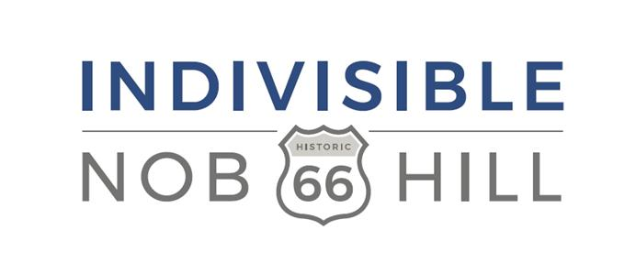
March for our Lives
Student Scholarship Information
February 26, 2018

Indivisible Nob Hill, an unincorporated grassroots progressive organization, is offering a scholarship to two female student leaders from Albuquerque High Schools to attend the March for our Lives event in Washington DC, on March 24, 2018 in keeping with our focus on growing young female leaders. Find out more about Indivisible Nob Hill at indivisiblenobhill.com
What does the Scholarship pay for? | Round trip airfare, 2 nights lodging, meals, ground transportation. A small stipend may be included for souvenirs depending on fundraising. A non-refundable round trip ticket will be purchased. Friday March 23- Sunday March 25, 2018. Students may also spend Sunday doing sightseeing in our nation's capital depending on plane schedules. Estimated value of $1000 per student. Students will be expected to share a hotel room.
How were the funds for the scholarship raised? | Donations from members of Indivisible Chapters in Albuquerque and other interested individuals in the Albuquerque area.
Who may apply for the scholarship? | Students must be at least 18 years old, female and student leaders in their school. Students under 18 are eligible to apply with parental consent but must be accompanied by an adult at their own expense. (INH cannot provide funds for the travelling adult).
What are the students expected to do? | Students are expected to travel and participate in the March for our Lives event representing Albuquerque High Schools and student activism. Upon their return, we would ask that they become involved in local voter registration drives and become Voter Registration Agents. We would also ask that they prepare a short presentation to deliver at an Indivisible Nob Hill meeting describing their experience. We would encourage them to become members of Indivisible Nob Hill and lead a student outreach program but this is not required.
Will the students be accompanied on the trip? | Reasonable efforts will be made by INH to provide a local host. However the students need to be ‘travel savvy’ and able to navigate airports and ground transportation on their own in the event a local host cannot be found. A full planned itinerary will be provided once it is finalized with detailed information on logistics that will be easy to follow.
Why is Indivisible Nob Hill offering this scholarship? | We believe that our democracy depends on the actions of our youth. We also believe that gun violence in America needs serious reassessment by our federal and state legislators. We hope that by offering this scholarship, we can spark an interest by future female leaders in government that leads to actions.
What else should I know? | Students applying should be able to provide proof of their own health insurance in case of emergency. Neither Indivisible Nob Hill (INH) nor it's officers or members assume any liability for the safety of the students, loss of property or possessions or other incidents while on this trip. Students are expected to adhere to the provided itinerary. Reasonable safety measures will be made. Students and/or parents/guardians must sign the Hold Harmless agreement attached.
How to apply | Contact Rayellen Smith at rayellen.indivisblenobhill@gmail.com with your nominations for students who fit the criteria for evaluation. Include contact information for each student (email and phone number).
When will decisions be made | Final decisions will be made no later than March 10, 2018 and students will be notified with the contact information provided.

Waiver, Release And Hold Harmless Agreement

In consideration of accepting this scholarship awarded by Indivisible Nob Hill, providing funds to allowing me to participate in the March for our Lives event on March 24, 2018 in Washington DC (the "Activity"), I (together with my parent or guardian, if I am under the age of eighteen (18) or under a legal disability) represent, covenant and agree, on behalf of myself and my heirs, assigns, and any other person claiming by, under or through me, as follows:

1. I acknowledge that participating in the Activity involves certain risks (some of which I may not fully appreciate) and that injuries, death, property damage or other harm could occur to me or others. I accept and voluntarily incur all risks of any injuries, damages, or harm which arise during or result from my participation in the Activity, including any associated travel, regardless of whether or not caused in whole or in part by the negligence or other fault of Indivisible Nob Hill , The the Officers of Indivisible Nob Hill, The Indivisible Project or any group related to Indivisible in the State of New Mexico including the New Mexico Indivisible Congress, and/or their committees, affiliates, officers, agents or insurers ,("Released Parties").

2. I waive all claims against any of the Released Parties for any injuries, damages, losses or claims, whether known and unknown, which arise during or result from my participation in the Activity, regardless of whether or not caused in whole or part by the negligence or other fault of any of the Released Parties. I release and forever discharge the Released Parties from all such claims.

3. I agree to indemnify and hold the Released Parties harmless from all losses, liabilities, damages, costs or expenses (including but not limited to reasonable attorneys' fees and other litigation costs and expenses) incurred by any of the Released Parties as a result of any claims or suits that I (or anyone claiming by, under or through me) may bring against any of the Released Parties to recover any losses, liabilities, costs, damages, or expenses which arise during or result from my participation in the Activity, regardless of whether or not caused in whole or part by the negligence or other fault of any of the Released Parties.

4. I have carefully read and reviewed this Waiver, Release And Hold Harmless Agreement. I understand it fully and I execute it voluntarily.

EXECUTED this day of __________________________________________________, 2018 .

Participant Signature______________________________________________________

Participant Printed Name ___________________________________________________

Parent/Guardian Signature (if participant is under 18 years of age)

______________________________________________________________________

Parent/Guardian Printed Name ______________________________________________________________________

