1. Gun Control

Since 1994, background checks have [blocked](https://everytownresearch.org/infographic-background-checks-save-lives/?link_id=3&can_id=d4081d8600ce606c5b648c3b773761e2&source=email-statefull-default-attn-tell-congress-to-close-this-gun-loophole&email_referrer=email_306456&email_subject=statefull-default-attn-tell-congress-to-close-this-gun-loophole) more than 3 million sales to prohibited users. But because federal gun [laws exempt unlicensed firearm sellers](http://lawcenter.giffords.org/gun-laws/policy-areas/background-checks/universal-background-checks/?link_id=4&can_id=d4081d8600ce606c5b648c3b773761e2&source=email-statefull-default-attn-tell-congress-to-close-this-gun-loophole&email_referrer=email_306456&email_subject=statefull-default-attn-tell-congress-to-close-this-gun-loophole), guns still find their way into the hands of illegal buyers and gun traffickers, dramatically increasing the likelihood of gun violence.

However, in the states that go beyond federal law and require background checks on all handgun sales, 47% fewer women are killed by intimate partners, 47% fewer people attempt suicide with a gun, and 53% fewer law enforcement officers are killed with a gun.

Universal background checks are widely supported across partisan lines and by gun owners. Expanding background checks to private and online sales is critical to reducing gun violence. There's no sensible reason Congress cannot close the loophole and there's no better time to do so than right now.

As we all know by now, student’s all over the country are speaking out and they have mobilized thousands to action. Their activism has Republicans like Marco Rubio, Rick Scott and Donald Trump suggesting they’re open to legislation. Their activism has [forced not one, not two, but nearly a dozen](https://thinkprogress.org/corporations-nra-f0d8074f2ca7/) (it could be more by the time you read this!) corporations to end their relationships with the NRA.

[Join a call with the ACLU](https://go.peoplepower.org/signup/students-know-your-rights-training-registration/?source=em20180224) to learn from student leaders and members of the ACLU legal team on constitutional rights to free speech and expression, and what it means for students who want to speak out. Also hear details on how to report any possible First Amendment violations.

INH is supporting the March 24 Student March for Our Lives in Washington DC by sponsoring 2 high school students (travel, lodging and food). If you’d like to donate to the efforts, please to go to <https://www.gofundme.com/march-for-our-lives-albuquerque>. If you’d like to order t-shirts in support of this event, please go to

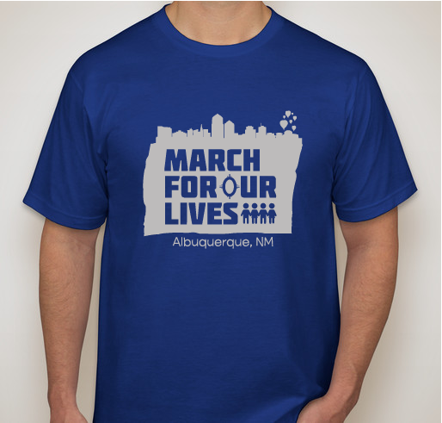

<https://www.customink.com/fundraising/march-for-our-lives-albuquerque?pc=TXN-167786&utm_campaign=fr_sup_confirmation_purchase&utm_source=fr_supporter_txn&utm_medium=email&utm_content=campaign2> The deadline to order is March 4th. Proceeds go towards costs for local event and the sale is sponsored by the local organization.

1. Net Neutrality

Last week, the FCC officially added its plan to destroy net neutrality, the concept that all content on the Internet be treated equally, to the federal register. That means we only have fifty-seven days to convince members of Congress to pass a Congressional Review Act (CRA) resolution to repeal this disastrous plan before it goes into effect.

All Democrats and one Republican have said they will support net neutrality bill in Senate, so call ours and let them know you’re behind them! For a script go to <https://stopthefcc.net/?source=thenation>