Order of Service

Welcome & Announcements

*Invocation

*Congregational Singing
Lord, Reign in Me

Offertory Prayer
Offertory Special

*Congregational Singing
Cornerstone
Christ is Mine Forevermore

Prayer

Message: Victory Through Christ

*Congregational Singing
King of My Heart

*Benediction

*Postlude

*Denotes standing
(Feel free to stand or sit as you feel comfortable)

New to CCC?

Welcome to Camby Community Church. Please take time to visit our welcome booth. Pastor Brad would welcome the opportunity to get to know you and answer any questions you have about our church, either in person or on the phone. Please call the church office or indicate on the attendance form.
Sermons Available Online or on CD

Pastoral Staff
Brad Long, Senior Pastor
Greg Jones, Youth Pastor
Charlie Paxton, Pastor Emeritus

Teaching
Leading
Caring

How to Contact Us
Camby Community Church
Door #1 (Office door)
8604 Camby Road
Camby, IN 46113
Phone: 317-856-6844
FAX: 317-821-9425
Email: mail@cambychurch.org
Website: www.Cambychurch.org

Office Hours
Monday – Friday
9:00 a.m. – 3:00 p.m.
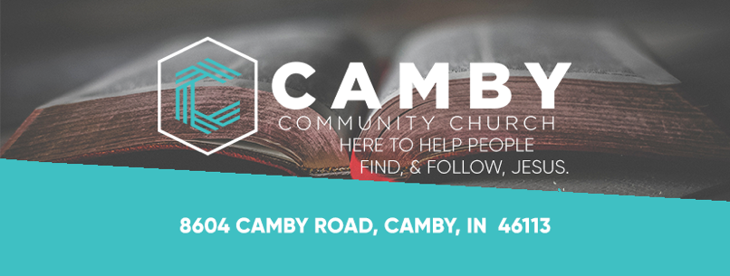

Victory Through Christ

“But thanks be to God! He gives us the victory through our Lord Jesus Christ.”
1 Corinthians 15:57

May 15, 2022

Sunday School 9:15 a.m.
Kids 4 Christ 10:15 a.m.
Morning Worship 10:30 a.m.
CSM 6:30 p.m.

K4C & CSM
K4C: Camby Kids 4 Christ (Age 4 through 5th grade)
CSM: Camby Student Ministries (Middle & High School Ministries)

Sunday School: 9:15 a.m.
Ages 4 through High School

Toddlers and Nursery: 10:30 a.m.
Parents: Please accompany your kids to the basement and sign them in.
Toddlers: Check in to the basement and pick up in room 1 in the basement.
Infants: Check in and pick up in the nursery in the lobby.

K4C: 10:15 a.m.
Ages 4 through 5th grade
Can't wait for Kids Worship today! We have an awesome morning ahead! Make sure to register for Day Camp and VBS!

CSM: 6:30-8:00 p.m.
End of the Year Party: Part 1 TONIGHT! See you at 6:30!

Part 2 is NEXT WEEK!

Look for the latest information on
Facebook and
Instagram@Cambysm
Instagram@CambyKids4Christ
Announcements

CCC Kitchen Fundraiser

A fundraiser will be held this Thursday evening, May 19, 6:30 p.m., to help with a desperately needed upgrade and refresh of the utensils in our kitchen, as well as provide funds for ingredients for the “Cooking for Christ” ministry. This will be a Pampered Chef fundraiser led by Deaconess Jeanna West.
Adult Sunday School

Old Testament Highlights
Fellowship Hall
Connie Wagner

I Don’t Have Enough Faith to be an Atheist
The House - Basement
Bob Lindhorn

Confidential

Pitch-In Breakfast

Next Sunday we will be having a pitch in breakfast during the Sunday school hour. Come fellowship with us!

Indiana Brass Choir Benefit Concert

Hosted by First Baptist Church, 680 N. Indiana St., Mooresville
4:00 p.m.
Today

Love Offering and donations of canned food accepted.

Benefit to support Churches in Mission.
Mission Box

May Mission Box is

Camp Scholarship Fund

Envelopes are by the mission box in the lobby.

Attendance Cards

Please place your attendance/prayer cards in the offering box located in the lobby.

This Week

Today: Sunday School 9:15 a.m.
K4C 10:15 a.m.
Worship 10:30 a.m
Bruce’s Small Group 1:00 p.m.
Book Club 2:00 p.m.
CSM 6:30 p.m.

Tuesday: Ladies Bible Study 10:00 a.m. & 6:30 p.m.

Wednesday: High School Small Group 7:00 p.m.
(at the Ivey Residence)

Thursday: CCC Kitchen Fundraiser 6:30 p.m.
Next Sunday: Congregational Pitch-In Breakfast 9:15 a.m.
K4C 10:15 a.m.
Worship 10:30 a.m.
CSM 6:30 p.m.

Save the Date

May 31-June 2 Day Camp for K4C
June 6-9 Middle School Camp
June 20-23 Vacation Bible School
June 27-July 2 High School Camp

