Order of Service

Welcome and Announcements

*Invocation

*Congregational Singing
Across the Lands

Offertory Prayer
Offertory

*Congregational Singing
Guide Me, O Thou Great Jehovah with God of Grace
Now I Belong to Jesus

Prayer

Message: Romans 15/16

*Congregational Singing
Turn Your Eyes Upon Jesus #491

*Benediction

*Postlude

*Denotes standing
(Feel free to stand or sit as you feel comfortable)

………….

New to CCC?

Welcome to Camby Community Church. Please take time to visit our welcome booth. Pastor Brad would welcome the opportunity to get to know you and answer any questions you have about our church, either in person or on the phone. Please call the church office or indicate on the attendance form.
Sermons Available Online or on CD

Pastoral Staff
Brad Long, Senior Pastor
Greg Jones, Youth Pastor
Charlie Paxton, Pastor Emeritus

Teaching
Leading
Caring

How to Contact Us
Camby Community Church
Door #1 (Office door)
8604 Camby Road
Camby, IN 46113
Phone: 317-856-6844
FAX: 317-821-9425
Email: mail@cambychurch.org
Website: www.cambychurch.org

Office Hours
Monday – Friday
9:00 a.m. – 3:00 p.m.
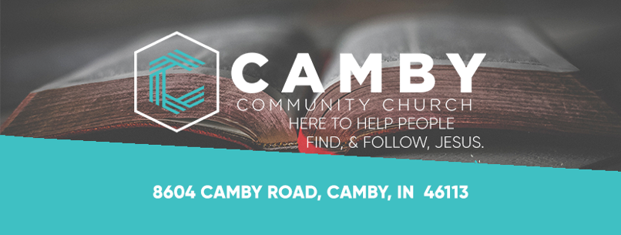

Romans 15/16

“But God demonstrates his own love for us in this:
While we were still sinners, Christ died for us.”
Romans 5:8

September 25, 2022

Sunday School 9:15 a.m.
Kids 4 Christ 10:15 a.m.
Morning Worship 10:30 a.m.
CSM 6:30 p.m.

K4C & CSM
K4C: Camby Kids 4 Christ (Age 4 through 5 th grade)
CSM: Camby Student Ministries (Middle & High School Ministries)

Sunday School: 9:15 a.m.
Ages 4 through High School

Toddlers and Nursery: 10:30 a.m.
Parents: Please accompany your kids to the basement and sign them in.
Toddlers: Check in to the basement and pick up in room 1 in the basement.
Infants: Check in and pick up in the nursery in the lobby.

K4C: 10:15 a.m.
Ages 4 through 5th grade
We look forward to seeing you and your family today! We are excited to teach your kids to know and love Christ and His Word! After the service, please pick up your child(ren) in their class!

CSM: 6:30 p.m.
We had a great time at the Middle School Retreat, so tonight will just be High School. We will continue our Relationship Goals series! See you at 6:30.
Make sure to get registered for High School Retreat!

Look for the latest information on
Facebook and
Instagram@Cambysm
Instagram@CambyKids4Christ

This Week
Announcements

Women’s Bible Study
Tuesdays 10am/6:30pm
Sept 27 – Nov 1

Jeremiah: Daring to Hope in an Unstable World by Melissa Spoelstra
Enter through the office door and proceed downstairs to the
Kids 4 Christ area.
You can still sign up in the lobby today or call the church office.
Cost of book: $14
Current Adult
Sunday School

Elisha & Elijah
Connie Wagner
Fellowship Hall

The New Testament in Antiquity (Video Series)
Ami Sunier
The House

Trunk-R-Treat
Oct. 29

Register in the lobby for
a Trunk or to Volunteer.

We can use donations
of candy.

Community
Worship Service

October 2
9 a.m.

This is an excellent opportunity to invite your family and friends to a special worship service at the Mooresville High School Auditorium. Worship will be led by professional recording artist Megan Duke
and testimony will be given by news personality Rich Nye.

Mission Box

September Mission Box is

OMS
(One Mission Society)

Envelopes are by the mission box in the lobby.

Attendance Cards

Please place your attendance/prayer cards in the offering box located in the lobby.

Today: Sunday School 9:15 a.m. K4C 10:15 a.m.
Worship 10:30 a.m.
Prayer Class 6:00 p.m.
CSM 6:30 p.m.

Tuesday: Women’s Bible Study 10:00 am. and 6:30 p.m.

Wednesday: Prayer Group 7:00 p.m.

Next Sunday: Community Service @ MHS 9:00 a.m.
CSM 6:30 p.m.

Save the Date

October 6 Senior Lunch
October 9 Book Club
October 10-12 CSM Mission Trip to Chicago
October 12 Congregational Business Meeting
October 16 Baptism/Tommy Richardson Presentation
October 23 Baby Dedication/Blood Drive
October 29 Trunk-R-Treat
November 6 Adult Mission to Churches in Mission
November 11-13 High School Retreat

Find our church on

@cambychurch

