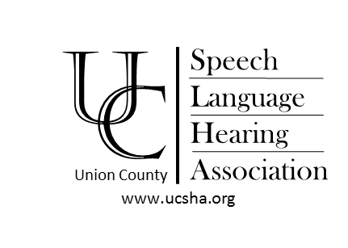
Title: The Speedy Speech Therapy Model

Description: Participants will be able to develop a thorough understanding of how to incorporate the Speedy Speech model into an RTI and/or speech therapy program. The presentation will discuss the latest research supporting alternate service delivery models and will highlight the evidence-based data collection and progress monitoring process. Various therapeutic techniques and strategies for 10-minute therapy will be shared for both articulation and language skills. Participants will have opportunity to view lesson videos and discuss ways to incorporate this methodology into their current program.

Presenters: JoAnn Tuttle, M.S. CCC-SLP is a highly experienced Speech-Language Pathologist, certified by the American Speech-Language-Hearing Association (ASHA), and licensed by the states of New York and New Jersey. She holds two Master's Degrees; Communication Disorders, and Educational Administration and Supervision. She has been working in the field of Speech Language Pathology for over 20 years, including as a Speech-Language Pathologist in the public school setting, as well as an Administrator of a Speech-Language-Hearing Department supervising over 30 Speech-Language Pathologists, Teachers of the Hearing Impaired and Educational Audiologists. She has a practice in Foreign Accent Modification, Articulation, and Language Development. She is an Educational Consultant for students with disabilities in various school districts and is regarded as an expert in articulation therapy. Throughout her career she has taught at the University level, worked in a New York City Hospital and provided professional training, development, and management.
Tamara Truax, M.S. TSHH is a highly experienced educator, specializing in the area of speech and language development. She has a background in Bilingual and Bicultural Education and is a New York state certified teacher. She holds degrees in Speech-Language Pathology, Bilingual Education, and Instructional Technology. Her work experience encompasses over 15 years as a teacher and therapist within the public school setting, and as a graduate level instructor. Tamara also has extensive experience in providing professional development workshops and maintains a private practice specializing in all areas of articulation and language development. She is the Executive Director of the EELEF program, and is experienced in coaching individuals and conducting group sessions
Date: Saturday, March 21, 2020
8:30am Check-in and breakfast
9am – 1pm Presentation

Place: Summit Speech School
705 Central Avenue
New Providence, NJ 07974 (908-508-0011)

Credit: 4 Hours Towards Licensure
NJ Dept. of Ed. Registered Development Provider, ID# 1617

Questions: Contact WWW.UCSHA.ORG
Please RSVP by March 11, 2020
Note: We must receive notice 48 hours before the program for cancellations. Sorry-no refunds after the 48-hour deadline.
Tear Off Below and Send with Remittance
UCSHA Registration Form Return form with check to:
Return by: March 11, 2020 Carol Zimmerman
Checks Payable to: UCSHA 23 Glenwood Road
Fanwood, NJ 07023 Conference Fee: Members ($45) _______ Non-Member ($50) _______

Name: ___________________________________________ Home/Cell Phone: ________________________________ Email: ___________________________________________

