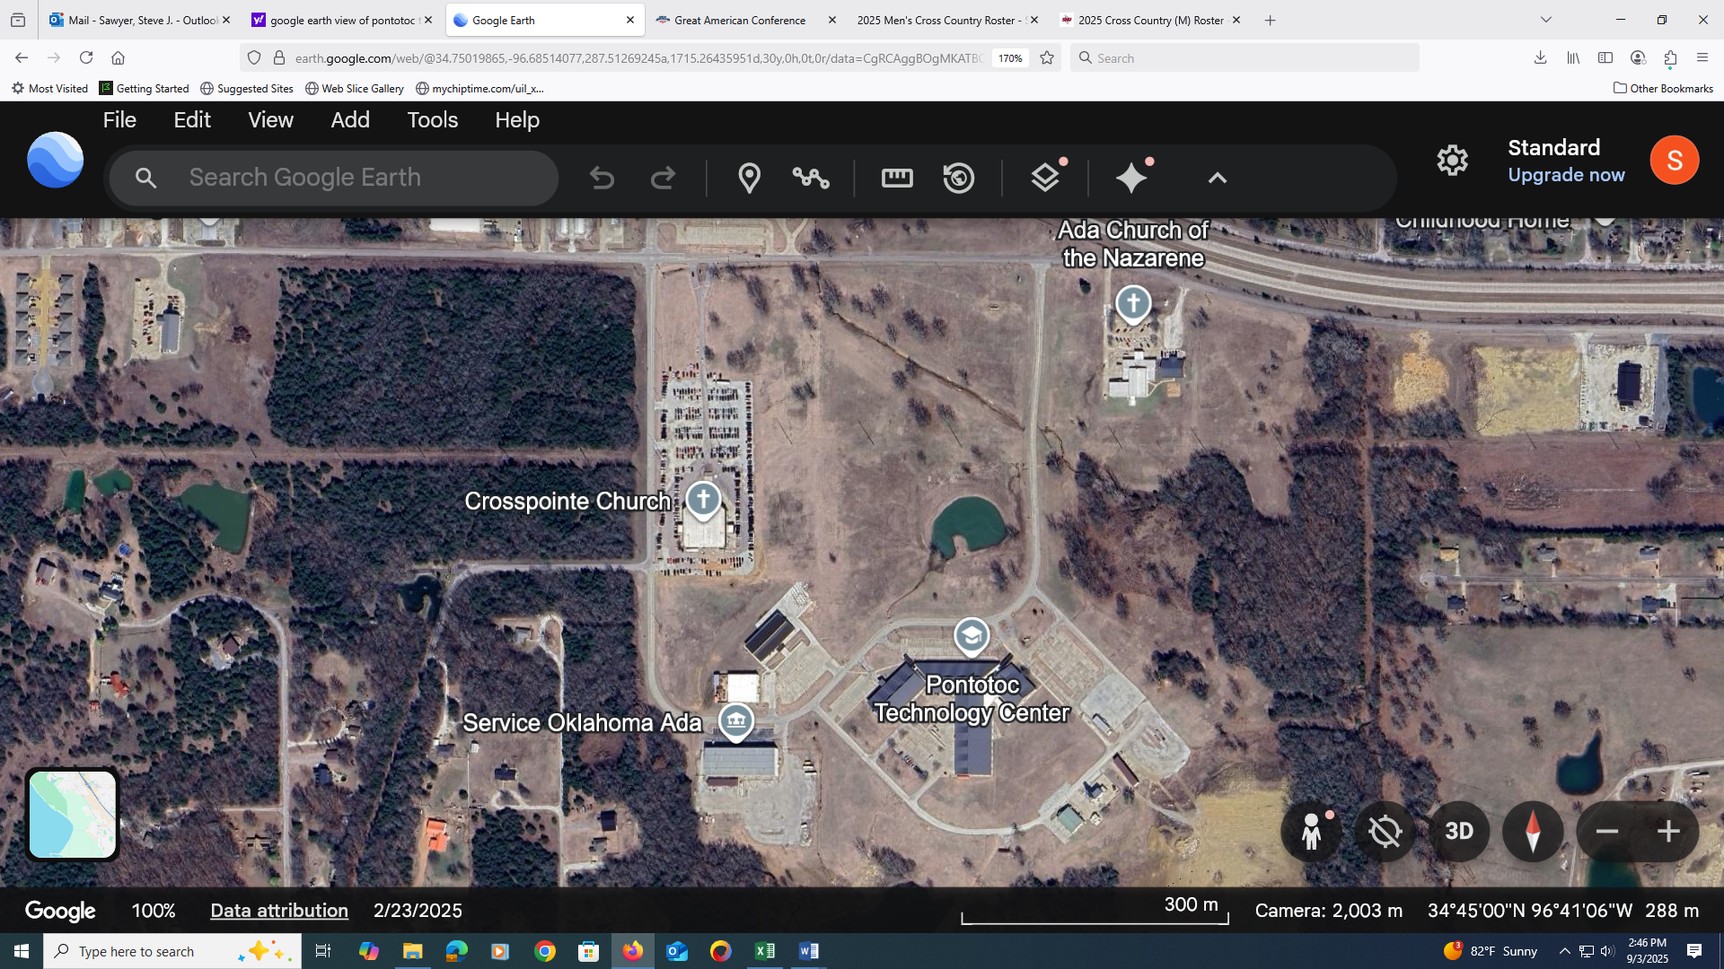

2 MI

1 MI

FINISH

START

5K COURSE MAP

LOOP 1

LOOP 2