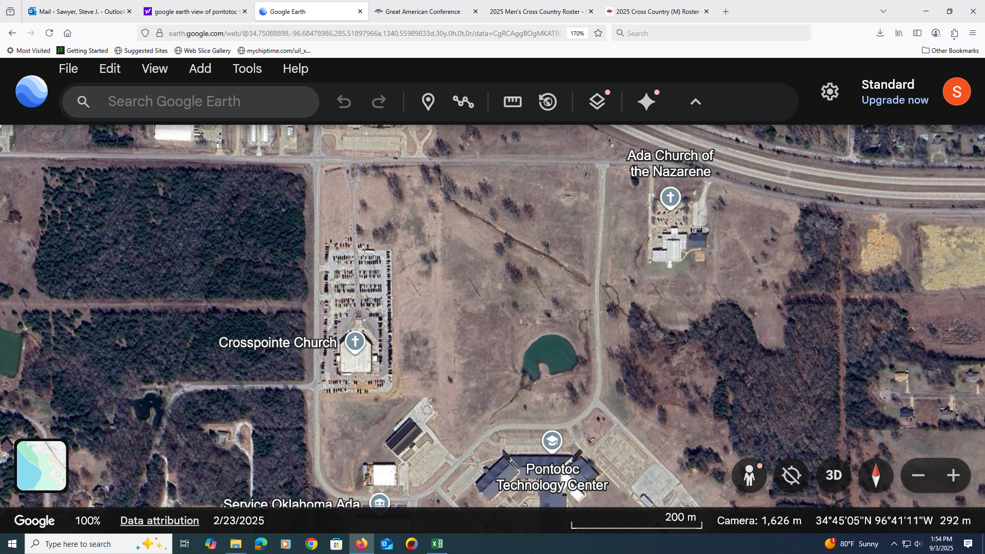

**JUNIOR HIGH GIRLS 24OO METER COURSE MAP**

**LOOP 1**

**LOOP 2**

1 MILE

FINISH

START