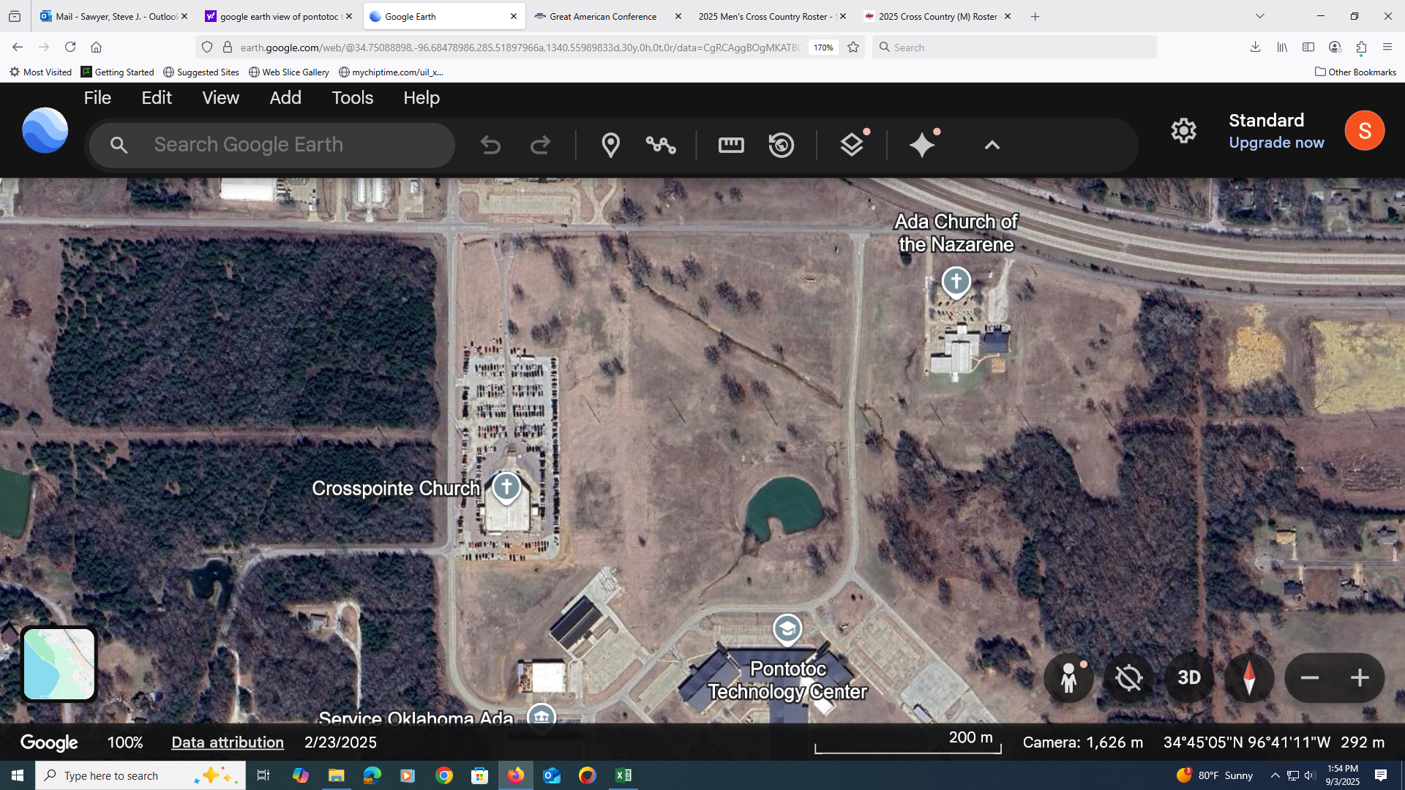

1 MI

**32OO METER COURSE MAP**

**LOOP 1**

**LOOP 2**

FINISH

START