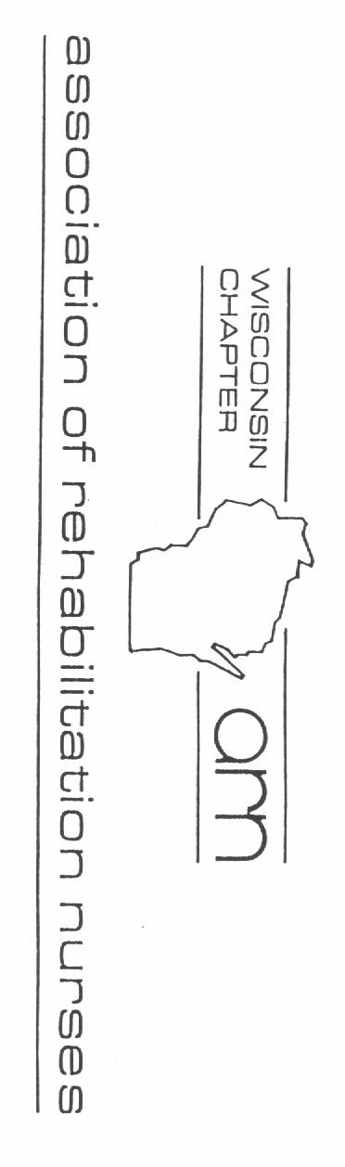**7:30-8:15 Registration/ breakfast**

**8:15-9:45 The Role of Assistive Technology in Rehab**

*Katie Schultz DPT, APT*

**9:45-10:15 Break, Networking & silent auction**

**10:15-11:15 Update on Disorders of Consciousness**

*Gerald Nora, MD, PhD*

## 11:15-12:15 Intro to Gender Diversity: Creating Welcoming Spaces

*Hudson Nummerdor, BS*

**12:15-1:15 Lunch, silent auction and general board meeting**

**1:15-2:45 Integrating Rehab & Safe Patient Handling programs**

*Andy Rich, MS, OTR/L, CSPHP*

**2:45-3:15 Break and silent auction**

**3:15-4:15 Addressing Wound & Skin in the Rehab Patient population**

*Nicole Rosin APNP, CRRN, Wcc*

**4:15–4:45 Wrap-up, Evaluation and Silent Auction Results**

Presents…

Hot Topics in Rehab Nursing

2019



Tuesday, September 17, 2019

7:30 - 4:45

The Ingleside Hotel

(formerly Country Springs) 2810 Golf Rd

Pewaukee, WI

## Mail registration and fees to:

***WARN Education Chair Anne Leclaire***

***7340 Wilburn Rd***

***Sun Prairie, WI 53590***

Name Address

City State Zip

Email Phone (home) (work)

WARN member $75

Non WARN members $100 Student w/ID $50 Lunch is provided

## Registrations due by Sept 10, 2019. No refunds for cancellation after Sept 15

Updates and current information for the rehabilitation nurse

# Intended audience:

Nurses with an interest in rehabilitation concepts working in various rehabilitation settings, including, but not limited to, acute, subacute, geriatric, pediatric, outpatient, homecare and skilled nursing facilities.

# Information:

UW Health University Hospital is an approved provider of continuing nursing education by the Wisconsin Nurses Association, an accredited approver by the American Nurses Credentialing Center‛s Commission on Accreditation. UW Health is the provider of CNE in a joint provider relationship with WARN –

WI Association of Rehabilitation Nurses

Activity Planner: Anne Leclaire MSN, RN, CRRN

6.5 contact hours

**To receive contact hours, participants must attend the entire activity**

* Identify 3 ways Assistive Technology can improve a client’s independence
* Describe the characteristics of the three levels of disorders of consciousness (DOC).
* Participants should be able to identify at least two strategies for improving quality of care for transgender, intersex, and gender diverse patients.
* Describe the links between safe mobility and clinical outcomes
* Describe current best practices in treating pressure injuries.

# Lodging Information

Nearby lodging available:

The Ingleside Hotel (262) 547-0201

theinglesidehotel.com

Best Western Waukesha Grand (262) 524-9300 ·

bestwesternpewaukee.com

Holiday Inn Milwaukee-Pewaukee West

(262) 506-6300 ·

holidayinn.com