Black Locust Flower Wine
adapted from Wild Wine Making, Easy & Adventurous Recipes Going Beyond Grapes
Used with permission of author Richard W. Bender

For 1 Gallon Batch  1 pound golden raisins  1 gallon of fresh locust flowers  (or 2 ounces dried)  1 gallon water  3 pounds sugar  1 packet wine yeast  Optional additives:  Stabilizer (potassium metabisulfite  aka Campden tablets)  Clarifier (chitosan & kieselsol  aka Super-Kleer) | 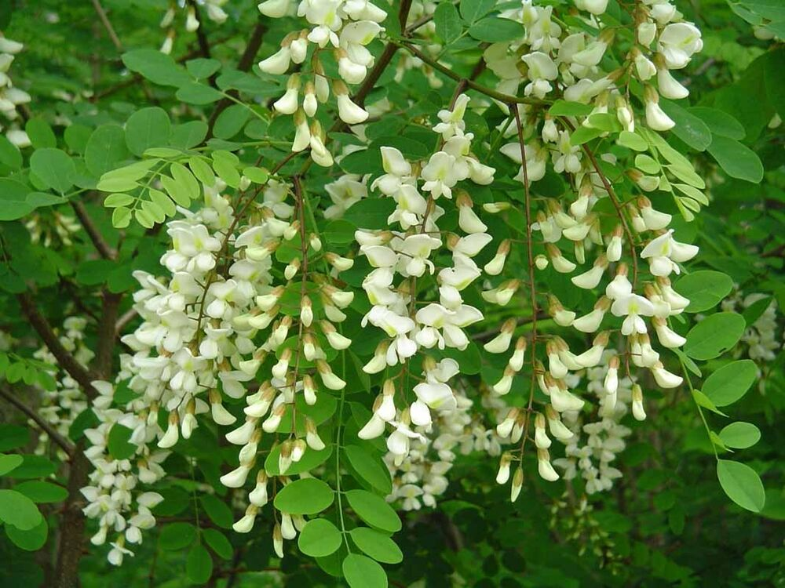

Preparation
- Gather ingredients. Shake flower clusters well to dislodge any bugs. Strip white flowers off the stems, discard stems and leaves. Store in refrigerator if not using immediately.
- Soak the raisins overnight in enough water to cover them. Chop the soaked raisins with their water in a blender.
Primary Fermentation
- Put chopped raisins and flowers in a mesh or muslin bag then place bag in the primary fermentation vessel.
- Bring the gallon of water to a boil in a large pot. Add the sugar and return to a boil, stirring to dissolve. Carefully add the boiling sugar water to the fermentation vessel. Cover and let cool to warm room temperature.
- Stir in the yeast and cover.
- Stir twice a day until fermentation slows (7-10 days).
Secondary Fermentation
- Squeeze liquid out of pulp and discard pulp.
- Rack wine into a secondary fermenter (fill to bottom of the neck. If you have more than 1 gallon, put extra into a suitable bottle with an airlock) and secure with bung and airlock.
- The next day if there is a deep layer of lees, rack into another secondary with an airlock.
- Allow wine to continue to ferment for at least 2 months.
Stabilizing and Clarifying
- The author does not use additives, preferring to rack every 2-3 months for at least 6 months, and preferably for a year, before bottling.

Banana Wine
Adapted by Lauren from a variety of recipes…

- 5 lbs ripe bananas (with skins on approximately 3 lbs)
- 2.5 lbs granulated sugar
- 1 gallon water
- white wine yeast (Red Star Premier Blanc)

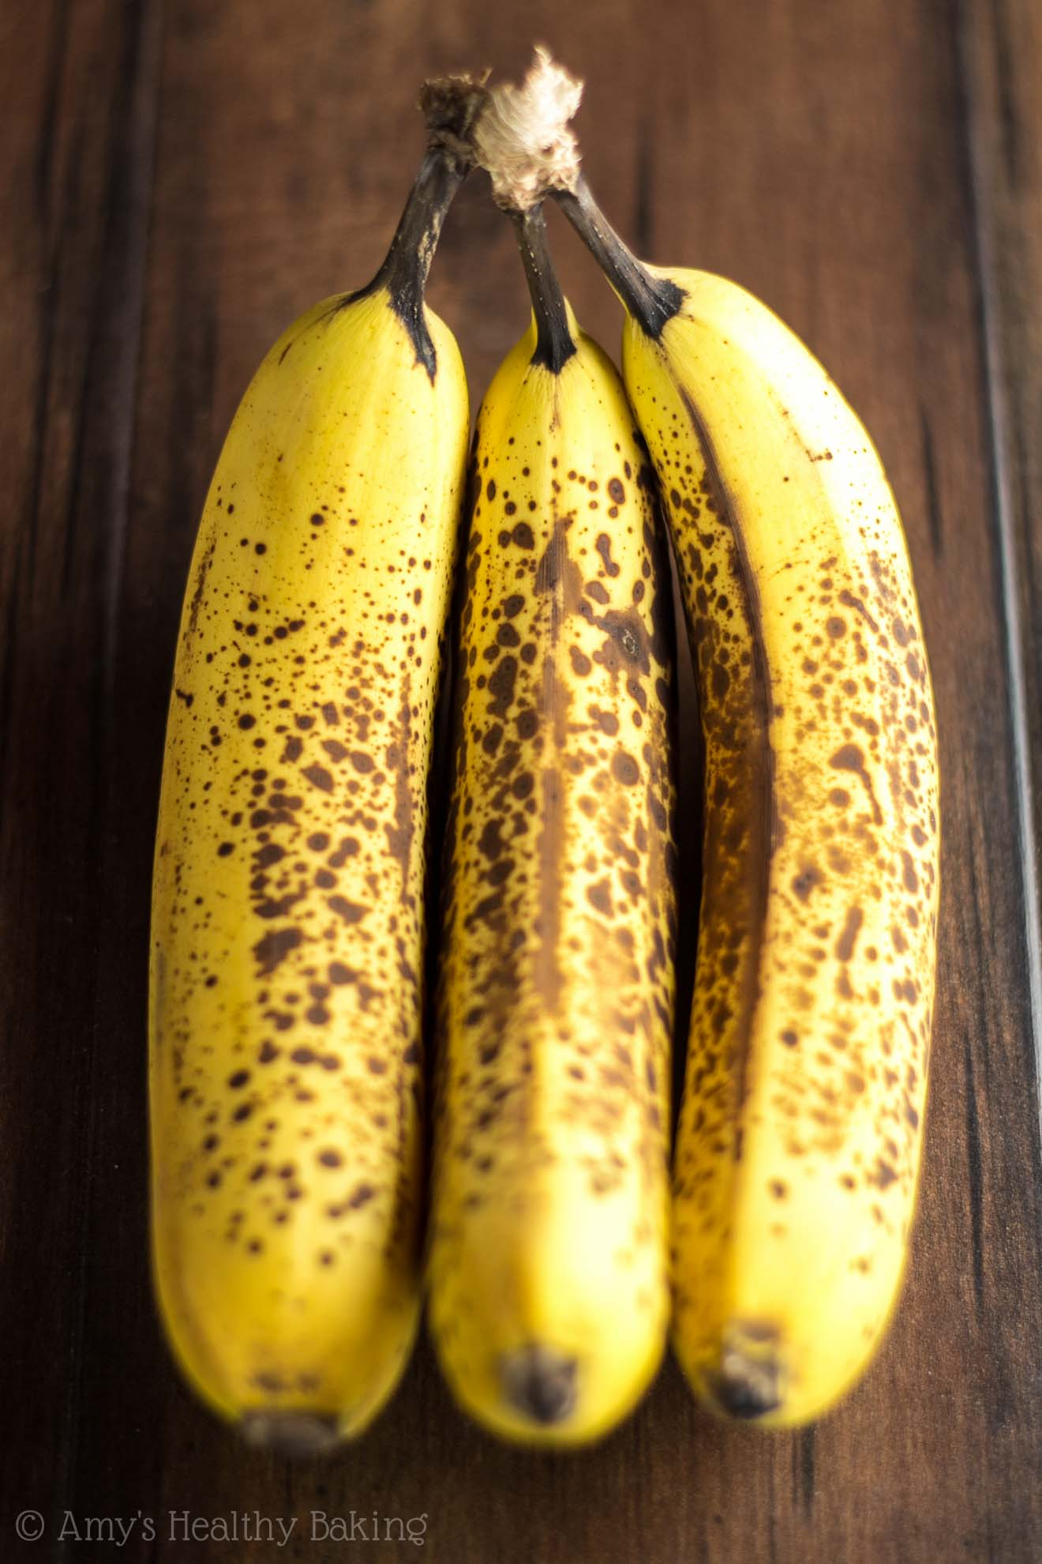
Slice bananas with skins and place both in a straining bag. Add sugar to primary. Pour boiling water into primary and stir. Put bag in primary. Cover with lid or clean towel.

When cool, add yeast and cover primary with lid fitted with airlock or clean towel. Stir twice a day. After 5 days, squeeze liquid from bag into fermenter. Discard solids. Recover.

Allow to ferment until fermentation slows (7-10 days). Transfer wine into secondary with airlock.

Ferment until S.G. is less than 1.000.

Allow to age in the carboy, racking off sediment every 2-3 months until clear.

Taste, adjust, bottle.

Jelly Wine (not Wine Jelly)
Recipe by Jack Keller, http://winemaking.jackkeller.net/request231.asp
Four things are required to make fruit juice turn into jelly: pectin (gelatin), sugar, acid, and heat. The secret to making wine from jelly is to make sure you neutralize all the pectin in the jelly.
This recipe is really intended for homemade jellies, but if commercial ones are used you are advised to read the ingredients very carefully and avoid any that contain potassium sorbate (or sorbic acid), sodium benzoate (or benzoic acid), or any chemicals you don't recognize or understand their purpose in the product.
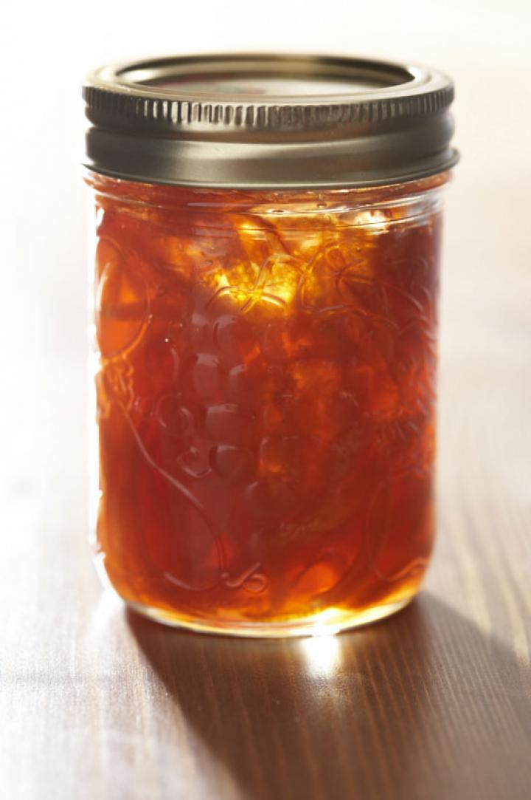
- 4 lbs (36 fl oz) any flavor jelly
- sugar to bring s.g. to 1.090
- 5 tsp powdered pectic enzyme
- 2-3 tsp citric acid *
- 1/2 tsp powdered grape tannin
- water to one gallon
- 1-1/4 tsp yeast nutrient
- 1 pkt general purpose wine yeast
* This really depends on the jelly. Add 2 teaspoons for high acid fruit, 3 teaspoons for low acid fruit. Other considerations: add more tannin for tannin-neutral jellies, like peach or apple mint. You can match the wine yeast to the fruit, just as you would for the fresh fruit itself, or use a general purpose yeast you like.
Bring 3 quarts of water to boil, remove from heat and stir in all the jelly. Cover and set aside 4-5 hours (until room temperature). Transfer to primary, stir in pectin enzyme, cover primary, and set aside 3 days. Transfer back to pot and bring to a boil and hold boil for 5 minutes. Put sugar, citric acid, powdered tannin, and yeast nutrient in primary. Pour liquid over dry ingredients in primary and stir until sugar is dissolved. Cover primary and set aside to cool to room temperature. At the same time, begin a yeast starter. When liquid is cool, check specific gravity and adjust to 1.095. Transfer to secondary but do not top up. Add activated yeast starter solution and cover with paper towel held in place with a rubber band. After 3 days seal with airlock. When vigorous fermentation subsides (5-7 days), top up; this will reduce the alcohol level slightly to a more amenable 11.5-12%. Wait 30 days and rack, sulfite, top up, and reattach airlock. Rack every 30 days (sulfite every other racking) until no new sediment forms and wine is clear. If wine doesn't fall perfectly clear in 60 days, add another teaspoon of pectic enzyme and wait 2 weeks. If still not clear, add another teaspoon. [NOTE: Be sure pectic enzyme has been stored properly. If wine does not clear after adding 7 teaspoons, replace the pectic enzyme.] Stabilize, sweeten if desired, wait 30 days, and bottle. Might taste after 3 months, but really should wait 6 or longer.

Welch’s Grape Juice Wine Recipe
Source: https://www.homebrewtalk.com/forum/threads/welchs-grape-juice-wine.21093/
- 2 cans (11.5 oz) Welch's 100% grape concentrate* [or equivalent amount bottled]
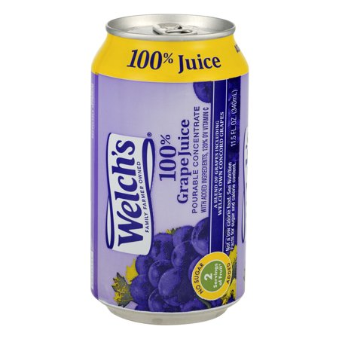
- 1-1/4 lbs granulated sugar
- 2 tsp acid blend (skip acid blend, for sweeter wine)
- 1 tsp pectic enzyme
- 1 tsp yeast nutrient
- water to make 1 gallon
- wine yeast
Bring 1 quart water to boil and dissolve the sugar in the water. Remove from heat and add frozen concentrate. Add additional water to make one gallon and pour into primary fermenter. (Alternatively, heat 1 quart of bottled grape juice to dissolve sugar, then top up fermenter with additional juice).
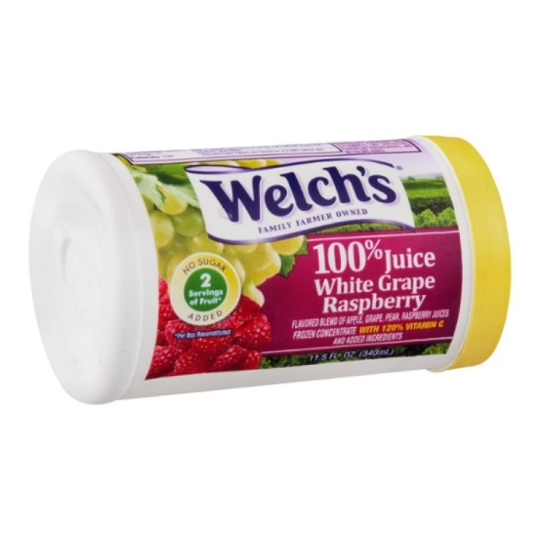
Add remaining ingredients except yeast.
Cover with an airlock set aside 12 hours. Add activated wine yeast and recover. When active fermentation slows down (about 5 days), fit airlock. After additional 30 days, if clear, degas, stabilize, sweeten if desired and bottle.

* Substitute other flavors or use equivalent volume of bottled juice.
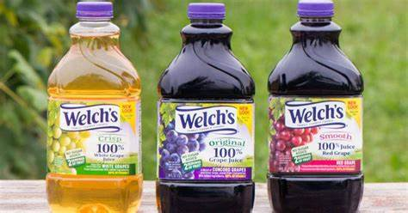

Pineapple Wine
Source: https://homebrewanswers.com/pineapple-wine-recipe/
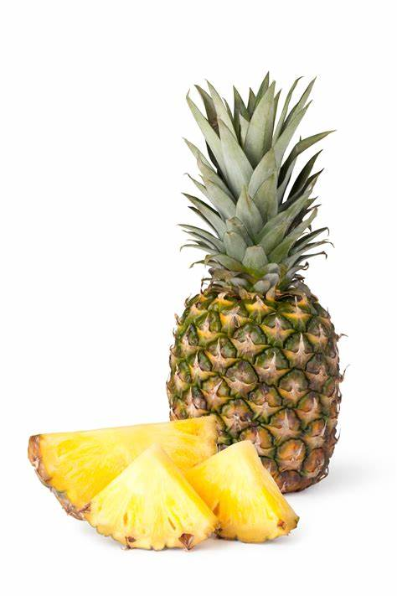
The leaves can be easily pulled from the crown of a ripe pineapple with a short tug. Under-ripe pineapples are slightly tarter but ok to use. The skins of over-ripe pineapples will have a grey powderiness and should be avoided because they may already be fermenting.
- 4 lbs Pineapple (fresh or canned)
- 1 gallon of Water (plus extra to top up)
- 800g (4 cups) Sugar
- 120g (1 cup) Golden Raisins (roughly chopped)
- 1/4 tsp Wine Tannin
- 1/4 tsp Acid Blend
- 1/2 tsp Pectic Enzyme
- 1 tsp Yeast Nutrient
- 1 Campden Tablet
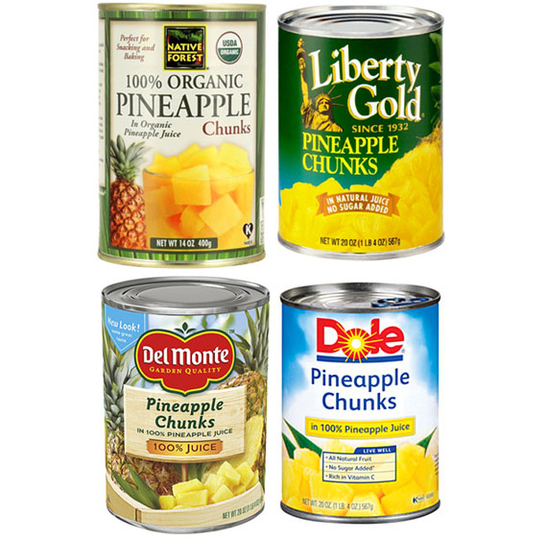
- 1 Sachet Yeast (Lalvin D-47 is a good choice)
1. Remove skin & core, cut pineapple into small thumb sized pieces.
2. Add raisins and pineapple chunks to a straining bag. Put the staining bag with the fruit and the raisins into a sanitized fermenting vessel and ensure the top of the bag is secured.
3. Heat half the water and all the sugar to dissolve. Bring the pan up to a boil and ensure all the sugar is stirred in to prevent scorching. Once boiling simmer for a few minutes.
4. Pour the hot sugar water over the fruit. Stir gently, then top up the fermenter with the remaining cool water and allow to cool to room temperature before adding a Campden tablet.
5. 12 hours after adding the Campden tablet, add the yeast nutrient, tannin, pectic enzyme, acid blend and stir gently.
6. After 24 hours, add the yeast by sprinkling onto the surface of the must (you can rehydrate the yeast according to the packet instructions). Cover the vessel, fit an airlock and allow to ferment.
7. Stir daily. After 10 days fermentation should have slowed or stopped. Remove the straining bag with pulp, squeezing liquid into fermenter. Cover the fermenting vessel and allow to settle.
8. The following day rack the wine to a carboy with a bung and airlock. Allow to ferment until the wine has reached finishing gravity, around 1.000 +/- 0.003.
9. Clear for several weeks or months. Rack to a clean carboy every month or two if any substantial sediment has begun to settle.
10. Check after at least 3 – 4 months. The pineapple wine will improve with ageing so leaving the wine in the carboy up to 6 – 8 months is perfectly fine. Sample the wine before bottling. If you would prefer a sweeter finish search for information about back sweetening wine. This pineapple wine is best aged in the bottle for up to 6 months before sampling. The longer you leave the wine the better as it will continue to improve with time.

