Some Reference Books

Winemaker’s Recipe Handbook  aka “The Purple Book”  Raymond Massaccesi  $7 Amazon*  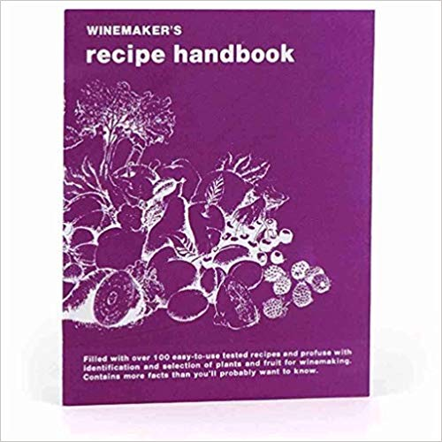  (Note: this is included in some wine equipment kits, and is often available at homebrew stores) | The Complete Guide to Making Your Own Wine at Home  John N. Peragine  Paperback $18 | The Home Winemaker’s Companion  by Gene Spaziani  Paperback $15  Kindle $10  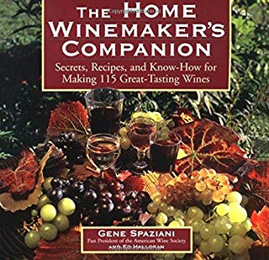
Wild Wine Making  by Richard W. Bender  Paperback $18  Kindle $10  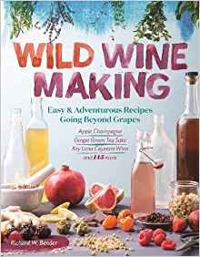 | Making Wild Wines & Meads  by Rich Gulling  Paperback $13  Kindle $10  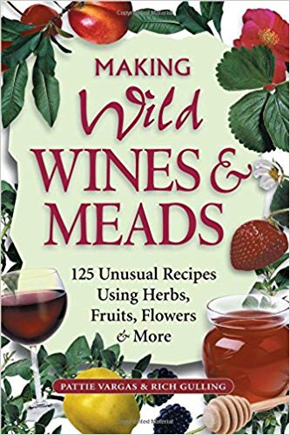 | Techniques in Home Winemaking  by Daniel Pambianchi  Paperback $17  Hardcover from $48  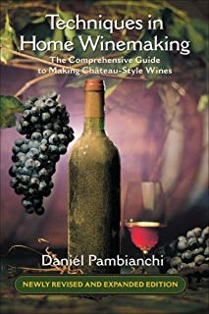

SAMPLE KITS – EQUIPMENT / SUPPLIES
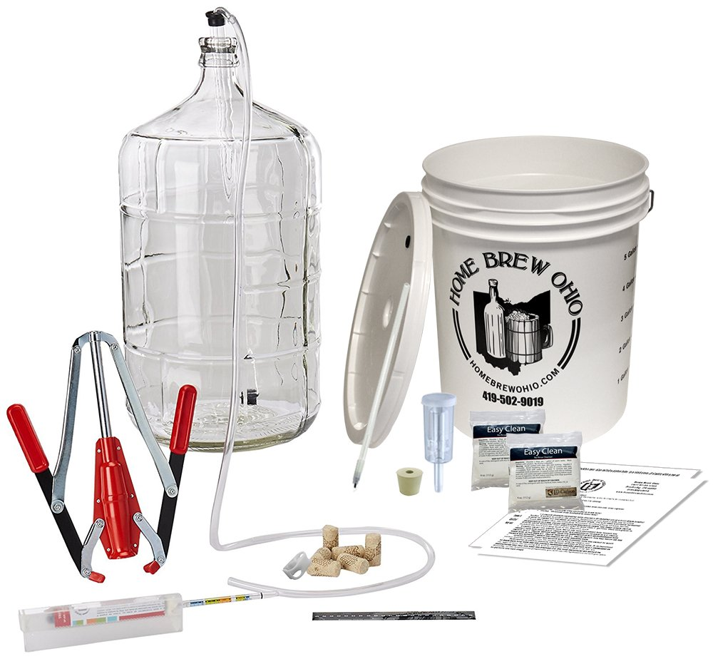 | “Bucket” type kit  $99.00 on Amazon  Includes  - 8 gallon fermenter / lid  - 6 gallon glass carboy  - #6.5 rubber stopper  - Airlock  - 2 packets of sterilizer  - auto-syphon  - auto-shut off bottle filler  - triple scale hydrometer  - adhesive thermometer  - 4' of hosing  - double lever corker  - 30 synthetic corks

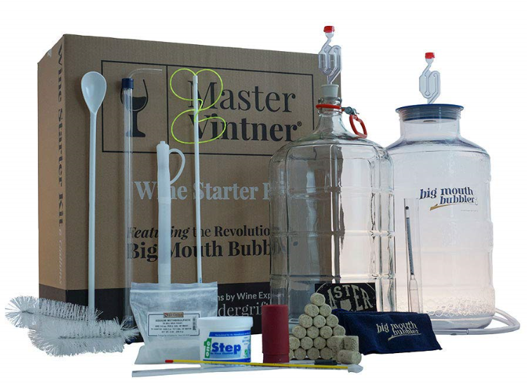 | “Big Mouth” Kit  $145.99 (Amazon)  - 6.5 gal Fermentor  - 6.5 gal Glass Carboy  - Instructional DVD  - Cleaning Cloth  - Degasser  - 2 drilled rubber bungs  - 2 Air Locks  - Auto Siphon  - Tubing & Clamp  - Bottle Filler & Tubing  - 24" Plastic Spoon  - Carboy Brush  - Carboy Handle  - Bottle Brush  - Impact Corker  - 30 #8 Corks,  - Lab Thermometer  - Hydrometer  - Test Jar  - 3-Piece Thief  - Sodium Metabisulfite  - OneStep cleanser  - 2 thermometers  Need corker ($12.99 Amazon)

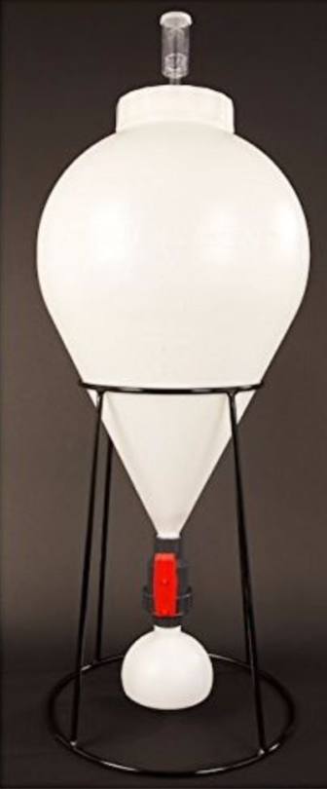 | FastFerment  $105 and up (Amazon)  “Fast Ferment makes it easy to brew and clean with a 6" removable screw top lid. At 7.9 US Gallons/30 Liters, the Fast Ferment is made for 5 - 6.5 US Gallon batches.”  This is essentially the primary fermenter and carboy in a single unit, which eliminates racking and transferring between buckets and carboys.  Recommend purchasing the Sampling Port Kit ($13)  You may still want to purchase degassing wand, corker / corks, bottling wand, hydrometer, thermometer, etc.  (A 3 gallon version is also available for $45).

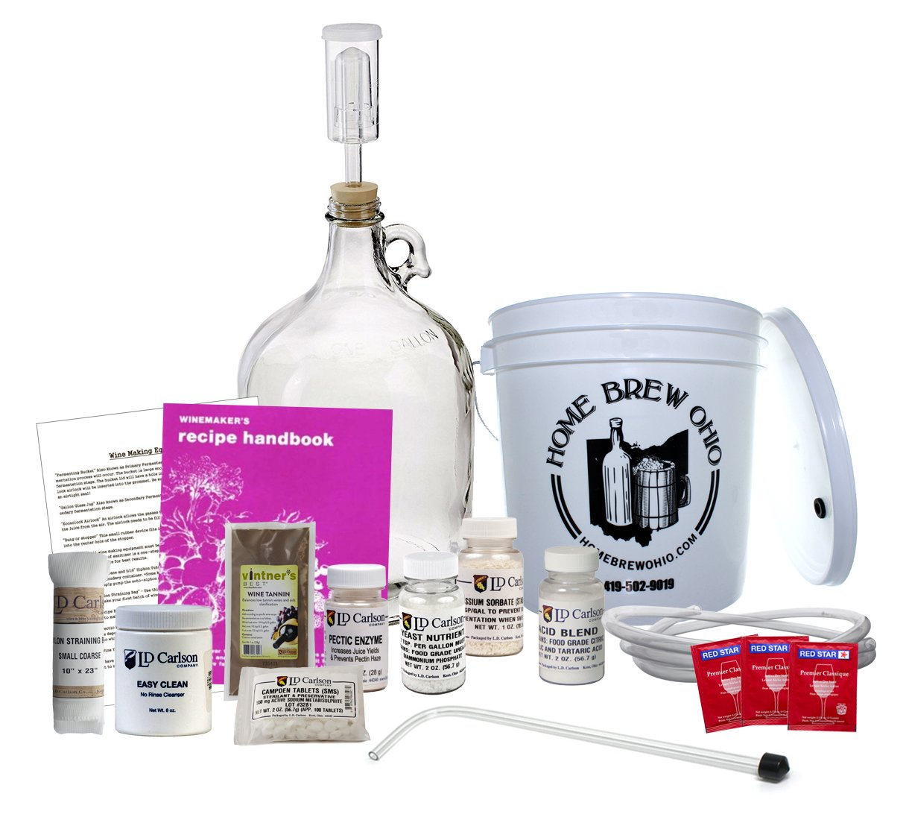 | 1 Gallon Fruit Wine Equipment Kit  $50 (Home Brew Ohio/Amazon)  - Winemaker Recipe Handbook / 101 One-Gallon Fruit Wine Recipes  - Includes enough additives to make up to 15 gallons of wine,  - 2-Gallon Plastic Fermenter with Lid,  - 1-Gallon Jug,  - Tubing,  - 15" Racking Cane,  - Airlock, and Drilled Screw-Top Cap,  - Straining Bag,  - 2 oz. Oxygen Wash,  - Campden Tablets,  - Pectin Enzyme,  - Potassium Sorbate,  - Yeast, Yeast Nutrient,  - Acid Blend and  - Wine Tannin  Note: Fruit, corker, corks and bottles are not included
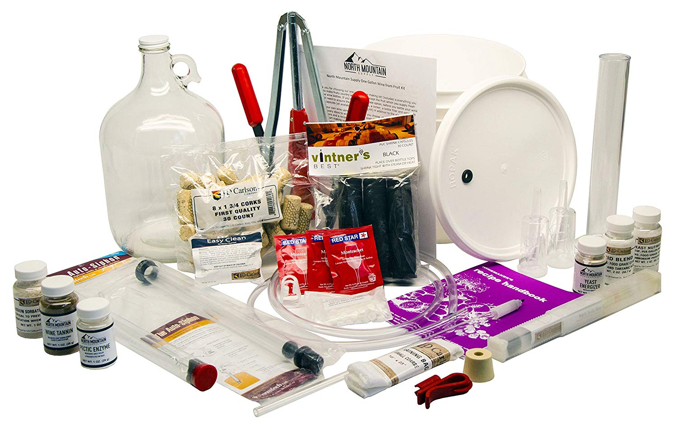 | 1 Gallon Wine from Fruit 30pc Kit  $93 (North Mount. Supply/Amazon)  - 2 Gallon Fermenter,  - 1 Gallon Glass Jug,  - Recipe Book,  - Step-by-Step Instructions,  - Auto-Siphon,  - 5' of Siphon Hose,  - 2 Airlocks,  - Bung & Screw Cap  - Straining Bag,  - 4oz Oxygen Wash,  - 50 Campden Tablets,  - Pectic Enzyme,  - Stabilizer,  - 3 Yeast Packs,  - Nutrients,  - Acid Blend,  - Tannin,  - Energizer,  - Hydrometer & Test Jar,  - Glass Wine Thief,  - Corks, Corker,  - Shrink Caps, &  - Bottle Filler

SAMPLE – WINE JUICE KITS
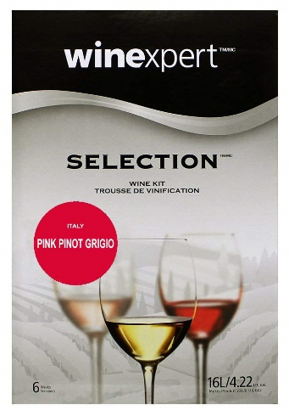  Selection  Regional grapes. Ready in 6 weeks. Age for more robust flavors.  New Zealand Pinot Noir $137  Chocolate Raspberry Port $110  Italian Pink Pinot Grigio $125 |  | 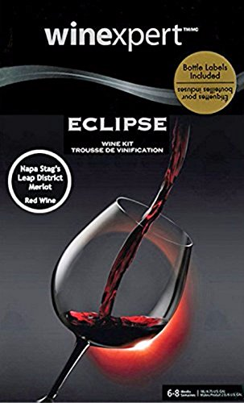  Eclipse  Specific wine sources. More juice. Ready in 8 weeks but definitely should be aged.  Italian Nebbiolo with grape skins $180  Napa Valley Stag’s Leap District Merlot /  grape skins $175  Washington Yakima Valley Pinot Gris $164
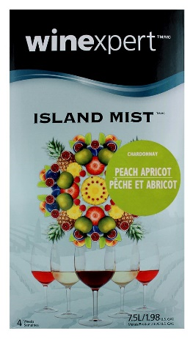  Island Mist Wines  Grape based with additional fruit juices. Ready in 30 days.  Peach Apricot Chardonnay $75  Strawberry White Merlot $70  Blueberry Pinot Noir $73  Pomegranate Zinfandel $80 | 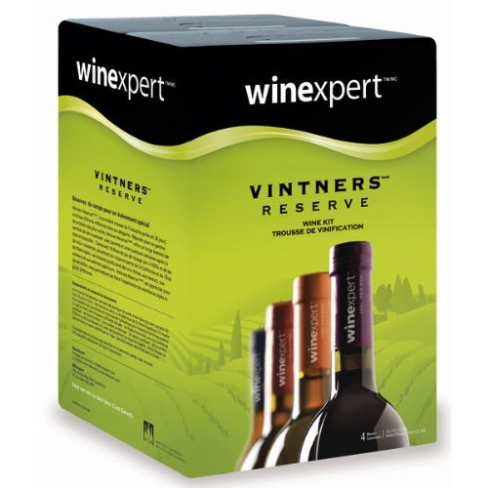  Vintner’s Reserve  Grape varietals. Ready in 30 days. Can be aged.  Sangiovese $90  Cabernet Sauvignon $80  Chardonnay $85  White Zinfandel $80 |  | 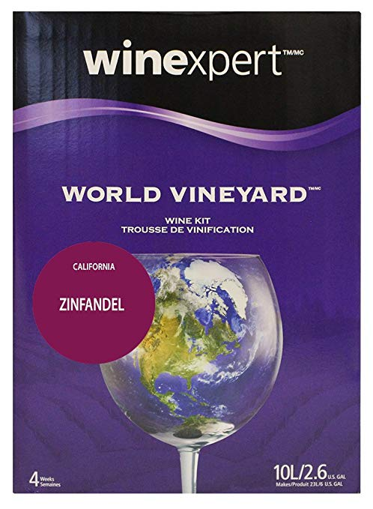  World Vineyard  Grape varietals specified by state/region. Ready in 30 days but improves with aging.  Chilean Merlot $73  Australian Cab Sav / grape skins $119  Italian Pinot Grigio $85  Chilean Sauvignon Blanc $90

