Somerset County Historical Society
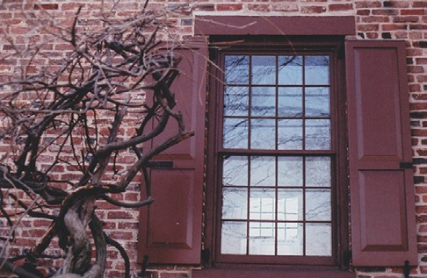
2019 Membership Application

Name __________________________________________________________________________________

Street Address / P.O. Box _________________________________________________________________

City __________________________________________ State ______________ Zip Code ____________

Phone ___________________________ Email ________________________________________________

Annual Membership Dues: ( ) $20.00 Individual Membership - Email Newsletter
( ) $24.00 Individual Membership - Print Newsletter

Additional tax-deductible donation
$10_____ $20 ____ $50 _____ $100 ____ Other _____

( ) $1,000 Life Membership

SCHS Memberships (except Life Memberships) are for the calendar year, Jan. 1 to Dec. 31.

Please mail your payment and completed application to the address below or go to https://somersethistorynj.org/membership to join online.

Somerset County Historical Society
9 Van Veghten Drive
Bridgewater, NJ 08807-3259
Attn: Membership

Please indicate which volunteer opportunities in which you are interested.

( ) Building & Grounds Maintenance
( ) Cemeteries
( ) Computer/Technology Support
( ) Fundraising/Grant Writing
( ) Genealogy/History Research
( ) Marketing/Outreach
( ) Newsletter

