Somerset County Historical Society
9 Van Veghten Drive, Bridgewater, NJ 08807
Telephone: 908/218-1281
Email: info@somersethistorynj.org website: https://somersethistorynj.org

2020 Membership Application

New_________ Renewal________
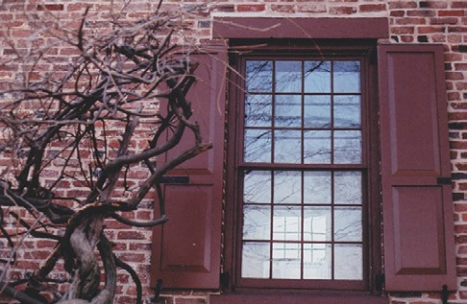
Your window of opportunity
Into Somerset’s past

Name __________________________________________________________________________________

Street Address / P.O. Box _________________________________________________________________

City __________________________________________ State ______________ Zip Code ____________

Phone ___________________________ Email ________________________________________________

Annual Membership Dues:
( ) $25.00 Individual Membership - Email Newsletter and/or mailed copy
( ) Send a mailed hard copy of the newsletter in addition to e-mail

Additional tax-deductible donation
$10_____ $20 ____ $50 _____ $100 ____ Other _____
( ) $1,000 Life Membership

SCHS Memberships (except Life Memberships) are for the calendar year, Jan. 1 to Dec. 31.

Please mail your payment and completed application to the address below or go to https://somersethistorynj.org/membership to join online.

Somerset County Historical Society
9 Van Veghten Drive
Bridgewater, NJ 08807-3259
Attn: Membership

Please indicate which volunteer opportunities interest you.

( ) Building & Grounds Maintenance ( ) Gardening
( ) Cemeteries ( ) Membership (personal contact)
( ) Computer/Technology Support ( ) Fundraising (Dance of the Decades)
( ) Grant Writing ( ) Housekeeping
( ) Genealogy/History Research ( ) Hospitality
( ) Website/e-mail/administration ( ) Programming (History Talks)
( ) Marketing/Outreach ( ) Museum Store
( ) Newsletter ( ) Oral Histories

