WELCOME TO
THE CHURCH OF THE STRAITS
Pastor David Wallis

November 15, 2020 10:30 a.m.

Welcome and Announcements

Remembering Our Veterans

*Call to Worship in Song screen
“I Will Sing”

*Prayer of Confession
Dear God, those who are willing to give their lives for freedom, know it comes at a cost. Jesus knows more than anyone that He paid a steep price for our salvation. We give eternal thanks in the precious name of The Lamb of God, Amen!

*Gloria Patri #623

*Hymn “America the Beautiful” #572
First Scripture Reading pg. 608
Psalm 119:45-48
Liturgist – Ron Cooper

Children’s Time

Sharing our Joys and Concerns
Silent Prayer and Pastoral Prayer
The Lord’s Prayer
Our Father, who art in heaven, hallowed be thy name. Thy kingdom come, thy will be done on earth as it is in heaven. Give us this day our daily bread. And forgive us our trespasses as we forgive those who trespass against us. And lead us not into temptation, but deliver us from evil. For thine is the kingdom, and the power, and the glory forever. Amen.

*Affirmation of Faith through Song screen
“Chainbreaker”

Second Scripture Reading pg. 1154
Galatians 5:1-12

Special Music Les Jackson and Bill Marvin

Sermon “It Is For Freedom That
Christ Has Set Us Free”

*Hymn #569
“Battle Hymn of the Republic”

*Benediction

*Postlude in unison
God be with you till we meet again;
By His counsels guide, up-hold you,
With His sheep securely fold you;
God be with you till we meet again.

There will be no Coffee Hour.

How to become a Christian
- Admit to God that you have done things that oppose His desires for you.
“For all have sinned and fall short of the glory of God.” Romans 3:23
- Acknowledge Jesus Christ as God’s only solution to your condition.
“Jesus answered, “I am the way and the truth and the life. No one comes to the Father except through me.”
John 14:6
- Ask God to forgive your sins and invite Jesus into your life.
“Yet to all who received him, to those who believed in his name, he gave the right to become children of God.”
John 1:12

What to Pray
“Lord Jesus, I need you. Thank you for coming to earth, living an unblemished life, and dying on the cross for my sins. I open the door of my life and receive you as Savior and Lord of everything I do. Make me the kind of person you want me to be.”

What to Do
Go to God in prayer daily.
Read God’s word daily.
Open your life to other Christian friends.
Worship God weekly at church.

If God is speaking to you this morning and you desire to receive Jesus Christ as your Savior and Lord, or desire prayer for a particular matter, we invite you to the front of the sanctuary at the close of the service where Pastor Dave and/or others will be glad to pray and talk with you.

THE CHURCH OF THE STRAITS STAFF
307 N. Huron Street • P.O. Box 430
Mackinaw City, MI 49701
231-436-8682 Office • 231-436-5765 Fax
231-436-5484 Parsonage
www.thechurchofthestraits.com cotsoffice@yahoo.com
Minister Pastor David Wallis
Youth Director Shannon Cooley
Head Ushers Todd Kohs, Carl Strieby and Greg Pietrowski
Organist/Pianist Loretta Martinek
Clerk Laura Jackson
Treasurers Janet Schaefer and
Donna Falor
Financial Secretary Cathy Brey
Secretary Judy Churchill

No Nursery at this time.

Liturgists in Coming Weeks:
Nov. 22 10:30 am Deb Moore
Nov. 29 10:30 am Julie Burnett

Sunday Worship Attendance

11/08/20 10:30 am - 67
11/10 /19 10:30 am - 93

Flowers: If you wish to have flowers on the Altar for any occasion, please contact the church office at 436-8682.

Hearing Devices are available from the sound booth. Please turn the device off and return it to the sound booth after the service.

The Mission of The Church of the Straits
To worship God faithfully
To grow together spiritually
To serve Jesus Christ and
our neighbor joyfully
… in the power of God’s Spirit.

CHURCH CALENDAR
November 15 – 22, 2020

SUN 11-15 3:00 pm AA
5:00 pm Prayer Group
6:00 pm Disciple IV Class

MON 11-16 3:00 pm Women’s Bible Study

TUE 11-17 7:00 pm BOG Meeting

WED11-18 Shoeboxes Due Back!!

THR 11-19 8:00 am Men’s Breakfast

SAT 11-21 9:00 am Men’s Group

SUN 11-22 9:30 am Adult Sunday School
10:30 am Traditional Worship
3:00 pm AA
5:00 pm Prayer Group
6:00 pm Disciple IV

ANNOUNCEMENTS

The Food Pantry will continue every other Wed. at 10am. Next dates are November 25th, Dec. 2nd and 23rd. The Pantry is in need of helpers on Wednesday mornings to pack and distribute the food. If you can help, please be at the church by 9 am. Thanks!

Anyone interested in joining the church is encouraged to talk to Pastor Dave. He will hold a few sessions before church in a few weeks.

S.A.R.M. “Campaign Postcard” has started! Youth near or far, this is an outreach project that any youth can participate in. Contact Shannon, Youth Director if you have any questions – 231-818-9467.

There is still time to return your 2021 Pledge! If you need a form, please contact the office.

It’s ShoeBox Time! Boxes are in Fellowship Hall to take and fill. Please remember there is a $9 donation per box to assist with world-wide shipping costs. Make checks payable to Samaritan’s Purse, NOT COS! Boxes are due back no later than Wednesday, November 18th!
2nd Annual Exercise for Your Soul challenge is starting tomorrow. See the insert for details. Challenge proceeds will go to purchase “coats for kids”. There will also be a large box in Fellowship Hall for donations of ‘”new with tags” kids coats. No used coats, please.

Now taking Poinsettia Orders. Plants are $11 this year and orders are due by December 4th. Order forms are on the sign-up table in Fellowship Hall.

Community Thanksgiving Service will be held here, along with St. Anthony’s on Tuesday, November 24th at 7:00 pm. Join us!

Hanging of the Greens will take place immediately following worship on Sunday, November 29th. A light lunch will be served. There will be a craft table for kids with Shannon. Help us dress our church for Christmas!

PRAYER REQUESTS
Please pray for the following persons from our prayer cards: the family of George Graway Sr, Ron Irwin, Greg Harwick, Dave Chevalier, Marianne Murray, Jerry Archer, Betty Strieby, Kay Watkins, Kim Wein, Ann Pfleegor, Amber (Shannon’s cousin) Tammy Brahm, Deanna Oches, Brooke, Terry Davis, Andrea Sarto, Evelyn Canales, Christina Beck, Karen Thompson, Scott Cool, Nelson LaPointe, David Hawver, Landon Masters, Ron Frazier, all Law Enforcement, Pastor Judith Harrington, Jamie Rayder, Skeeter Barrette, Alvina Williams, Mark Clemens, JoAnn Rinehart, James Boyke, David Tomaski, Carol Brown, Cless Hurlburt, B.J. Magers, Bill Marvin, Bill Szubielak, Beth Wickliffe, Craig Morlanen, Bob Wheelan, Nancy Sheldon, Joanne Wallin, Peter Larson, Agatha Anderson, David Cluley, Kandi Soler, Linda Gilsman, Ted Stone, Ricki Caswell, Irene Rasmussen, Jeanine Clemens, Katie Darrow, Casey Holsinger, Naomi Gomez, Katie Roberts, Leslie Sherman, John Delis, Rick Pauley, Mary Marquis, Theresa Gonzales, Chuck Adkins, Bill Nowaske, Adam Greenly, Jimmy Wilkins, Julie Burnett, Janet Schaefer, Doris Rottschalk, Kate Walugembe, and our Military.

Nikki Haneczek

Welcome to Our Service

The Church of the Straits
Covenant Order of Evangelical Presbyterians (ECO)
and
United Methodist
Federated

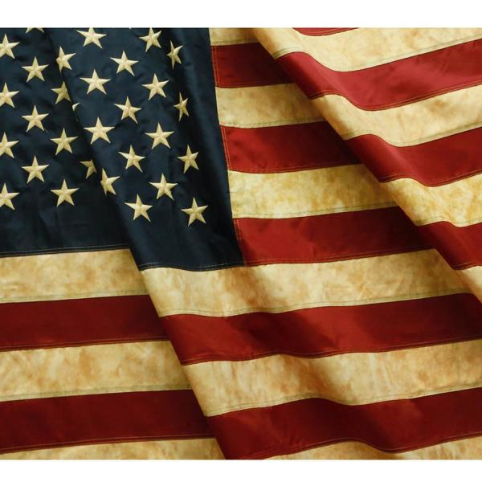

STAND FAST
in the liberty wherewith
Christ hath made us free.
Galatians 5:1

