WELCOME TO
THE CHURCH OF THE STRAITS
Pastor David Wallis

December 27, 2020 10:30 a.m.
First Sunday of Christmas

Welcome and Announcements

*Call to Worship in Song screen
“As the Deer”

Prayer of Confession
Love came down at Christmas! Love fulfilled at Calvary! Love unleashed at the Resurrection! Love continues in the Church, through Christ our Lord, Amen!

*Gloria Patri #623

*Hymn #92
“Love Divine, All Loves Excelling”
First Scripture Reading pg. 782
Jeremiah 31:3-6
Liturgist – Julie Burnett

Children’s Time

Sharing our Joys and Concerns
Silent Prayer and Pastoral Prayer
The Lord’s Prayer
Our Father, who art in heaven, hallowed be thy name. Thy kingdom come, thy will be done on earth as it is in heaven. Give us this day our daily bread. And forgive us our trespasses as we forgive those who trespass against us. And lead us not into temptation, but deliver us from evil. For thine is the kingdom, and the power, and the glory forever. Amen.

*Affirmation of Faith through Song screen
“Indescribable”

Second Scripture Reading pg. 955
Matthew 1:18-25

Sermon “Extraordinary Love!”

*Hymn #138
“Go Tell It on the Mountain”
*Benediction

*Postlude in unison
God be with you till we meet again;
By His counsels guide, up-hold you,
With His sheep securely fold you;
God be with you till we meet again.

There will be no Coffee Hour.

How to become a Christian
- Admit to God that you have done things that oppose His desires for you.
“For all have sinned and fall short of the glory of God.” Romans 3:23
- Acknowledge Jesus Christ as God’s only solution to your condition.
“Jesus answered, “I am the way and the truth and the life. No one comes to the Father except through me.”
John 14:6
- Ask God to forgive your sins and invite Jesus into your life.
“Yet to all who received him, to those who believed in his name, he gave the right to become children of God.”
John 1:12

What to Pray
“Lord Jesus, I need you. Thank you for coming to earth, living an unblemished life, and dying on the cross for my sins. I open the door of my life and receive you as Savior and Lord of everything I do. Make me the kind of person you want me to be.”

What to Do
Go to God in prayer daily.
Read God’s word daily.
Open your life to other Christian friends.
Worship God weekly at church.

If God is speaking to you this morning and you desire to receive Jesus Christ as your Savior and Lord, or desire prayer for a particular matter, we invite you to the front of the sanctuary at the close of the service where Pastor Dave and/or others will be glad to pray and talk with you.

THE CHURCH OF THE STRAITS STAFF
307 N. Huron Street • P.O. Box 430
Mackinaw City, MI 49701
231-436-8682 Office • 231-436-5765 Fax
231-436-5484 Parsonage
www.thechurchofthestraits.com cotsoffice@yahoo.com
Minister Pastor David Wallis
Youth Director Shannon Cooley
Head Ushers Todd Kohs, Carl Strieby and Greg Pietrowski
Organist/Pianist Loretta Martinek
Clerk Laura Jackson
Treasurers Janet Schaefer and
Donna Falor
Financial Secretary Cathy Brey
Secretary Judy Churchill

No Nursery at this time.

Liturgists in Coming Weeks:
Jan. 03 10:30 am need someone
Jan. 10 10:30 am need someone

Sunday Worship Attendance

12/20/20 10:30 am - 47
12/22/19 10:30 am - 95

Flowers: If you wish to have flowers on the Altar for any occasion, please contact the church office at 436-8682.

Hearing Devices are available from the sound booth. Please turn the device off and return it to the sound booth after the service.

The Mission of The Church of the Straits
To worship God faithfully
To grow together spiritually
To serve Jesus Christ and
our neighbor joyfully
… in the power of God’s Spirit.

CHURCH CALENDAR
December 27, 2020 – January 3, 2021

SUN 12-27 3:00 pm AA

Happy New Year!

SAT 1-02 9:00 am Men’s Group

SUN 1-03 10:30 am Traditional Worship
3:00 pm AA

ANNOUNCEMENTS

The Food Pantry dates are January 6th and 20th. If you can help, please be at the church by 9 am. Thanks!

Need transportation to the doctor or the store? Need someone to pick-up prescriptions or groceries? How about minor handyman repairs? Call us, Ron Illikman 231-445-8482 or Clif Kennedy 231-436-5851. We are members of St Anthony’s Catholic Church providing a Christian missionary service. So, if you have a need or just need a little assistance during these difficult times and you live in the Mackinaw/ Carp Lake area, call and we will be happy to meet your needs.

There is still time to return your 2021 Pledge! If you need a form, please contact the office.

Thank you to Donna Falor for the beautiful Christmas wreaths on the front doors ♥

2021 Giving Envelopes are on the table in Fellowship Hall. If you don’t see your name and want envelopes, please notify the office.

**There will be NO Sunday School, Prayer Group or Disciple Class on Dec. 27th or Jan. 3. All will resume on January 10th

If you ordered a poinsettia, you make take it home with you today!

A “from the bottom of my heart” thank you to all those who sent “Happy 60th Birthday” wishes, cards, gifts and love. I noticed that 25 years of ministry were acknowledged as well. I guess between two churches, that is true. I’m getting old! Ha ha! We are so blessed to be a part of this lovely church community. Also, thank you Disciple Class for the surprise birthday party! You are awesome.
Love you, Dave

PRAYER REQUESTS
Please pray for the following persons from our prayer cards: Stella Smith, Craig Day, Matt & Nikki Haigh, Ron Irwin, Greg Harwick, Dave Chevalier, Marianne Murray, Kay Watkins, Kim Wein, Amber (Shannon’s cousin) Tammy Brahm, Deanna Oches, Brooke, Terry Davis, Andrea Sarto, Evelyn Canales, Christina Beck, Karen Thompson, Scott Cool, Nelson LaPointe, David Hawver, Landon Masters, Ron Frazier, all Law Enforcement, Pastor Judith Harrington, Jamie Rayder, Skeeter Barrette, Alvina Williams, Mark Clemens, JoAnn Rinehart, James Boyke, David Tomaski, Carol Brown, Cless Hurlburt, B.J. Magers, Bill Marvin, Bill Szubielak, Beth Wickliffe, Craig Morlanen, Bob Wheelan, Nancy Sheldon, Joanne Wallin, Peter Larson, Agatha Anderson, David Cluley, Kandi Soler, Linda Gilsman, Ted Stone, Ricki Caswell, Irene Rasmussen, Jeanine Clemens, Katie Darrow, Casey Holsinger, Naomi Gomez, Katie Roberts, Leslie Sherman, John Delis, Rick Pauley, Mary Marquis, Theresa Gonzales, Chuck Adkins, Bill Nowaske, Adam Greenly, Jimmy Wilkins, Julie Burnett, Janet Schaefer, Doris Rottschalk, Kate Walugembe, and our Military.

Nikki Haneczek

Welcome to Our Service

The Church of the Straits
Covenant Order of Evangelical Presbyterians (ECO)
and
United Methodist
Federated

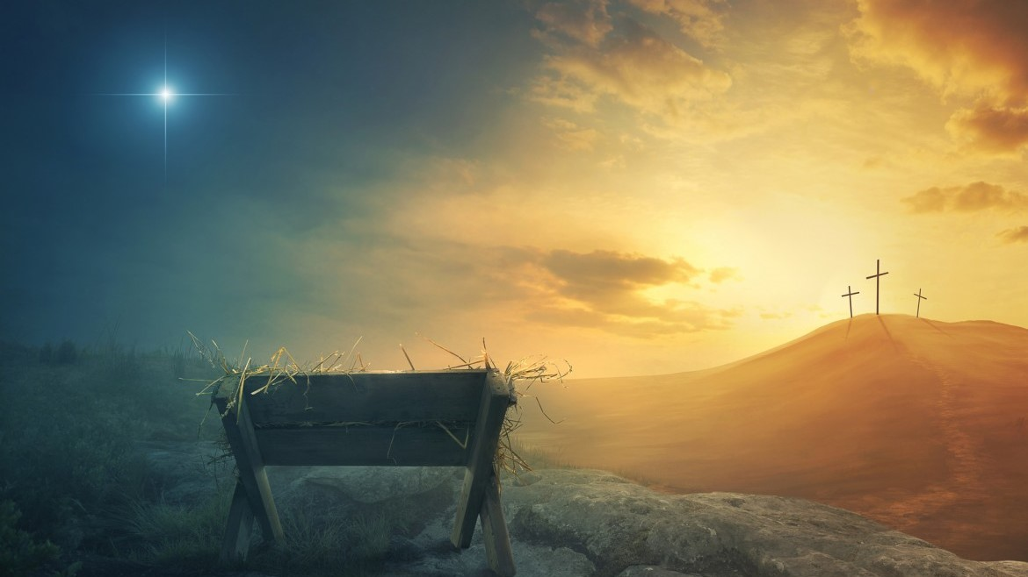

Love came down at Christmas

