WELCOME TO
THE CHURCH OF THE STRAITS
Pastor David Wallis

March 31, 2019 10:30 a.m.

Welcome and Announcements
- Please sign our attendance pads; pass it down the pew, take time to note with whom you are sitting, so that you can greet them later.
- Green Prayer Cards may be filled out with your joys/prayer concerns. Ushers will collect them during prayer time.

*Call to Worship in Song screen
“There Is None Like You”

*Prayer of Confession
Father, sometimes we’d rather be in the grandstands than be a disciple. We want to do our thing, not yours. Forgive us and lead us in your ways, in Jesus’ name, Amen!

*Gloria Patri #623

*Hymn “I’d Rather Have Jesus” #517

First Scripture Reading pg. 625
Liturgist – Don Hawver Proverbs 1:1-7

Children’s Time

*Affirmation of Faith through Song screen
“God Will Make a Way”

Sharing our Joys and Concerns
Silent Prayer and Pastoral Prayer
The Lord’s Prayer
Our Father, who art in heaven, hallowed be thy name. Thy kingdom come, thy will be done on earth as it is in heaven. Give us this day our daily bread. And forgive us our trespasses as we forgive those who trespass against us. And lead us not into temptation, but deliver us from evil. For thine is the kingdom, and the power, and the glory forever. Amen.

Giving our Tithes and Offerings
Offertory
Doxology #625
*Prayer of Dedication

Second Scripture Reading pg. 1027
Luke 9:57-62

Sermon
“Who’s Going to Adapt, Me or You?”

*Hymn “Near to the Heart of God” #497

*Benediction

*Postlude in unison
God be with you till we meet again;
By His counsels guide, up-hold you,
With His sheep securely fold you;
God be with you till we meet again.

***************

Please join us for refreshments after the service in Fellowship Hall.
Everyone is welcome!

How to become a Christian
- Admit to God that you have done things that oppose His desires for you.
“For all have sinned and fall short of the glory of God.” Romans 3:23
- Acknowledge Jesus Christ as God’s only solution to your condition.
“Jesus answered, “I am the way and the truth and the life. No one comes to the Father except through me.”
John 14:6
- Ask God to forgive your sins and invite Jesus into your life.
“Yet to all who received him, to those who believed in his name, he gave the right to become children of God.”
John 1:12

What to Pray
“Lord Jesus, I need you. Thank you for coming to earth, living an unblemished life, and dying on the cross for my sins. I open the door of my life and receive you as Savior and Lord of everything I do. Make me the kind of person you want me to be.”

What to Do
Go to God in prayer daily.
Read God’s word daily.
Open your life to other Christian friends.
Worship God weekly at church.

If God is speaking to you this morning and you desire to receive Jesus Christ as your Savior and Lord, or desire prayer for a particular matter, we invite you to the front of the sanctuary at the close of the service where Pastor Dave and/or others will be glad to pray and talk with you.

THE CHURCH OF THE STRAITS STAFF
307 N. Huron Street • P.O. Box 430
Mackinaw City, MI 49701
231-436-8682 Office • 231-436-5765 Fax
231-436-5484 Parsonage
www.thechurchofthestraits.com cotsoffice@yahoo.com
Minister Pastor David Wallis
Youth Director Vicki Wagonis-Bryers
Head Ushers Todd Kohs and
Greg Pietrowski
Organist/Pianist Loretta Martinek
Clerk Laura Jackson
Treasurer Janet Schaefer
Financial Secretary Cathy Brey
Secretary Judy Churchill

In the Nursery – for 1st grade and younger
Mar. 31 – Laura Jackson
Apr. 7 – Emma Zabik
Apr. 14 – Ariel Durant

Liturgists in Coming Weeks:
Apr. 07 – Elizabeth Zabik
Apr. 14 – Ross Bell
Apr. 21 – Elizabeth Zabik

Sunday Worship Attendance

3/24/19 10:30 am 69
3/25/18 10:30 am 102

Flowers: If you wish to have flowers on the Altar for any occasion, please contact the church office at 436-8682.

Hearing Devices are available from the sound booth. Please turn the device off and return it to the sound booth after the service.

The Mission of The Church of the Straits
To worship God faithfully
To grow together spiritually
To serve Jesus Christ and
our neighbor joyfully
… in the power of God’s Spirit.

CHURCH CALENDAR
March 31 – April 7, 2019

SUN 3-31 3:00 pm AA
5:00 pm Prayer Group
6:00 pm Disciple III

MON 4-1 3:00 pm Women’s Bible Study

TUE 4-2 10:00 am Senior Chair Yoga
6:30 pm PPRC Meeting

WED 4-3 10:00 am Food Pantry

THR 4-4 8:00 am Men’s Breakfast

SAT 4-6 9:00 am Men’s Accountability

SUN 4-7 9:30 am Adult Sun. School
10:30 am Traditional Worship
3:00 pm AA
5:00 pm Prayer Group
6:00 pm Disciple III

ANNOUNCEMENTS

Operation Christmas Child Shoeboxes –
April is stuffed animals / toys.

Easter Flower Order Forms are in Fellowship Hall on the Sign-up table. Orders need to be to the church office no later than April 8th.

Youth Program Update:
Yay, a very successful Mackinaw Straits WyldLife Club was held on March 20, 11 youth attended. Games and more games were played! Sally Bell provided a very fun icebreaker at the beginning of club. What fun it was to learn many things about the kids that they didn’t know about each other. Jane Boyke provided great food. I want to give a shout out to Kristi Laninga for providing the other games we
played and a special thanks to Ariel Durant, Izzie House, and Greg Pietrowski for leading the games. We all had fun, youth and adults.

For April, we will have club meetings on April 10th & 24th, 6pm – 7:30pm.
I am looking for more volunteers, if interested, please call me or email me. It takes a village to raise the kids. Thank you, Vicki

Altar Flowers this morning are in loving memory of Tom Limberg from Liz and family.

Altar Flowers this morning are in loving memory of Don Pepper from Dawn Pepper, Andrea Pepper and Jim Hardeman.

Ladies and Men ☺ of the church, The Willing Workers are putting together a Church of the Straits Cookbook. Please submit your favorite recipes to Rose LaPointe as soon as possible, thanks!

Easter Bunny Lunch for kids of all ages, will be on Saturday, April 13th from 11am to 1pm. Games, crafts, prizes and more….
There will be a “Cake Walk” again this year. It has been in the past, the highlight of the lunch! If you could bake a good cake, cupcakes, or fancy cookies we could use the donations.
Thank you, Anne Vieau 436-7482

PRAYER REQUESTS
Please pray for the following persons from our prayer cards: Helen Snell, Dawn Pepper, Sandra Millbocker, Kari Bedell, Jim Rose, Ann Phleegor, Jeanine Clemens, Don Bedell, Katie Darrow, Jim Rose, Amy Rogala, Casey Holsinger, Joel Thies, Riley & Pat Martin, Jack Keck, Nancy Branch, Sam Clark, Karen Geary, Barb Lennon, Meredith Cole, Dorothy Churchill, Carol Fischer, Jodi Prieur, Naomi Gomez, Diane Stevens, Jim Yager, Angela Williams, Christina Beck, Taylor Fritz, Paige DeWitte, Katie Roberts, Al Artz, Leslie Sherman, John Delis, youth at Tip of the Mitt, Rick Pauley, Mary Marquis, Theresa Gonzales, Staci Belanger, Chuck Adkins, Bill Nowaske, Sharon Bonter, Jennifer Cole, Pryce Redmond, Adam Greenly, Herb Plaunt, Florence Tracy, Hailey Williams, Alvina Williams, Laurel Birk, Adam Cripps, JoAnn Wallin, Tillie Frazier, Denice Hansen, Jolene Rogala, Nathan Raboin, Dave Bryers, Jimmy Wilkins, Marilyn Cole, Julie Burnett, Julie Mallory, Janet Schaefer, Doris Rottschalk, Janice Wallis, Arvella Tenbrink, Lisa Emelander, Marty Mol, Mason Brey, Kate Walugembe, and our Military.

Nikki Haneczek

Welcome to Our Service

The Church of the Straits
Covenant Order of Evangelical Presbyterians (ECO)
and
United Methodist
Federated

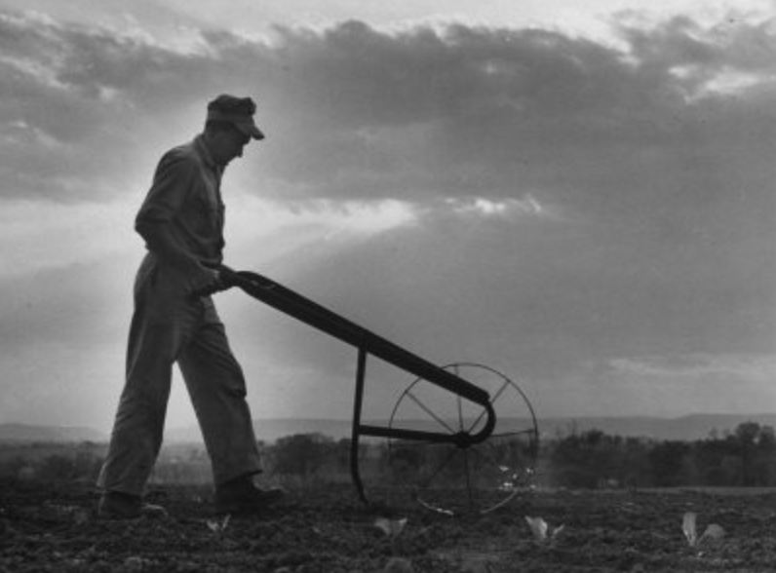

Follow Me

