Welcome to The Church of the Straits
July 21, 2019 9:00 & 11:00 a.m.
Pastor David Wallis

Welcome and Announcements
- Please sign our attendance pads; pass it down the pew, take time to note with whom you are sitting, so that you can greet them later.
- Green Prayer Cards may be filled out with your joys/prayer concerns. Ushers will collect them during prayer time.

This morning we are pleased to welcome the Bloomingdale Christian Fellowship Youth.

This ministry began as a Bloomingdale High School club in 1973 when Jim Vukelich was hired as the high school counselor. It has continued on as a nondenominational community youth ministry since then.

Today we welcome at least 28 members of the group. Jim has been taking the high school groups camping at Wilderness State Park since 1974, so some of the kids are former campers. They do some Bible studies out at the campsite, as well as worship, including campfires when the sun sets and a lot of other activities.

Over the years, Jim has seen a lot of kids come to know Jesus on these trips and so the kids and Jim very much look forward to "camp" each summer. Most of the kids in the group do not attend church when they first come to the group. Of course, Jim prays that in addition to coming to know Jesus and being discipled some, that they will also get plugged into a local church in their area.

Jim will talk more about their tie to Mackinaw and his own experience in the services. But when Jim first came to Wilderness State Park in 1970, he had just finished his junior year at Western Michigan University. He made a profession of faith in Jesus when he was in seventh grade but his time on the beach at the park in 1970 was the major turning point for him.

Bloomingdale is located about 290 miles south of Mackinaw City. If you follow the lake shore down to South Haven and then come inland about 16 miles, you will reach Bloomingdale.

THE CHURCH OF THE STRAITS STAFF
307 N. Huron Street • P.O. Box 430
Mackinaw City, MI 49701
231-436-8682 Office • 231-436-5765 Fax
231-436-5484 Parsonage
www.thechurchofthestraits.com cotsoffice@yahoo.com
Minister Pastor David Wallis Youth Director Vicki Bryers
Head Ushers Todd Kohs, Carl Strieby Clerk Laura Jackson
and Greg Pietrowski Financial Sec. Cathy Brey
Organist Loretta Martinek Secretary Judy Churchill
Treasurer Janet Schaefer / Donna Falor

Hearing Devices: Hearing devices are available from the sound booth. Please turn the device off and return it to the sound booth after the service.

Liturgists for July 28 Liturgists for August 4
9 a.m. – Ken Bender 9 a.m. – need someone
11 a.m. – Ann Hayes 11 a.m. – need someone
Nursery Care is provided at both services

Sunday Worship Attendance
07/14/19 9 a.m. – 78 11 a.m. – 50
07/15/18 9 a.m. – 90 11 a.m. – 65

PRAYER REQUESTS
Please pray for the following persons from our prayer cards: Rochelle Kennedy, Lisa Wallis, Bob Bach, Mona Scharffe, Martha Bell, Ted Stone, Beth Mottsinger, Shirley Maiville, Mary Sikkens, Larry Dodson, Carla Stone, David Canales, Barb and George Lennon, Fred Provost, Ronnie Cooper, Suzanne Darrow, Tim Zabik, Mary Terrian, Connie Ware’s mom, John Kurtz, DanTassier, Pastor Dave, Kathy Neill, Jennifer Davis, Mary Beth, Benny, Ricki Caswell, Dick Campbell, Nan Keck, Pastor Jerry Tallman, Katie Leach, Carol Fischer, Irene Rasmussen, Jim Rose, Jeanine Clemens, Don Bedell, Katie Darrow, Casey Holsinger, Jodi Prieur, Meredith Cole, Naomi Gomez, Diane Stevens, Katie Roberts, Al Artz, Leslie Sherman, John Delis, youth at Tip of the Mitt, Rick Pauley, Mary Marquis, Theresa Gonzales, Staci Belanger, Chuck Adkins, Bill Nowaske, Sharon Bonter, Adam Greenly, Hailey Williams, Laurel Birk, Adam Cripps, Tillie Frazier, Denice Hansen, Jolene Rogala, Nathan Raboin, Dave Bryers, Jimmy Wilkins, Marilyn Cole, Julie Burnett, Janet Schaefer, Doris Rottschalk, Janice Wallis, Arvella Tenbrink, Marty Mol, Mason Brey, Kate Walugembe, and our Military.

The Mission of The Church of the Straits
To worship God faithfully
To grow together spiritually
To serve Jesus Christ and
Our neighbor joyfully
…in the power of God’s Spirit.

CHURCH CALENDAR
July 21 – 28, 2019

SUN 7-21 3:00 p.m. AA
6:00 p.m. Prayer Meeting

MON 7-22 3:00 p.m. Women’s Bible Study

TUE 7-23 11:00 a.m. Evangelism Meeting
7:00 p.m. BOG Meeting

WED 7-24 6:00 p.m. Youth Relay and Ice Cream Social
THR 7-25 9-3:00 p.m. St. Anthony’s Community Garage Sale

SAT 7-27 9:00 a.m. Men’s Group

SUN 7-28 9:00 a.m. Traditional Worship
10:15 a.m. Adult Sunday School
11:00 a.m. Traditional Worship
3:00 p.m. AA
6:00 p.m. Prayer Meeting

ANNOUNCEMENTS

Summer is here! Thru Labor Day Sunday, we need ushers/greeters & liturgists at both the 9am & 11am services. Sign-up sheets are in Fellowship Hall.

For Operation Shoebox – July is clothing: socks, underwear, shoes, sandles, mittens, hats, smal purses, totes.
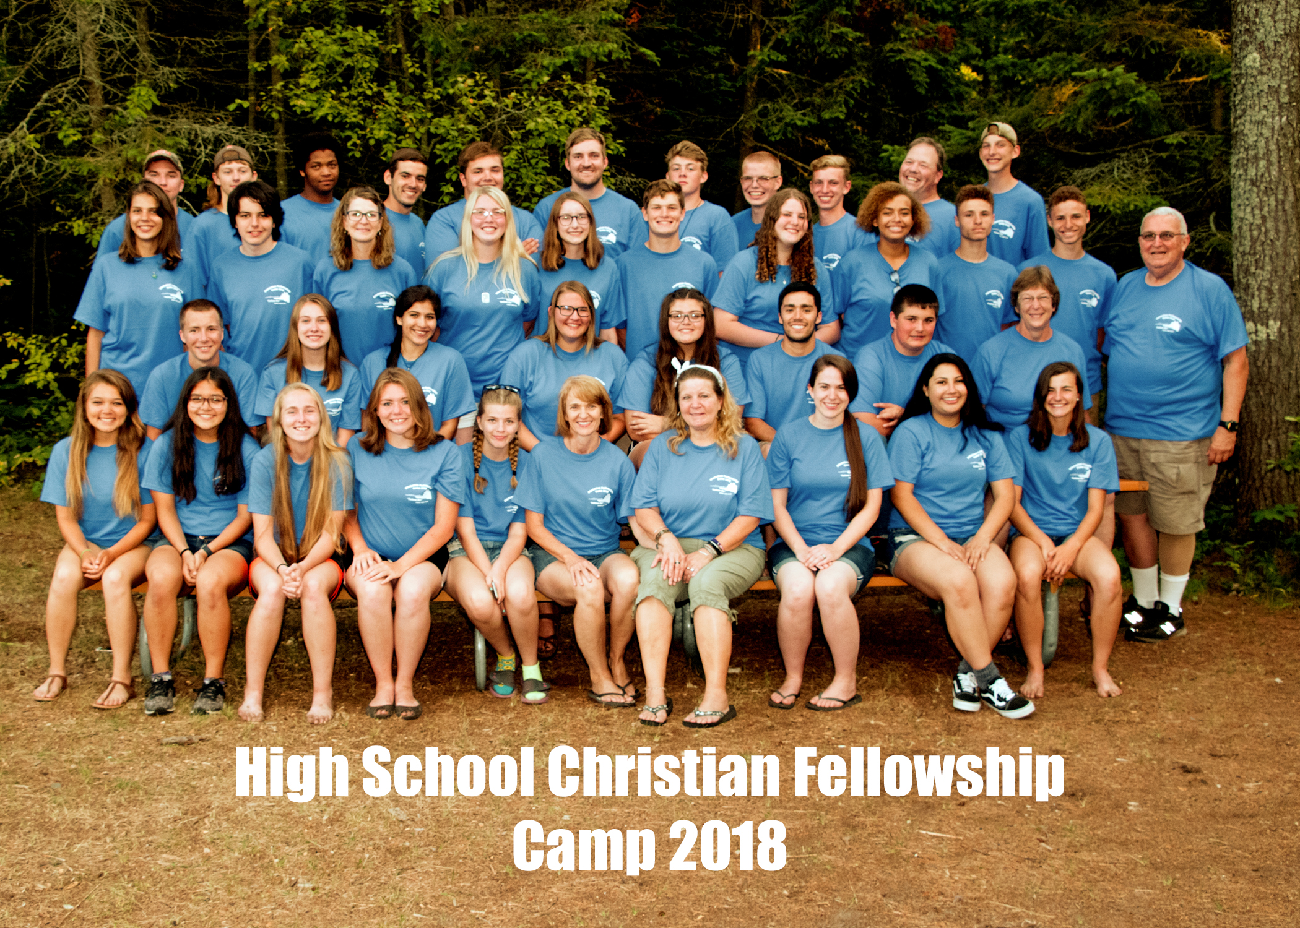
St. Anthony’s Annual Garage Sale – Thursday, July 25th, 9:00 am – 3:00 pm. Bake Sale & Antiques. Goodwill offering on all purchases, except antiques and specialty items. Something for everyone!!

Sunday, July 28 will be VBS Sunday. Instead of ‘Wish Lists’ for needed items and groceries, we are asking for $$ donations. That way, craft items can be ordered and grocery items purchased for exactly what we need. Thank you in advance for supporting VBS. Volunteers are ALWAYS welcome! Call “Sheriff Judy” in the office if you have any questions.

Beginner Tai Chi Class; once a week on Tuesdays, 10:00 am St. Anthony’s Parish Life Center has begun!!!. Open to all the community. The class will last an hour and is free. No experience needed - the class will be based for beginners with focus on balance, breathing, and relaxation. It will be offered for July, Aug.,
& Sept. For more information, call Marcia at 810-227-4127.

Calling all youths, 4th grade on up.
Come play relay games and then eat ice cream.
Church of the Straits, Wednesday, July 24th, 6-8pm. Come prepared to have fun!
Welcome to Our Worship Service

Thanks, Vicki

The Church of the Straits
Covenant Order of Evangelical Presbyterians (ECO)
and
United Methodist
Federated
