WELCOME TO
THE CHURCH OF THE STRAITS
Pastor David Wallis

July 28, 2019 9 & 11 a.m.

SUNDAY

Welcome and Announcements
- Please sign our attendance pads; pass it down the pew, take time to note with whom you are sitting, so that you can greet them later.
- Green Prayer Cards may be filled out with your joys/prayer concerns. Ushers will collect them during prayer time.

*Call to Worship in Song screen
“Breathe”

*Prayer of Confession
God, the enemy is real but so is the solution. You are our hope, our king, and our victory, in Jesus’ name, Amen!

*Gloria Patri #623

*Hymn “Rise Up, O Church of God” #293
First Scripture Reading
Exodus 17:9-13 pg. 71
Liturgist – Ken Bender 9 am
Liturgist – Ann Hayes 11 am

Children’s Time Jim Stevens
VBS Favorite Songs

*Affirmation of Faith through Song screen
“In Christ Alone”

Sharing our Joys and Concerns
Silent Prayer and Pastoral Prayer
The Lord’s Prayer
Our Father, who art in heaven, hallowed be thy name. Thy kingdom come, thy will be done on earth as it is in heaven. Give us this day our daily bread. And forgive us our trespasses as we forgive those who trespass against us. And lead us not into temptation, but deliver us from evil. For thine is the kingdom, and the power, and the glory forever. Amen.

Giving our Tithes and Offerings
Offertory
Doxology #625
*Prayer of Dedication

9 am – Volunteer Choir
“The Wise May Bring Their Learning” #583

11 am – Special Music Ed & Joyce Weiss
“The King is Coming”

Second Scripture Reading pg. 1149
2 Corinthians 12:7-10

Sermon “How is the Enemy Defeated?”

*Hymn “There is Power in the Blood” #191

*Benediction

*Postlude in unison
God be with you till we meet again;
By His counsels guide, up-hold you,
With His sheep securely fold you;
God be with you till we meet again.

Please join us for refreshments between Worship Services in Fellowship Hall.
Everyone is welcome!

How to become a Christian
- Admit to God that you have done things that oppose His desires for you.
“For all have sinned and fall short of the glory of God.” Romans 3:23
- Acknowledge Jesus Christ as God’s only solution to your condition.
“Jesus answered, “I am the way and the truth and the life. No one comes to the Father except through me.”
John 14:6
- Ask God to forgive your sins and invite Jesus into your life.
“Yet to all who received him, to those who believed in his name, he gave the right to become children of God.”
John 1:12

What to Pray
“Lord Jesus, I need you. Thank you for coming to earth, living an unblemished life, and dying on the cross for my sins. I open the door of my life and receive you as Savior and Lord of everything I do. Make me the kind of person you want me to be.”

What to Do
Go to God in prayer daily.
Read God’s word daily.
Open your life to other Christian friends.
Worship God weekly at church.

If God is speaking to you this morning and you desire to receive Jesus Christ as your Savior and Lord, or desire prayer for a particular matter, we invite you to the front of the sanctuary at the close of the service where Pastor Dave and/or others will be glad to pray and talk with you.

THE CHURCH OF THE STRAITS STAFF
307 N. Huron Street • P.O. Box 430
Mackinaw City, MI 49701
231-436-8682 Office • 231-436-5765 Fax
231-436-5484 Parsonage
www.thechurchofthestraits.com cotsoffice@yahoo.com
Minister Pastor David Wallis
Youth Director Vicki Wagonis-Bryers
Head Ushers Todd Kohs, Carl Strieby and Greg Pietrowski
Organist/Pianist Loretta Martinek
Clerk Laura Jackson
Treasurer Janet Schaefer
Financial Secretary Cathy Brey
Secretary Judy Churchill

In the Nursery – for 1st grade and younger
July 14 –
July 21 –

Liturgists in Coming Weeks:
Aug. 4 9:00 am John Spencer
Aug. 4 11:00 am need someone
Aug. 11 9:00 am Julie Burnett
Aug. 11 11:00 am need someone

Sunday Worship Attendance

7/21/19 9am – 106 11am – 95
7/22/18 9am – 67 11am – 74

Flowers: If you wish to have flowers on the Altar for any occasion, please contact the church office at 436-8682.

Hearing Devices are available from the sound booth. Please turn the device off and return it to the sound booth after the service.

The Mission of The Church of the Straits
To worship God faithfully
To grow together spiritually
To serve Jesus Christ and
our neighbor joyfully
… in the power of God’s Spirit.

CHURCH CALENDAR
July 28 – August 4, 2019

SUN 7-28 3:00 pm AA
6:00 pm Prayer Group

MON 7-29 3:00 pm Women’s Bible Study

WED 7-31 10:00 am Worship Meeting
11:00 am VBS Meeting

THR 8-1 8:00 am Men’s Breakfast

FRI 8-2 10:00 am James Hiser Memorial

SAT 8-3 9:00 am Men’s Accountability

SUN 8-4 9:00 am Traditional Worship
10:15 am Adult Sunday School
11:00 am Traditional Worship
2:00 pm Internment Service for David Miller
3:00 pm AA
6:00 pm Prayer Group

ANNOUNCEMENTS

Operation Christmas Child Shoeboxes –
August is school supplies – rulers, scissors, crayons, markers, pencils & erasers, paper, calculators, etc.

Katie Darrow would appreciate help with rides to Petoskey 3 times a week for dialysis. Sign up in Fellowship Hall, thank you!

Beginner Tai Chi Class; once a week on Tuesdays, 10:00 am St. Anthony’s Parish Life Center. Open to all the community. The class will last an hour and is free. No experience needed - the class will be based for beginners with focus on balance, breathing, and relaxation. It will be offered for July, Aug., & Sept.
For more information, call Marcia at 810-227-4127.
An Internment Service will be held for David J. Miller, on Sunday August 4, 2019 for family and friends at the Lakeview Cemetery, Mackinaw City at 2:00 pm. Following the internment, we will gather at The Church of the Straits for fellowship, sharing memories and lunch.

Today is VBS Sunday. Instead of ‘Wish Lists’ for needed items and groceries, we are asking for $$ donations. That way, craft items can be ordered and grocery items purchased for exactly what we need. Thank you in advance for supporting VBS. Volunteers are ALWAYS welcome! VBS runs Monday August 12-Friday August 16 from 9am to noon. Everyone is welcome to come to the Final Program on Friday at noon!! Call “Sheriff Judy” in the office if you have any questions.
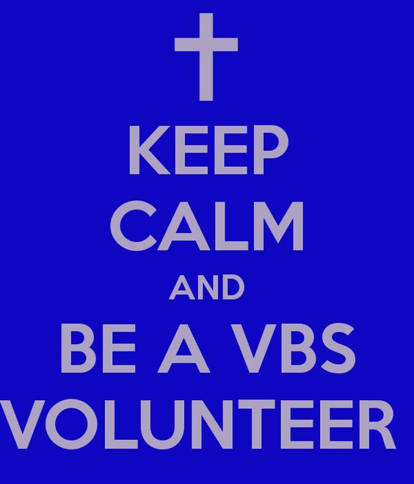

PRAYER REQUESTS
Please pray for the following persons from our prayer cards: the family of Marty Mol, Nelon LaPointe, Scott Holmquist, John Burke, Lisa Wallis, Rochelle Kennedy, Bob Bach, Mona Scharffe, Martha Bell, Ted Stone, Beth Mottsinger, Shirley Maiville, Mary Sikkens, Larry Dodson, Carla Stone, David Canales, Barb and George Lennon, Jon Darrow, Ronnie Cooper, Suzanne Darrow, Tim Zabik, Mary Terrian, Connie Ware’s mom, John Kurtz, DanTassier, Pastor Dave, Kathy Neill, Jennifer Davis, Mary Beth, Benny, Ricki Caswell, Dick Campbell, Nan Keck, Pastor Jerry Tallman, Katie Leach, Carol Fischer, Irene Rasmussen, Jim Rose, Jeanine Clemens, Don Bedell, Katie Darrow, Casey Holsinger, Jodi Prieur, Meredith Cole, Naomi Gomez, Diane Stevens, Katie Roberts, Al Artz, Leslie Sherman, John Delis, youth at Tip of the Mitt, Rick Pauley, Mary Marquis, Theresa Gonzales, Staci Belanger, Chuck Adkins, Bill Nowaske, Sharon Bonter, Adam Greenly, Hailey Williams, Laurel Birk, Adam Cripps, Tillie Frazier, Denice Hansen, Jolene Rogala, Nathan Raboin, Dave Bryers, Jimmy Wilkins, Marilyn Cole, Julie Burnett, Janet Schaefer, Doris Rottschalk, Janice Wallis, Arvella Tenbrink, Mason Brey, Kate Walugembe, and our Military.

Nikki Haneczek

Welcome to Our Service

The Church of the Straits
Covenant Order of Evangelical Presbyterians (ECO)
and
United Methodist
Federated

