WELCOME TO
THE CHURCH OF THE STRAITS
PASTOR DAVID WALLIS

December 24, 2021 Christmas Eve Service 7:00 PM

Prelude

Greeting

*Introit “It Came upon the Midnight Clear” #128

Lighting of the Christ Candle The Prillwitz Family

*Call to Worship
Pastor: Tonight old dreams die and new dreams come to life. The Promise is fulfilled!
People: Glory to God in the highest, and on earth, peace.
Pastor: Hope gives way to joy and prayer to proclamation.
People: Glory to God in the highest, and on earth, peace.
Pastor: Our candles illuminate our story. Dawn invades midnight. The Light of the World has come.
People: Glory to God in the highest, and on earth, peace.
Pastor: And this light is a light for all; igniting a flame within the soul, warming us from within, radiating love, lighting our lives with the presence of God-come-alive in human flesh within us and among us now and always.
People: Glory to God in the highest, and on earth, peace.

Prayer of Thanksgiving

The Lord’s Prayer
Our Father, who art in heaven, hallowed be thy name. Thy kingdom come, thy will be done on earth as it is in heaven. Give
us this day our daily bread. And forgive us our trespasses as we forgive those who trespass against us. And lead us not into temptation, but deliver us from evil. For thine is the kingdom,
and the power, and the glory forever. Amen.

Special Music “What Child Is This?” Les Jackson & Loretta Martinek

Scripture Reading Micah 5:1-5 pg. 922

Christmas Offering Blessing
*Doxology pg. 625

Children’s Special Music “Go, Tell It on the Mountain”
“Down in My Heart”

Time with the Children – A Mini Nativity Message

Nativity in Bethlehem:
Song: “O Holy Night!” vs. 1 & 2 #148
Reading: Luke 2:1-7
Song: “O Little Town of Bethlehem” vs. 1 & 2 #141
Reading: Luke 2:8-12
Song: “While Shepherds Watched Their Flocks” vs. 1 & 4 #135
Reading: Luke 2:13-16

Song: “Angels We Have Heard on High” vs. 1 & 4 #132
Reading: Matthew 2:1-10
Song: “We Three Kings” vs. 1 & 5 #166
Reading: Matthew 2:11-12

Song: “ Joy to the World!” vs. 1 & 4 #125

Candlelighting
For the spreading of the light. As we share the light of our candles we
witness to the Light of God in Jesus Christ. This is the Light which
Darkness cannot overcome! The Pastor will light a candle from the
Christ Candle and then the ushers will bring the light to each row.
Please take the light from the person next to you by tipping your unlit
candle to the candle with the flame next to you. DO NOT TIP A LIT
CANDLE. When all the candles are glowing, we will sing “Silent Night”.
Raise your lit candles high whenever there is any reference to
Jesus’ name.

Extinguishing of the Light
The congregation may exit the Sanctuary with the candles. You may
take the candle with you or place it in the baskets provided at the
door.

Prayer and Blessing
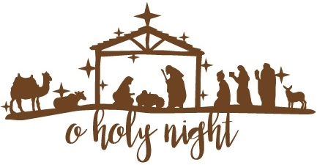

Silent Night

Silent night, holy night, All is calm, all is bright
Round yon virgin mother and Child. Holy infant, so tender and mild,
Sleep in heavenly peace, Sleep in heavenly peace.

Silent night, holy night, Shepherds quake at the sight.
Glories stream from heaven afar, Heavenly hosts sing alleluia;
Christ the Savior is born! Christ the Savior is born!

Silent night, holy night, Son of God, love’s pure light
Radiant beams from Thy holy face, With the dawn of redeeming grace
Jesus, Lord, at Thy birth, Jesus, Lord, at Thy birth.


May the Spirit of Christmas
bring you Peace,
The Gladness of Christmas
give you Hope,
The Warmth of Christmas
grant you Love.

* Christmas Offering Envelopes will go towards Pastor Discretionary Fund for Community Needs.

* If you ordered a poinsettia for the Sanctuary, you may take it home
following the service tonight.

The Church of the Straits
Covenant Order of Evangelical Presbyterians (ECO)
and
United Methodist
Federated
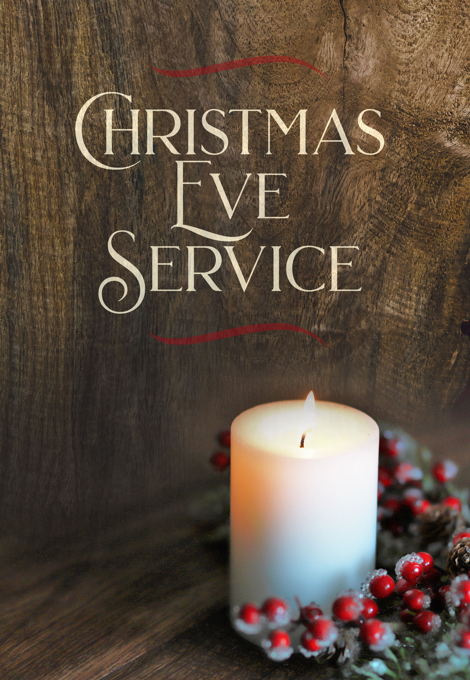

Welcome to Our Worship Service

