

Non-Profit Org.

U.S. Postage

PAID

Mackinaw City

Michigan 49701

Permit No. 1

United Methodist and ECO Presbyterian

**The Church of the Straits**

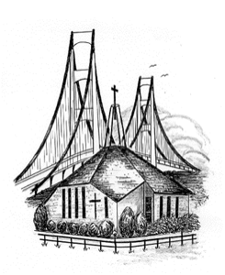

P.O. Box 430 * Mackinaw City, MI 49701

Return Service Requested

James 1:2-4 says, “Consider it pure joy, my brothers and sisters, whenever you face trials of many kinds, because you know that the testing of your faith produces perseverance. Let perseverance finish its work so that you may be mature and complete, not lacking anything.”

**Mike’s Musings**

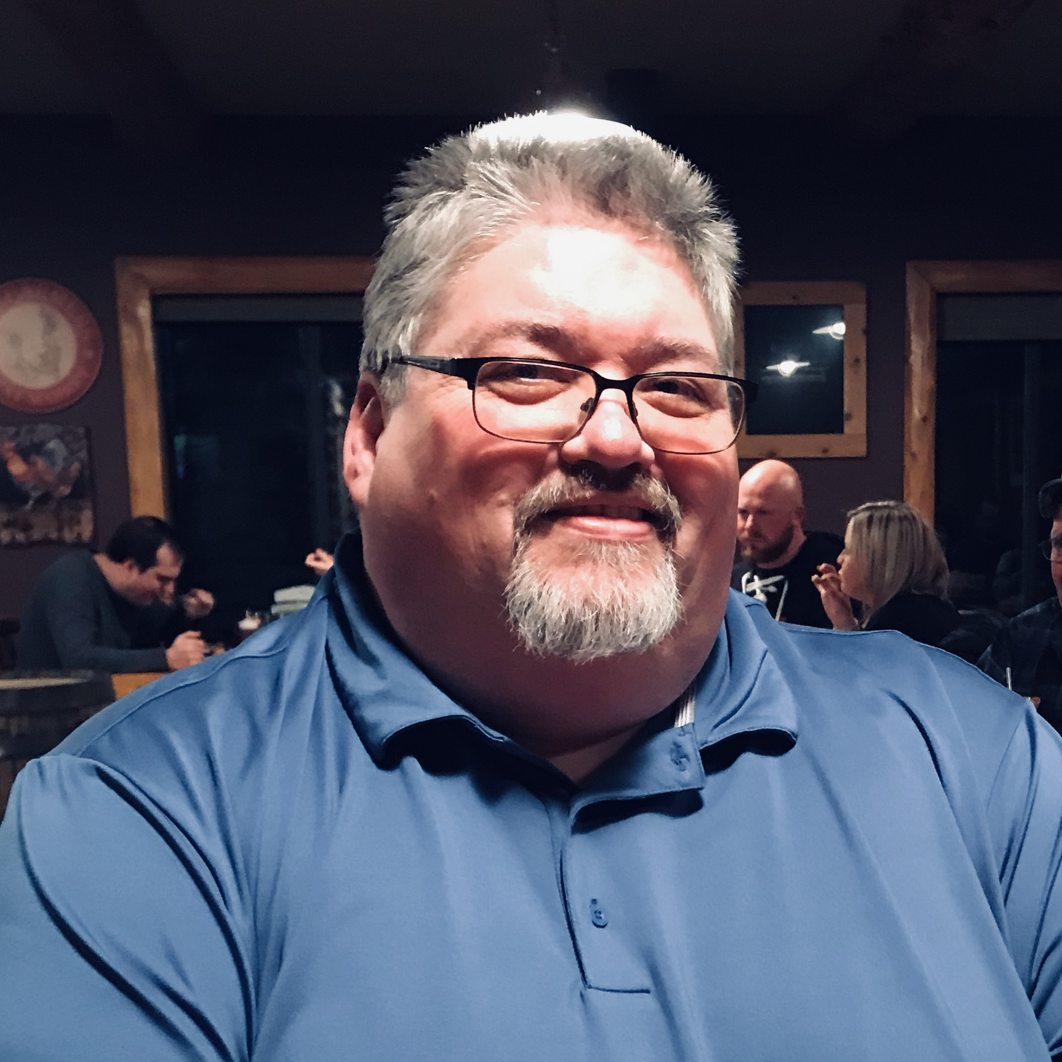

    I have been writing articles for our newsletter for a few years now. Many of you even say they have liked my articles. Writing gives me peace in a somewhat stormy life. Many of you know I suffer from chronic pain. Right now my pain is particularly bad. I could sit and wonder why, but I have chosen to say instead that this is only temporary. As a follower of Jesus, I claim this verse as proof that God is making me more mature through my walk.

    I’m not alone in my suffering though. Across America and the world, people are suffering with death, with disease, with hunger and sickness. My wife Donna says we all have suffering and I do agree with that. Yours may look different than mine does, but it none the less is suffering. I write this article to encourage having a new mindset. One of trust and peace, knowing God is working in your life, and cares for you deeply.  It all comes down to this with any problem you have, either you trust God to get you through whatever trouble you are experiencing or you don’t. I want you to think about your life so far. Have you made it through bad things in your past? What makes you think you won’t get through what you are currently facing? The worst case scenario of life is that we die, but to believers in Jesus, dying means going to heaven to be with our Lord. You can see where I’m going with this. Trust that God will bring you through whatever you are suffering from because God hasn’t failed you yet. He never will either. Can I get an AMEN?



**Please submit any newsletter** articles, pictures, etc. to the office by the 15th of the month for the following month**.** Thanks!

**Please note:** there will be NO Prayer Group or Disciple IV classes on December 27nd or January 3rd. **Adult Sunday School dates to be announced.** All resume on Sunday January 10th. *Enjoy the holidays!*

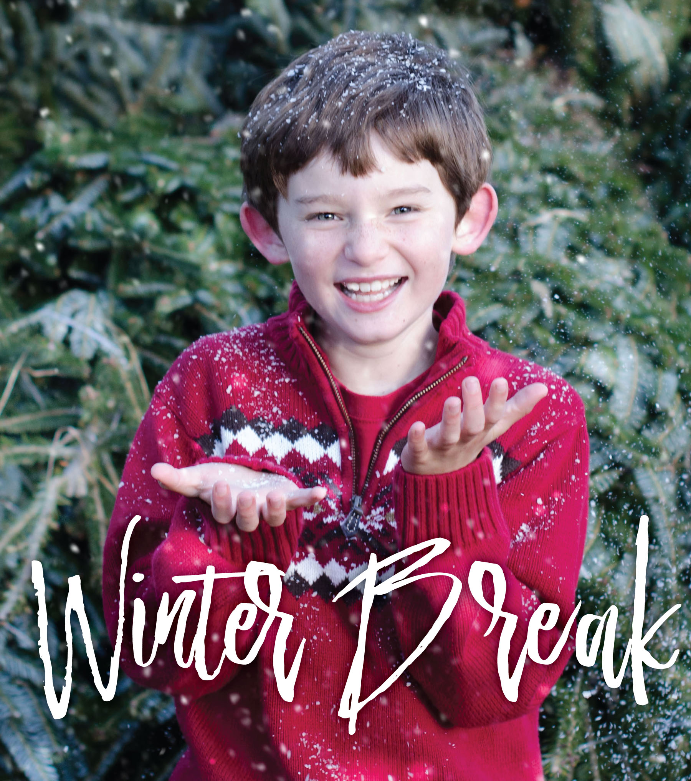

Need transportation to the doctor or the store? Need someone to pick-up prescriptions or groceries? How about minor handyman repairs? Call us, **Ron Illikman 231-445-8482 or Clif Kennedy 231-436-5851.**



We are members of St Anthony’s Catholic Church providing a Christian missionary service. So, if you have a need or just need a little assistance during these difficult times and you live in the Mackinaw/ Carp Lake area, call and we will be happy to meet your needs.

**Operation Shoe Box  
*The Big Packing Party*** was held on Wednesday, November 11th. COS packed 36 boxes with the items donated throughout the year. ***Thank you*** to all who donated and helped with the packing! In all we collected 61 boxes to bless children of the world. Please keep these children in your prayers as boxes are delivered.

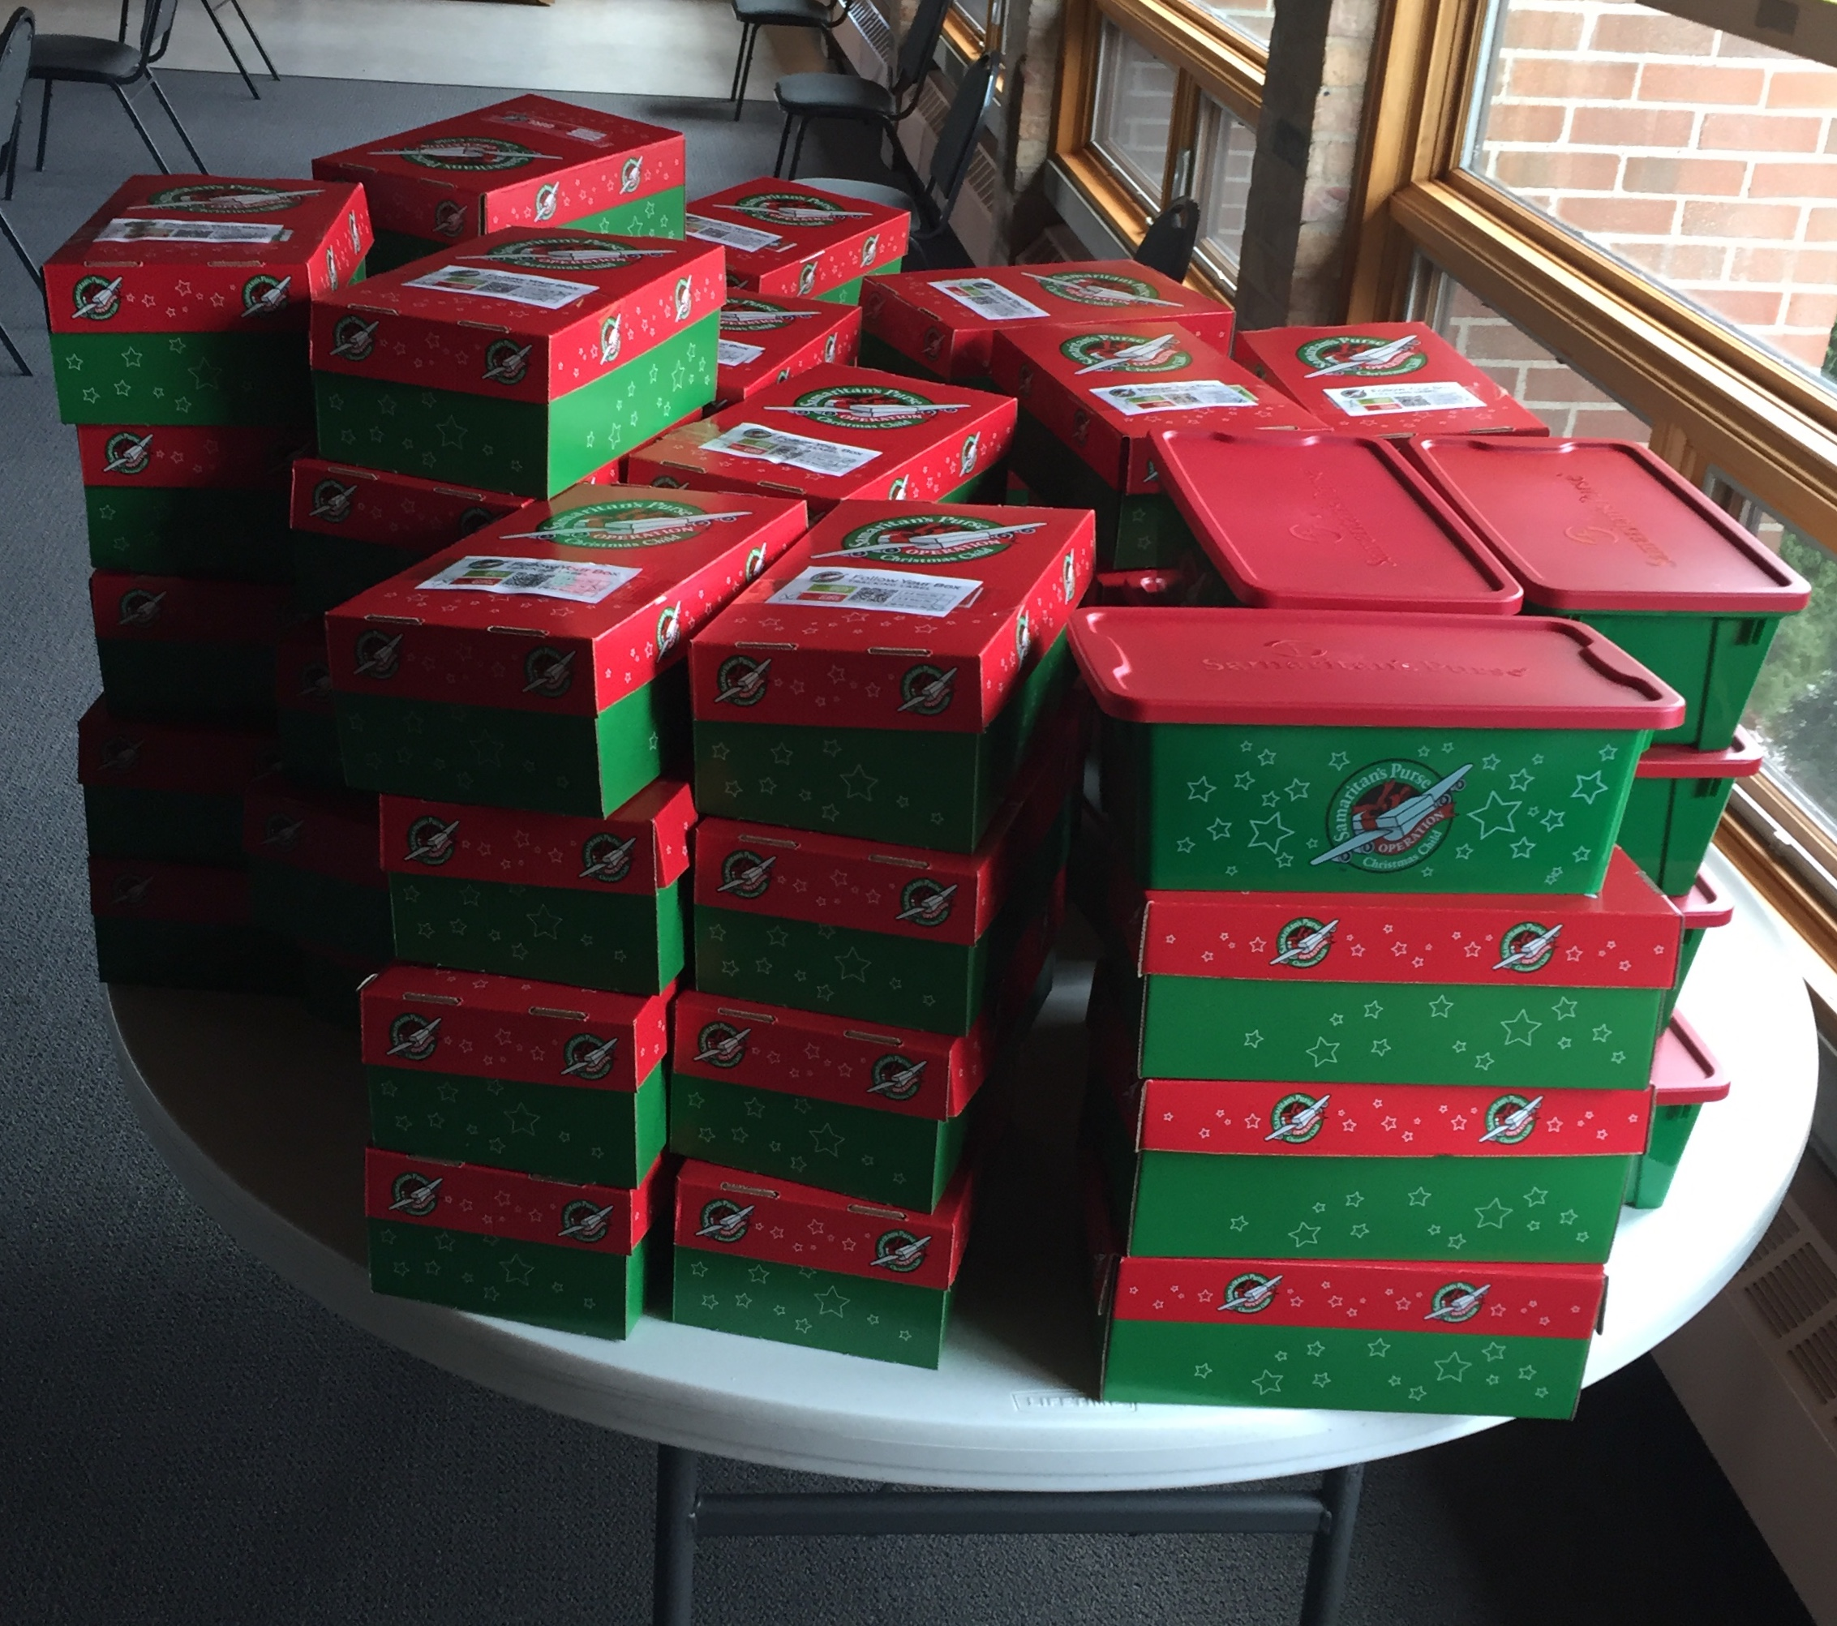

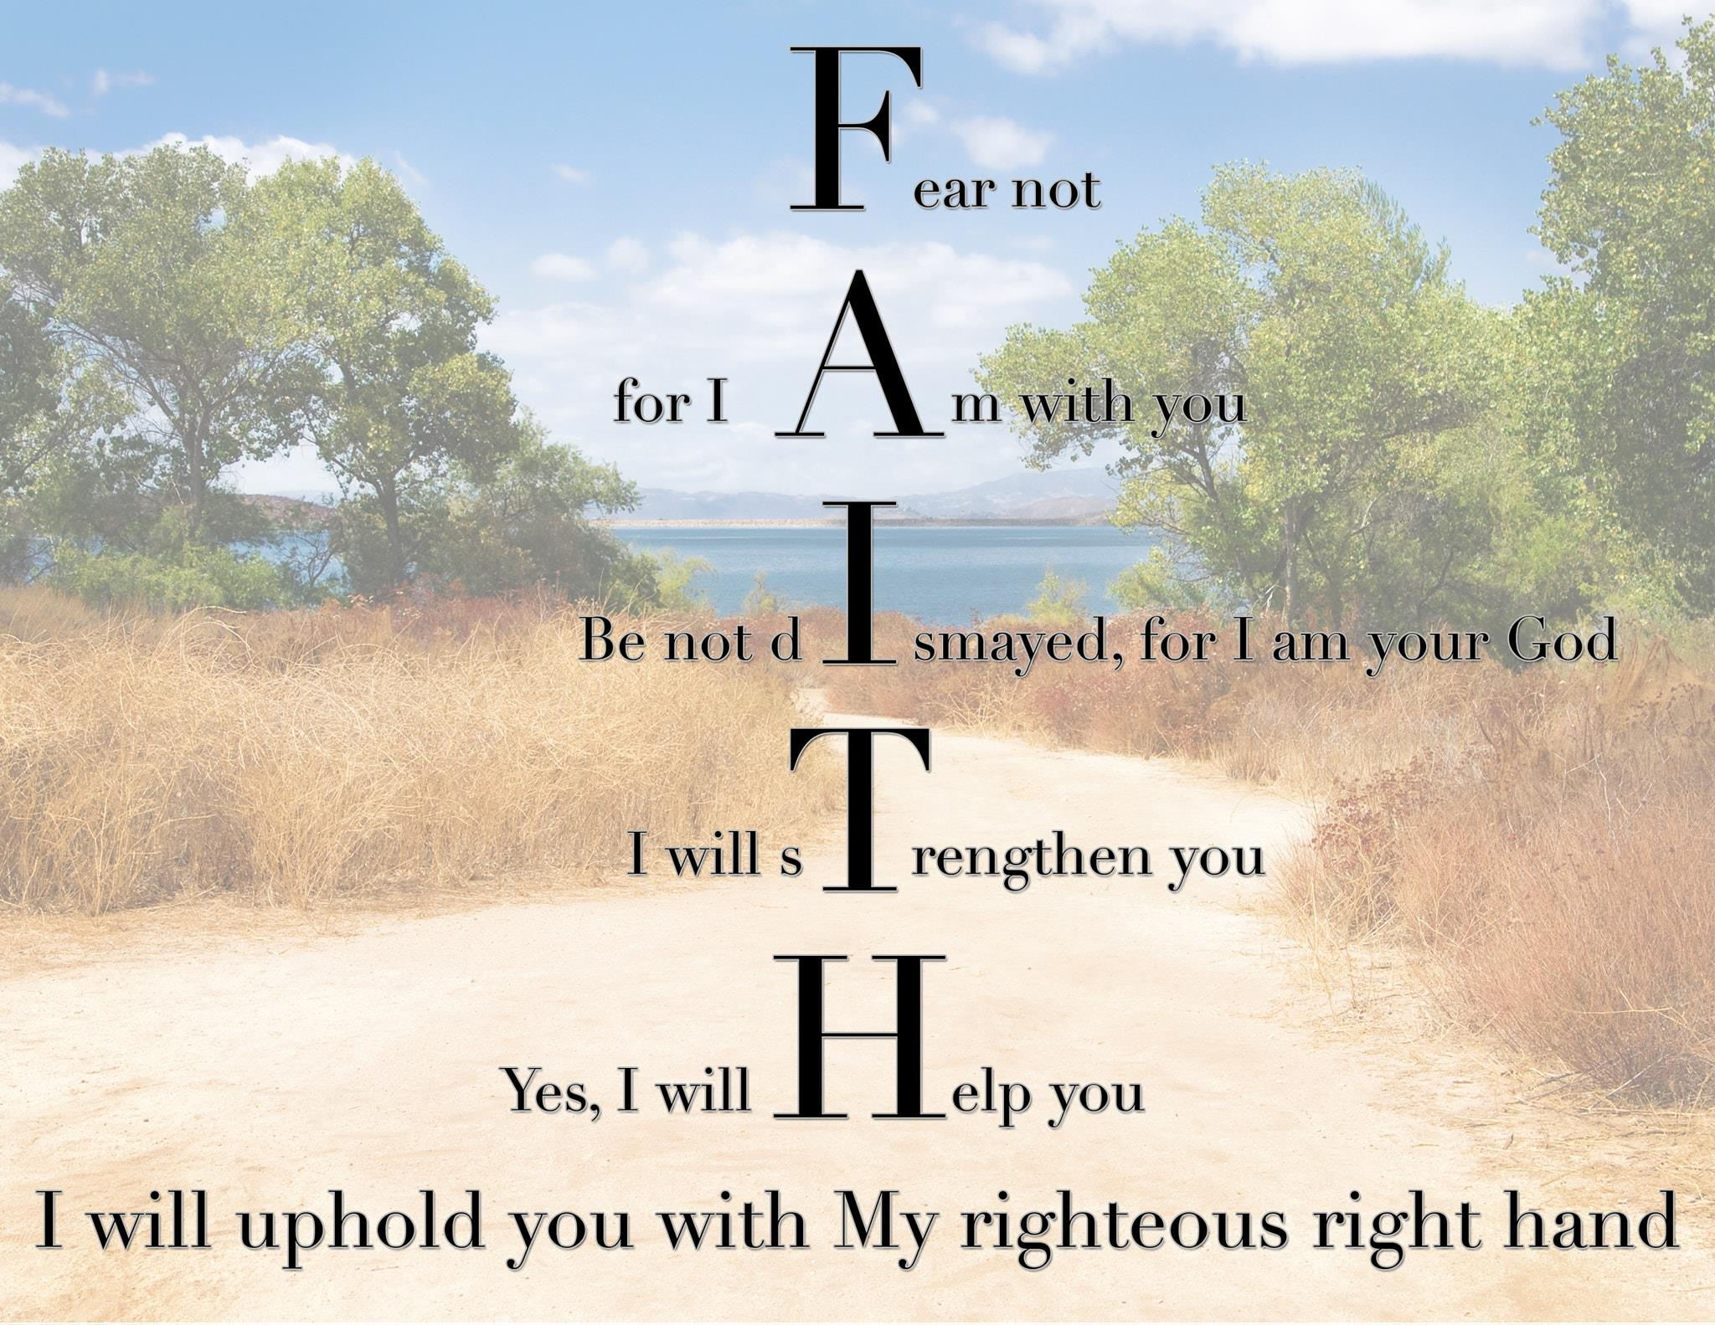

**The Finance Committee** is writing the church budget for 2021. They're placing their trust in God and believing in our members and friends to support the church's ministry. Let us show our faithfulness with good stewardship through our time, talents and treasures. It’s not too late to send in your pledge if you have not done so!

*“Fear not, for I am with you; do not be dismayed,   
 for I am your God!” ~Isaiah 41:10*



Due to covid restrictions this year, the **Annual Parsonage Openhouse** and the **Annual Church Potluck** have been cancelled. But do not let that steal your Joy!



This is the season of sound.

Of bells and carols,

and voices that fill our hearts.

Help me hear them all, Lord.

Amidst the chatter and the news,

the hatred, and the divide,

give me a loving filter

for all the noise of our world.

Help me to listen for the truths   
 of my faith.

I know your love will guide me

to hear what I need to hear.

I know your word will comfort me

through the mayhem.

I know your grace will provide

some welcome silence.

And when the quiet comes,

I promise to stop.

I promise to savor the season.

I promise to celebrate the joy that is   
 Jesus.

And to give you, our Father,   
 all the Glory.

This is my Christmas prayer.

S.A.R.M – Ongoing and Upcoming

We are making the youth room look “youthful”!! This project is really coming along nicely. I invite you to come and check out the progress ☺ A big ‘thank you’ to all of the children and parents that have helped paint and decorate the youth room.

December “Campaign Postcard” is *Celebrate the Reason for the Season,* *the birth of Jesus Christ*.

The second annual *Challenge for Your Soul* is underway. This is a 20-day challenge where the first 10 days you name something that you are thankful for, the second 10 days you name something you are thankful for and something nice you did for someone else. If you don’t meet your daily goal, you owe 25¢ in challenge money. Challenge money donations will go towards Coats for Kids. SARM and The Salvation Army are helping local children stay warm this winter. The need is great and the winters are cold. Please help us help others! If you find it in your heart to donate, please make sure your challenge donations have “SARM coats” on the memo line. There is also a drop box in the Fellowship Hall for **new coats with tags.** All challenge donations must be made before December 12. SARM youth and parents will be shopping for coats on December 13.

God bless you and thank you for supporting SARM. The youth ***need*** this program more than ever!!

Much love and God bless,

Shannon Cooley, Youth Director

If you would like a plant to decorate the Sanctuary for the Christmas season, please fill out the following form. After Christmas Eve, you may take your plant home, or give it away as a gift.

**IN LOVING MEMORY OF:** __________________________________________________________________________________

**IN HONOR OF:**

_________________________________________

_________________________________________

**GIVEN BY:** _________________________________________

Each 6” potted poinsettia is $11.00.

Your order must be in no later than

**Friday December 4th** at the church office.

Please make check payable to Church of the Straits.

Church of the Straits,

P.O. Box 430

Mackinaw City, MI 49701





**Seasons of Hope**

The Christmas message is that there is hope for a ruined humanity – hope of pardon, hope of peace with God, hope of glory – because at the Father’s will Jesus Christ became poor, and was born in a stable so that 30 years later he might hang on a cross.

~ J.I. Packer

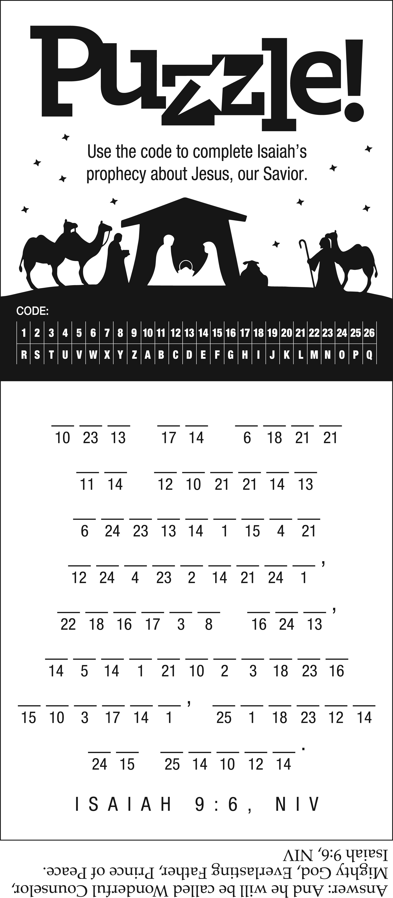

Straits Talk Newsletter  
December 2020



Minister Pastor David Wallis  
 Youth Director Shannon Cooley

Head Ushers Todd Kohs and

Greg Pietrowski

Organist Loretta Martinek

Treasurer Donna Falor  
 Financial Secretary Cathy Brey

Clerk Laura Jackson

Secretary Judy Churchill

Office Phone: 231 436-8682

Pastor’s Home Phone: 231 436-5484

E-mail – Pastor – [davidloveslisa87@gmail.com](mailto:davidloveslisa87@gmail.com)

Church office – [cotsoffice@yahoo.com](mailto:cotsoffice@yahoo.com)

Church website – [www.thechurchofthestraits.com](http://www.thechurchofthestraits.com)

The Mission of The Church of the Straits  
To worship God faithfully  
To grow together spiritually

To serve Jesus Christ and

our neighbor joyfully

…in the power of God’s Spirit.

**OUR WORSHIP SCHEDULE**

Traditional Worship 10:30 a.m.

Adult/Youth Sunday School 9:30 a.m.

Christmas Eve Service 7:00 p.m.

* * * * * * * * * * * * * * * * * * * * * * * * * * * * * * * * * *

Dear Church Family, 2020

As another year comes to an end, we look back at 2020! It’s been a very different year. We have ventured through a lot this year but it’s such a joy to   
know that God is with us no matter what.

We want you to know how much we love all of you. We have missed being able to worship with all of you and miss the Sunday morning hugs. We pray that each of you feel the presence of our Lord and Savior as we celebrate his birth. What an awesome gift that fills our hearts with hope, love and joy. May we all share the gift of God’s love as we embark on 2021.



From our Home to yours,

Merry Christmas!!

We love you!

Hugs, Pastor Dave and Lisa