

Non-Profit Org.

U.S. Postage

PAID

Mackinaw City

Michigan 49701

Permit No. 1

United Methodist and ECO Presbyterian

**The Church of the Straits**

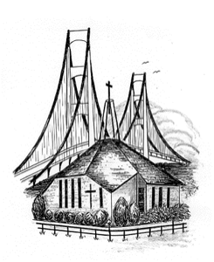

P.O. Box 430 * Mackinaw City, MI 49701

Return Service Requested

Sometimes I sit and listen to a sermon and BAM I feel the Holy Spirit speaking to me about my life. It isn’t condemnation, it is conviction. Sometimes it is something I knew I had been doing wrong, other times it was something I didn’t know I needed to correct. I’m sure you all have had those moments.

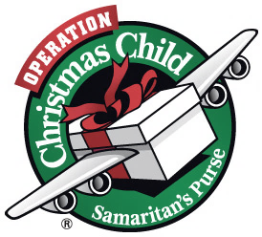

**Mike’s Musings**

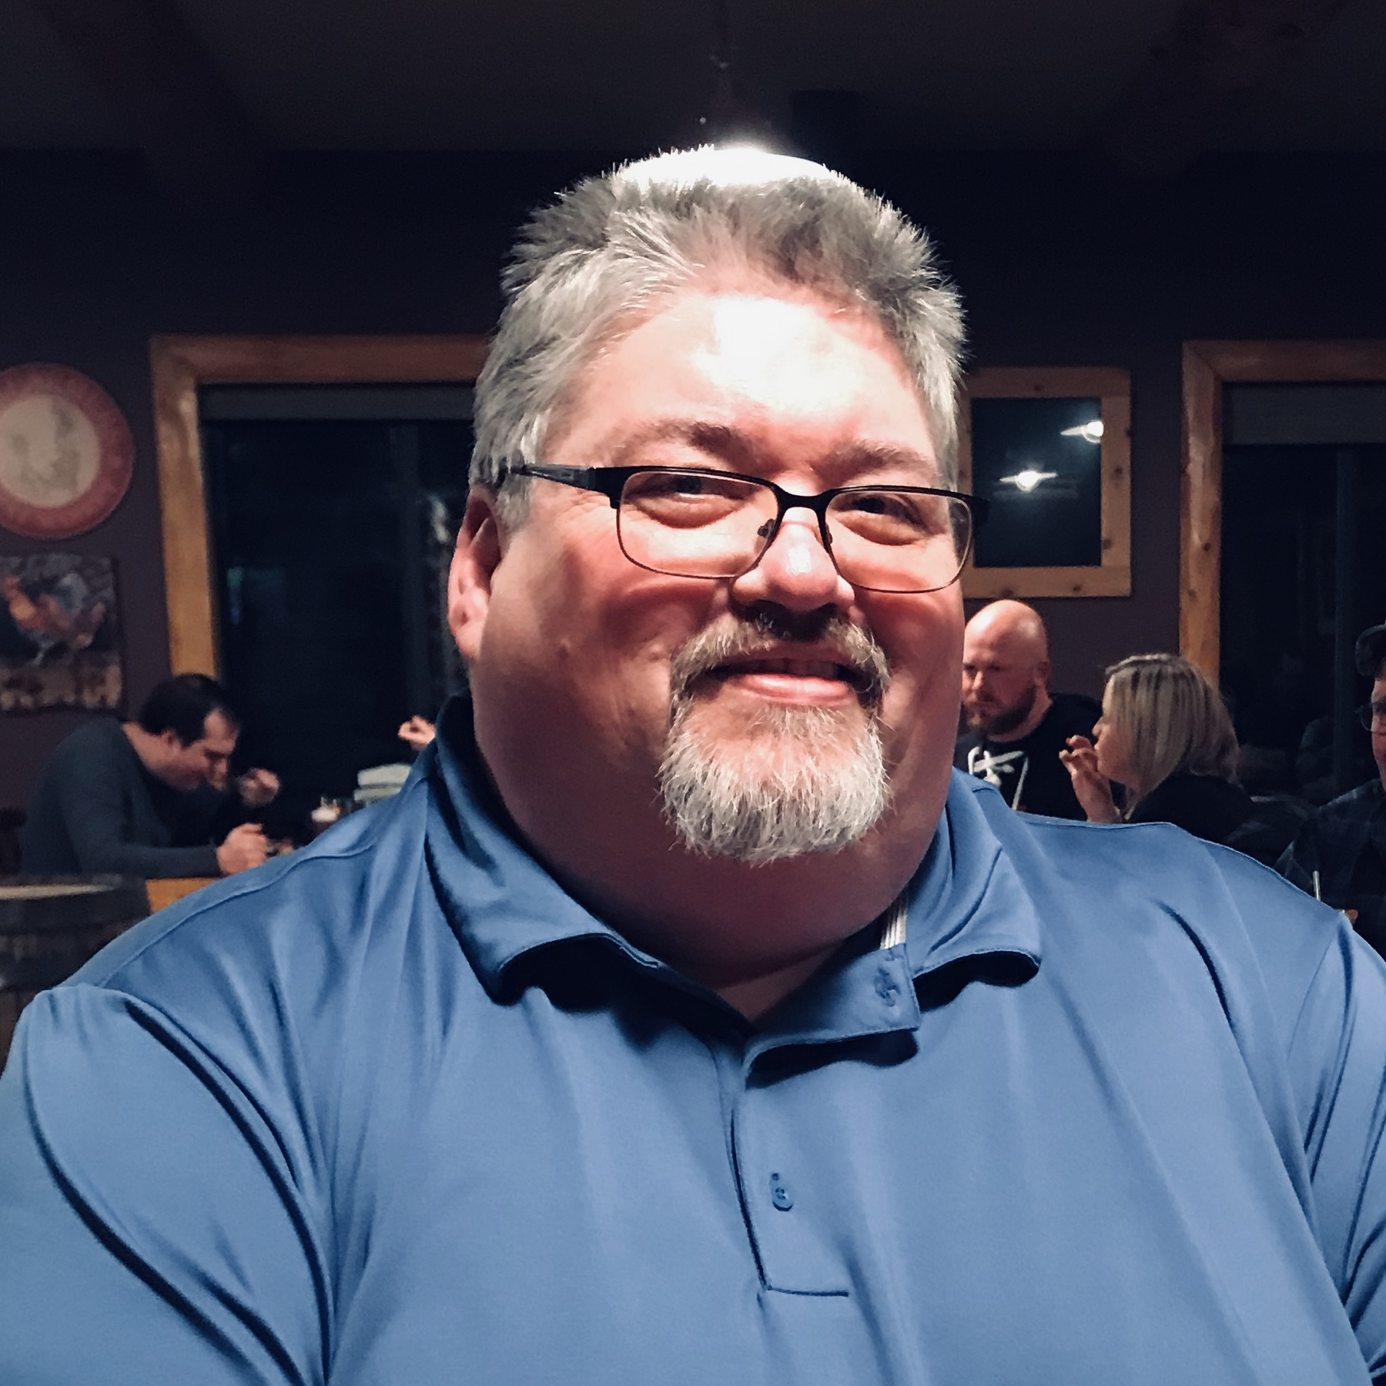

    As we grow in our Christian faith God reveals more to us. Many people who don’t know Christ think we have a set of rules that we live by, but that is far from what God intends for us. The things God wants for us is to stay away from things that will bring harm to us, whether that is physical harm or spiritual harm. You see in Peter 5:8 it says, “Be alert and of sober mind. Your enemy the devil prowls around like a roaring lion looking for someone to devour.” God wants to keep us from having this happen. Mathew 26:41 says, “Watch and pray so that you will not fall into temptation. The spirit is willing, but the flesh is weak.”

    I used to think that this meant I had to work harder to make my life right, but it doesn’t! It means I have to turn this part of my life over to God and let Him do the work. You and I are powerless to do battle on our own. It took me a lot of years of falling flat on my face to realize this fact, God doesn’t intend for us do it alone and yet many times we think we can. Jesus said in Matthew 11:29, “Take my yoke upon you and learn from me, for I am gentle and humble in heart, and you will find rest for your soul.” So how do we learn from Him? We must spend time studying His word. Paul also said in Philippians 4:6, “Do not be anxious about anything, but in every situation, by prayer and petition, with thanksgiving, present your requests to God.”

    So if you are struggling with sin or your problems are overwhelming you, give it all to God. He wants only good things for you. The world doesn’t understand this. Trust in the Lord and you won’t be disappointed.



**Please, please** let the church office know when you leave Mackinaw City for your ‘winter home’. Newsletters are returned and the church is charged for return postage costs. We want to stay connected to you and hope you feel the same way. Thank you!



**Due to continuing need, the** Food Pantry will be open **EVERY OTHER WEEK** on Wednesdays at 10am. October dates are the 14th, and 28th.

The Food Pantry is in desperate need of folks to help pack and distribute the food on Wednesday mornings. If you are interested in this wonderful ministry, please be at the church by 9:00 am on Food Pantry days.

**Operation Shoe Box**Packing month is coming! Get your donations in – thank you!   
Any shoebox item is welcome!  
*Games, small puzzles, little Etch-a-Sketch, marbles, etc!!*

Watch for the Packing Party Announcement in the next newsletter. Also, there will be boxes in Fellowship Hall if you want to pack your own box!

Boxes are due back no later than Thursday, November 19th. There is suggested donation of $9 per box. This donation is critical for Operation Christmas Child to collect, process, and ship shoebox gifts to more than 100 countries. It also provides for ministry materials such as The Greatest Gift Gospel Booklet and The Ministry Partner Guide.



**Dear Church of the Straits,**

We want to extend our sincerest thank you to the church, it’s members and the community for your generous donation of shoes to Sole Searching for Jamaican School Kids. Your donations will make a huge difference to the children in Jamaica. So far we have collected over 380 pairs of shoes and we couldn’t have done it without your help!

Donations will be delivered to Jamaica in October, 2020. Again, thank you for your support and we look forward to working with you next season. May our Heavenly Father continue to bless you.

Sincerely,   
David Brown, founder  
Sole Searching for Jamaican School Kids

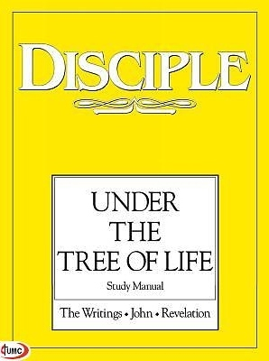

**Pastor Dave’s Disciple IV  
Class** will begin Sunday,   
October 4th at 6:00 p.m.  
Lesson 17 should be completed  
by the start of the class. *Anyone* is welcome to join in, even if you haven’t taken Disciple I, II or III. Call the office for a book!



**Please update your directory** Ken and Kristi Laninga no longer have a Mackinaw PO Box.   
Please use:  
 2838 W US 23   
 Cheboygan, MI 49721





We extend our sympathy to the families of those who have entered the Church Triumphant:

Bob Bonter (Karen Krueger’s son), who passed   
 away August 29, 2020.

Rochelle Kennedy, who passed away August 31,   
 2020.

Laurel Birk, who passed away September 1, 2020.

Jolene Rogala, who passed away September 7,   
 2020.

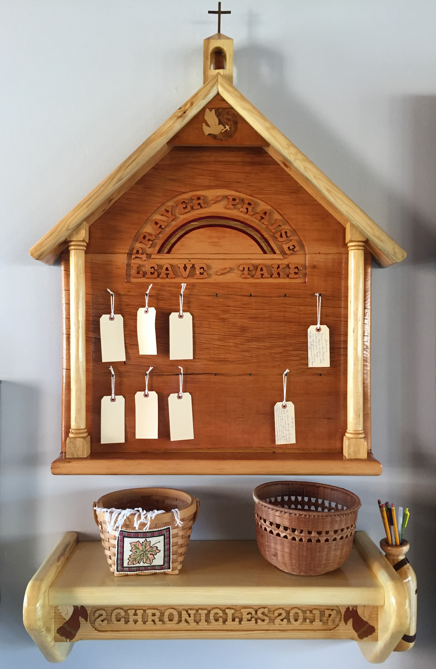

**New Prayer Board**

The next time you are in Fellowship Hall, take a look at our beautiful new Prayer Board, just to the right of the drinking fountain. A vision from Rose LaPointe, and brought to life by our master wood-worker, Carl Strieby. Feel free to leave a prayer request, or take a prayer card to pray over. Prayers can be signed or anonymous.

Greetings from S.A.R.M.!

S.A.R.M. is starting “Campaign Postcard”. At the beginning of each month, youth will receive a package with the theme of the month and materials to create a one-of-a-kind postcard. Also enclosed will be a stamped addressed return envelope to send the finished postcards back to SARM. Postcards will be due back when they are finished or no later than the first of each month.

The goal of “Campaign Postcard” is to spread the Word of God and thank people that sacrifice their time to help others in the community. To reach out to people that might need to know someone cares for them. Each month will be a different theme – Police, Nurses, First Responders, the Elderly, Sick Children, Veterans, Children with Disabilities – the possibilities are endless! There will also be a coordinating Bible verse to go along with the theme. If kids have a suggestion for an organization or group, they can send it along with their postcards when they return them.

This will be an ongoing project and SARM is going to try and touch as many people as possible with the Word of God.

If you have children or grandchildren who would like to participate, call Shannon at 231-818-9467, or email at:  
cooleyshannon46@gmail.com. Children do not have to attend here at COS. They could be anywhere in the country as this is a “through the mail” project! This project is going to be a lot of fun!

Blessings,

Shannon Cooley, Youth Director

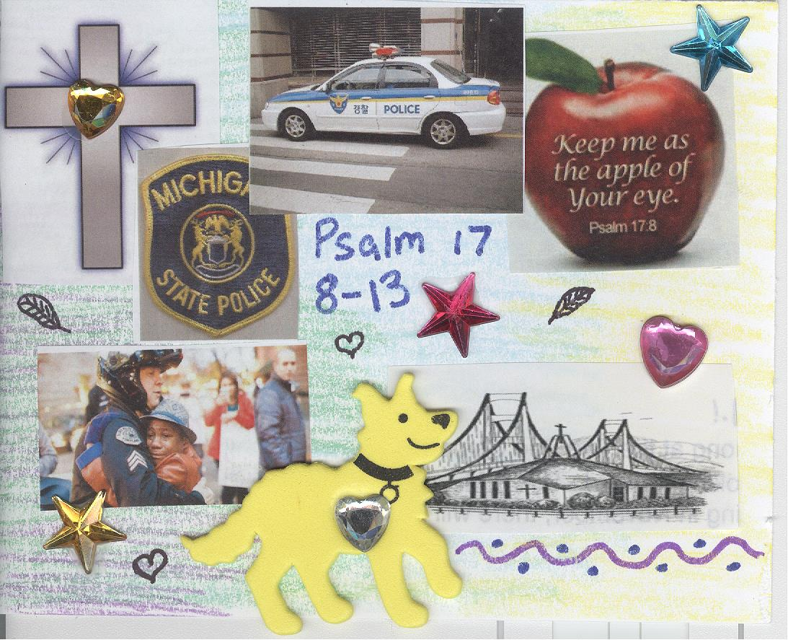

**A Singular Focus** When we try to focus on too many things at once, sometimes we end up doing nothing well. During a visit to their house (see Luke 10:38-42), Jesus tells Martha that only one thing is needed and that Mary has chosen rightly. Surely Jesus doesn’t mean that quiet devotion is needed while serving others is not. But when we let ourselves get “worried and distracted by many things,” we may lose sight of the one crucial thing: love.  
 St. Francis is credited with the following quote: “God came to my house and asked for charity. And I fell on my knees and cried, ‘Beloved, what may I give?’ ‘Just love,’ God said. ‘Just love.’”  
 And in Galatians 5:6 (NRSV), St. Paul writes, “For in Christ Jesus … the only thing that counts is faith working through love.” Amid all the worthy pursuits that fill your days, remember to choose rightly — by choosing love.



“Nothing [is] more truly artistic than to love people.” ~Vincent Van Gogh

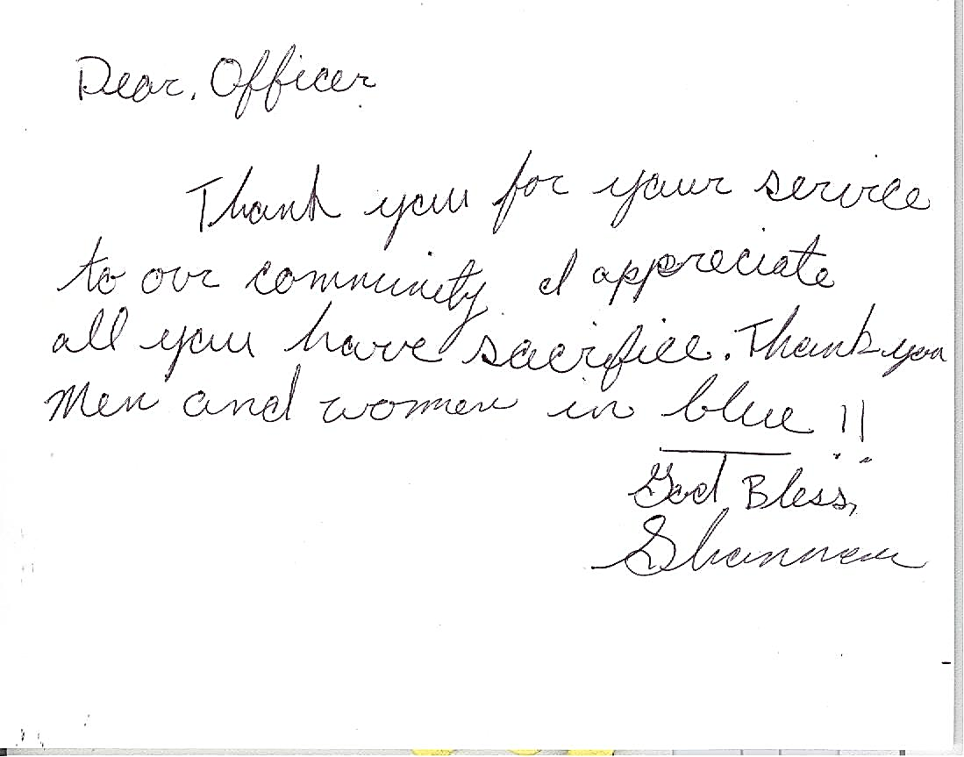

Straits Talk Newsletter  
October 2020



Minister Pastor David Wallis  
 Youth Director Shannon Cooley

Head Ushers Todd Kohs and

Greg Pietrowski

Organist Loretta Martinek

Treasurer Donna Falor  
 Financial Secretary Cathy Brey

Clerk Laura Jackson

Secretary Judy Churchill

Office Phone: 231 436-8682

Pastor’s Home Phone: 231 436-5484

E-mail – Pastor – [davidloveslisa87@gmail.com](mailto:davidloveslisa87@gmail.com)

Church office – [cotsoffice@yahoo.com](mailto:cotsoffice@yahoo.com)

Church website – [www.thechurchofthestraits.com](http://www.thechurchofthestraits.com)

The Mission of The Church of the Straits  
To worship God faithfully  
To grow together spiritually

To serve Jesus Christ and

our neighbor joyfully

…in the power of God’s Spirit.

**OUR WORSHIP SCHEDULE**

Traditional Worship 10:30 a.m.

Adult/Youth Sunday School 9:30 a.m.

Bible Quiz Answer: A (See Matthew 7:2-27)

* * * * * * * * * * * * * * * * * * * * * * * * * * * * * * * * * *

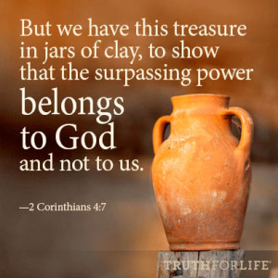

You know what? I feel very blessed living where I do in good ole Northern Michigan. We don’t have to deal with the hurricanes down south, the massive wildfires out west, tornados in the midwest, or even earthquakes. Yes, we have snow in the winter but really, we are very fortunate. That being said, I do pray for those who are dealing with natural disasters even now. Our son’s brother in law had quite a bit of damage to his property and building during the most recent hurricane so it does hit somewhat close to home, so to speak.

We may not have to deal with those kind of macro disasters, but we do have to deal with difficulties in our own lives from time to time. Sometimes they personally feel more disastrous then a hurricane or tornado. The loss of a loved one or a terrible cancer diagnosis can just crush us, but I want to share with you how it doesn’t have to keep us in distress forever.

Let me share with you a text from Paul (one who truly knew tough times – see 2 Corinthians 5:3-10) in 2 Cor. 4:7-10, *“But we have this treasure in jars of clay to show that this all surpassing power is from God and not from us. We are hard pressed on every side, but not crushed; perplexed, but not in despair; persecuted, but not abandoned; struck down, but not destroyed. We always carry around in our body the death of Jesus, so that the life of Jesus may also be revealed in our body.”* Now, much of what Paul is talking about here is persecution for our faith but what also emanates from this is that when we are struggling with anything that gets us down and affects our faith, we can get through it. God’s power is sufficient. Jesus can relate. We can have victory and show the power of God not only in death but in life and living.

Paul does not mince words. We are hard pressed, perplexed, persecuted and struck down, but we are not defeated. Jesus took care of the ugly stuff. He paid the price for our own sin. He shows us the way through and out of our difficult situations and promises us that in the end, we will have victory.

Do not be so enamored with your difficult circumstances that you won’t allow God to walk you through it. What you may be going through is nothing that surprises or overwhelms God. He’s got it if you will give it to him.

That all being said, the hurricanes and wildfires that come and go in our life won’t be nearly as monumental when we are going through them with Jesus. That is exactly what I have found in my life.

God Bless each and every one of you,

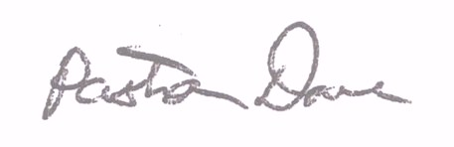

Pastor Dave