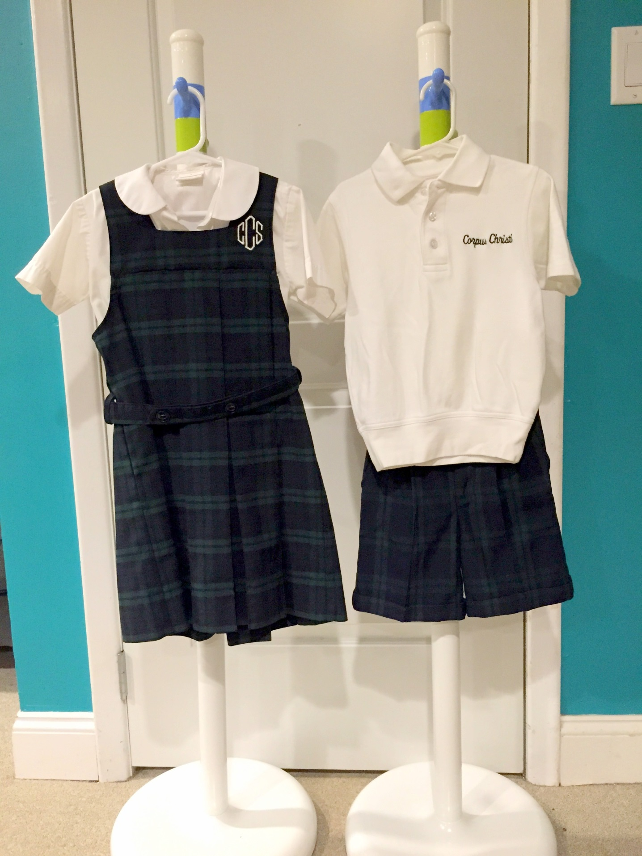
Summer Uniforms: Girls K-4
White Peter Pan Short Sleeve Blouse, CCS Jumper, with navy blue knee/crew socks or
CCS white embroidered golf shirt, plaid walking shorts, dark belt with blue crew or knee socks.
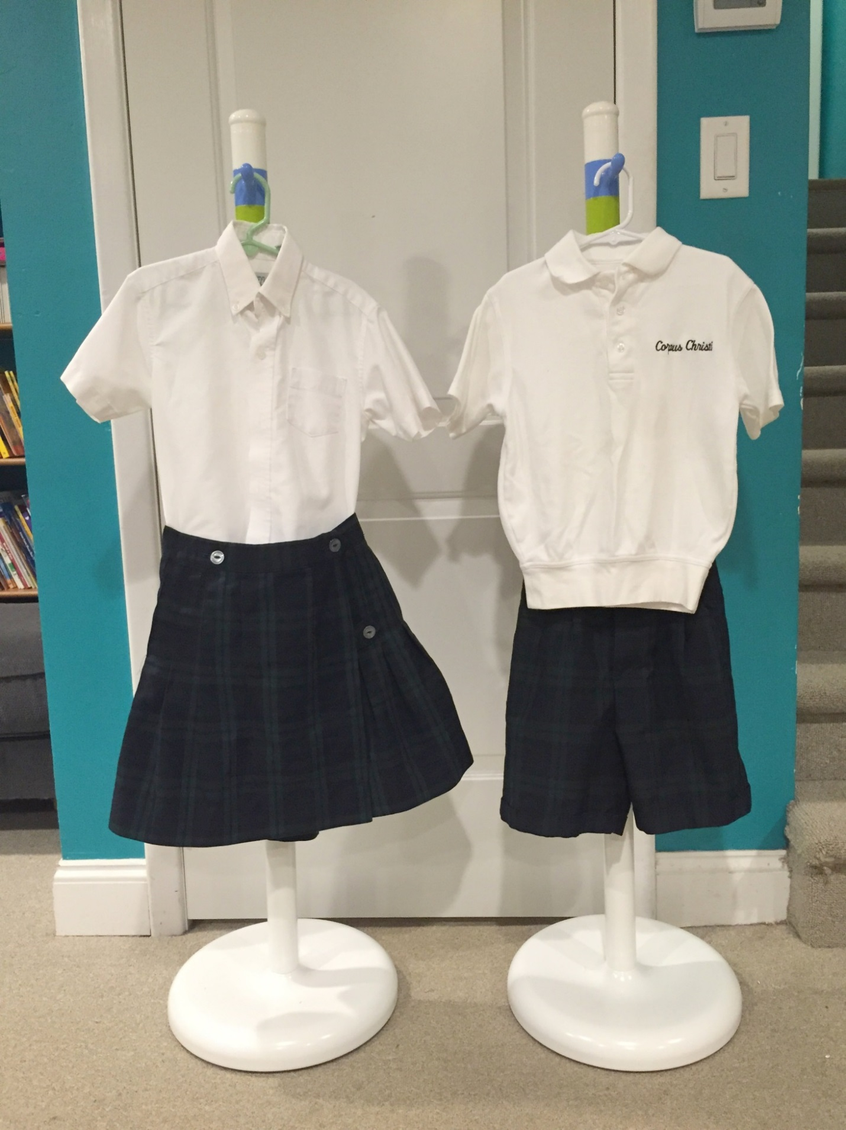
Summer Uniforms: Girls 5-8
CCS white embroidered golf shirt or white oxford blouse, plaid kilt with navy knee/crew socks or Walking shorts, CCS white embroidered golf shirt or oxford cloth blouse with navy blue crew/knee socks.
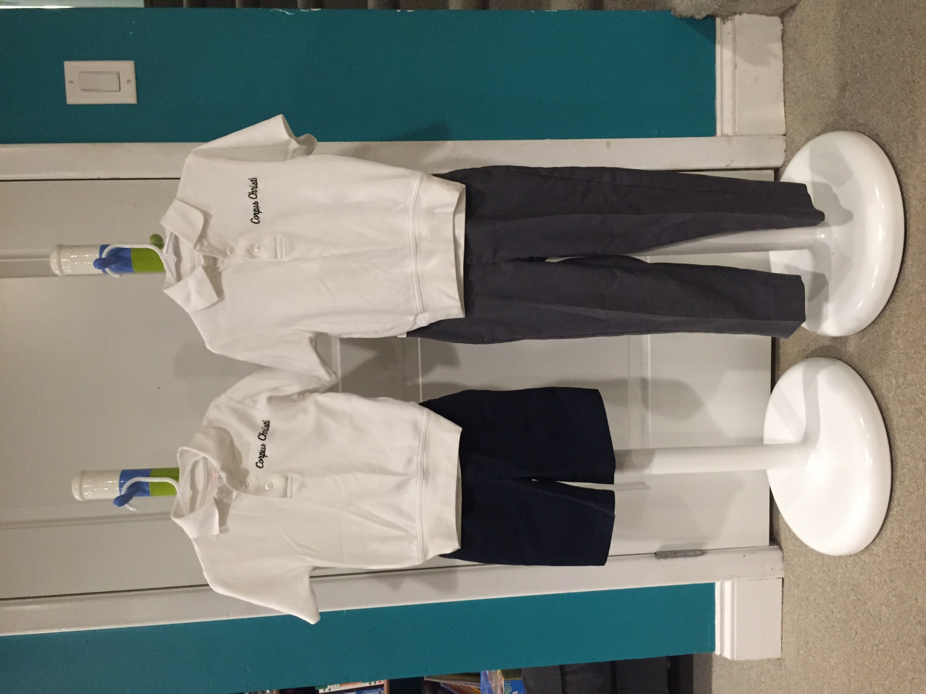
Summer Uniforms: Boys K-8
Navy walking shorts or gray dress slacks with a CCS white embroidered golf shirt, dark belt and white or dark socks with shorts & dark socks with grey dress slacks.
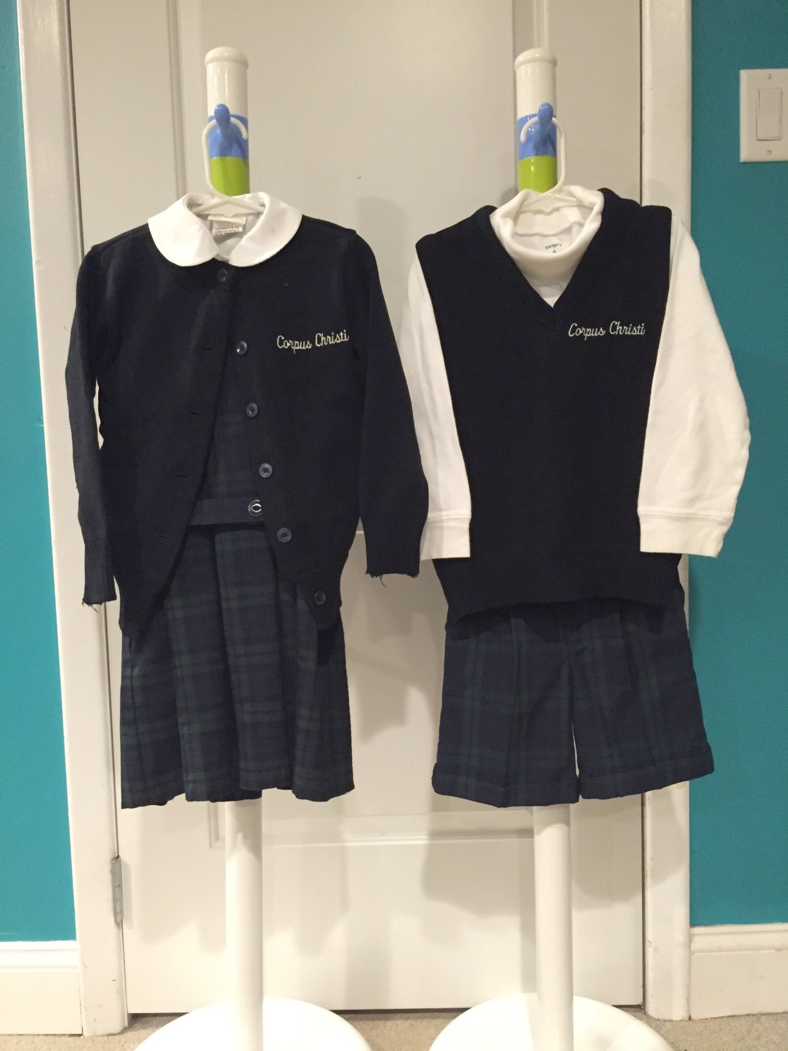
Winter Uniforms: Girls – K-4
CCS Jumper with a Peter Pan collared blouse (or white turtleneck), a CCS navy cardigan sweater with navy blue tights or navy knee socks; or
White turtleneck with a CCS navy sweater vest, plaid walking shorts, dark belt & navy blue tights or knee socks.
Not pictured: Navy blue uniform long pants purchased from Flynn and O’Hara can be worn.
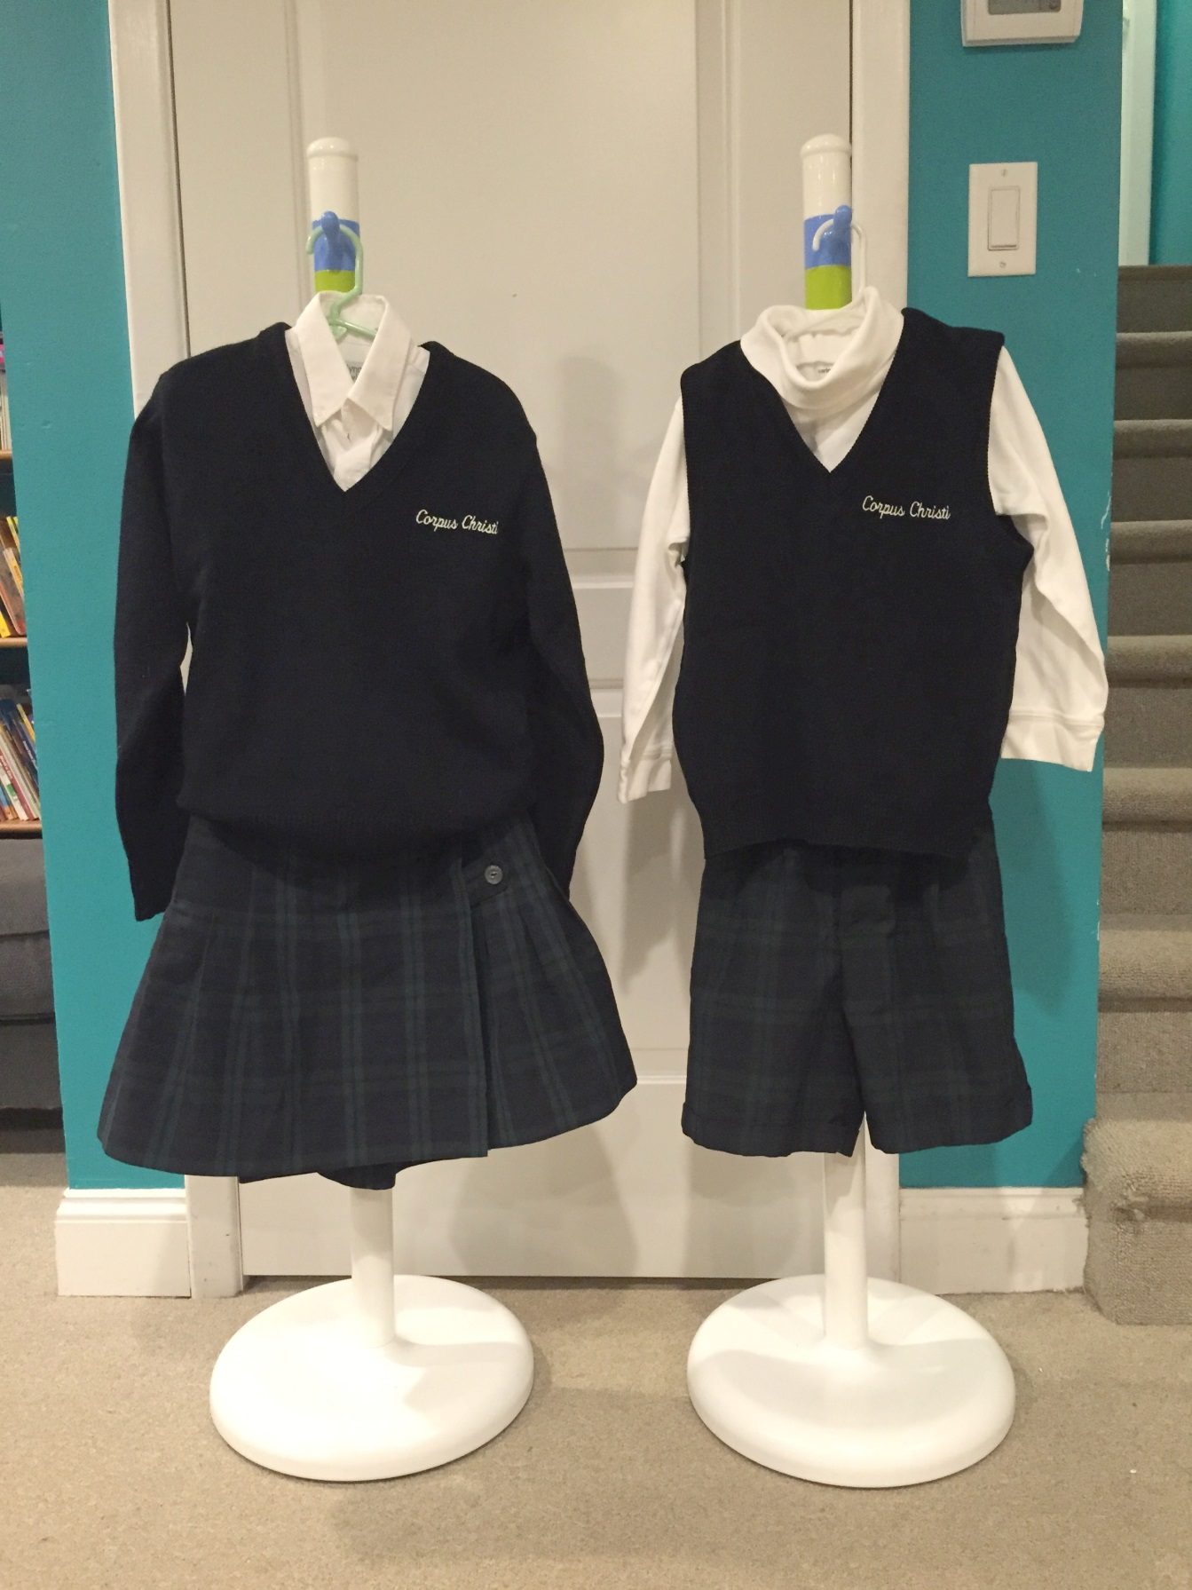
Winter Uniforms: Girls 5-8
Plaid kilt or walking shorts, a white oxford blouse (or white turtleneck), with CCS navy sweater or sweater vest, navy blue tights or knee socks.
Not pictured: Navy blue uniform long pants purchased from Flynn and O’Hara can be worn.
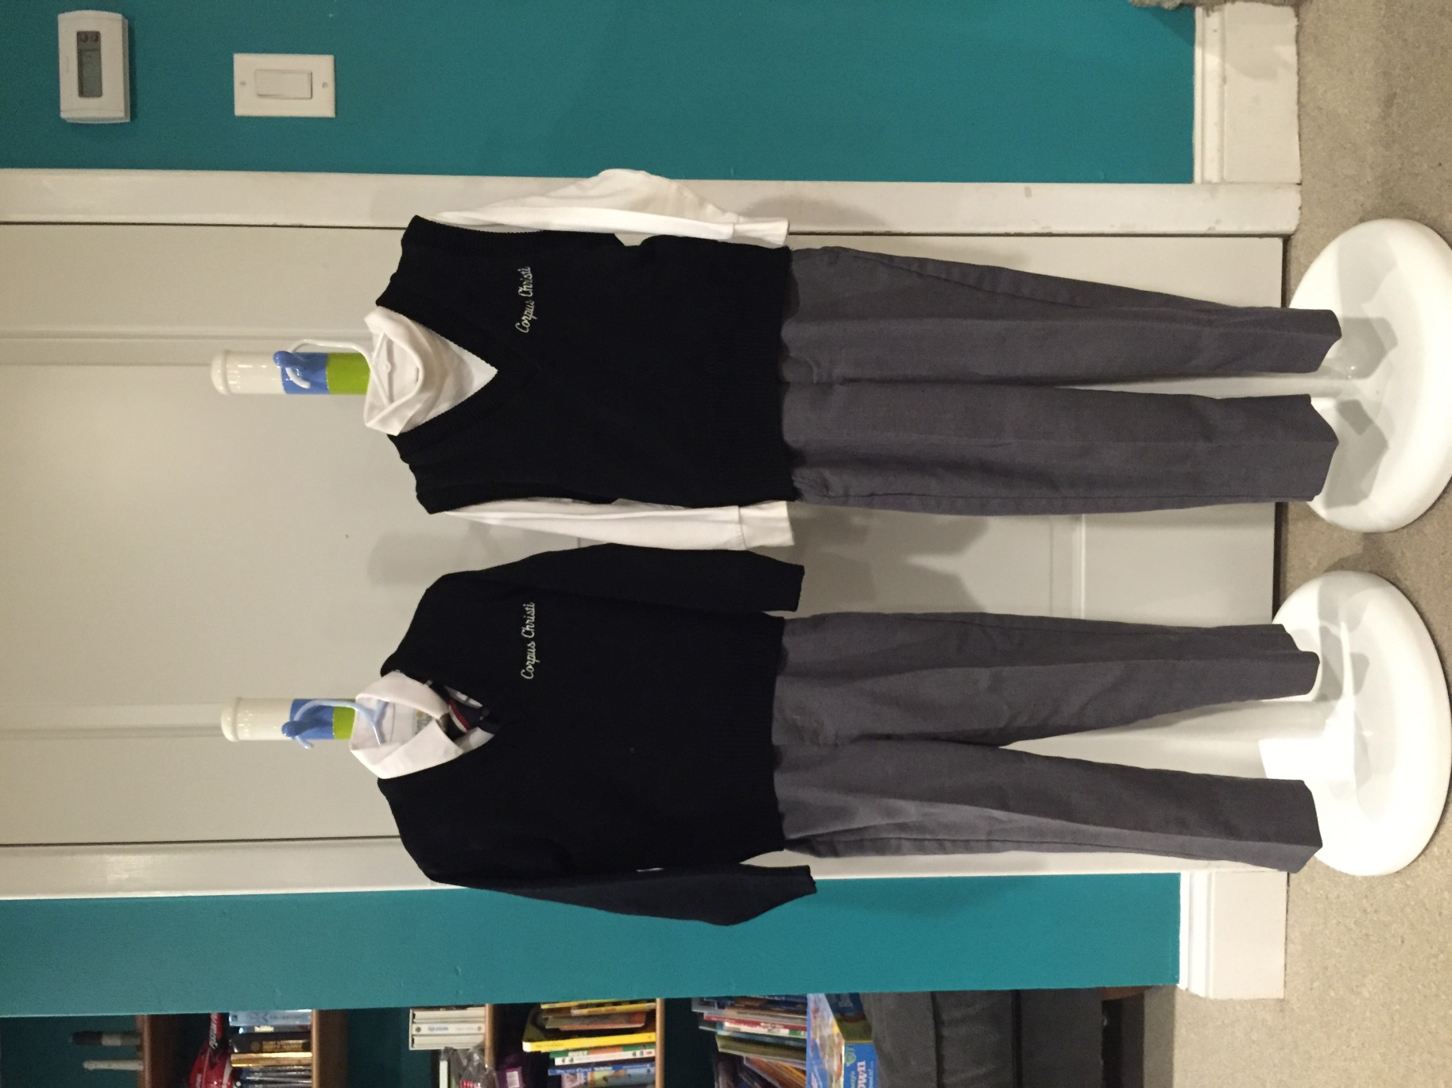
Winter Uniforms: Boys – K-8
Gray dress slacks with white oxford shirt and school tie or white turtleneck. A CCS navy sweater or CCS navy sweater vest must also be worn as part of the winter uniform. Dark socks are required.
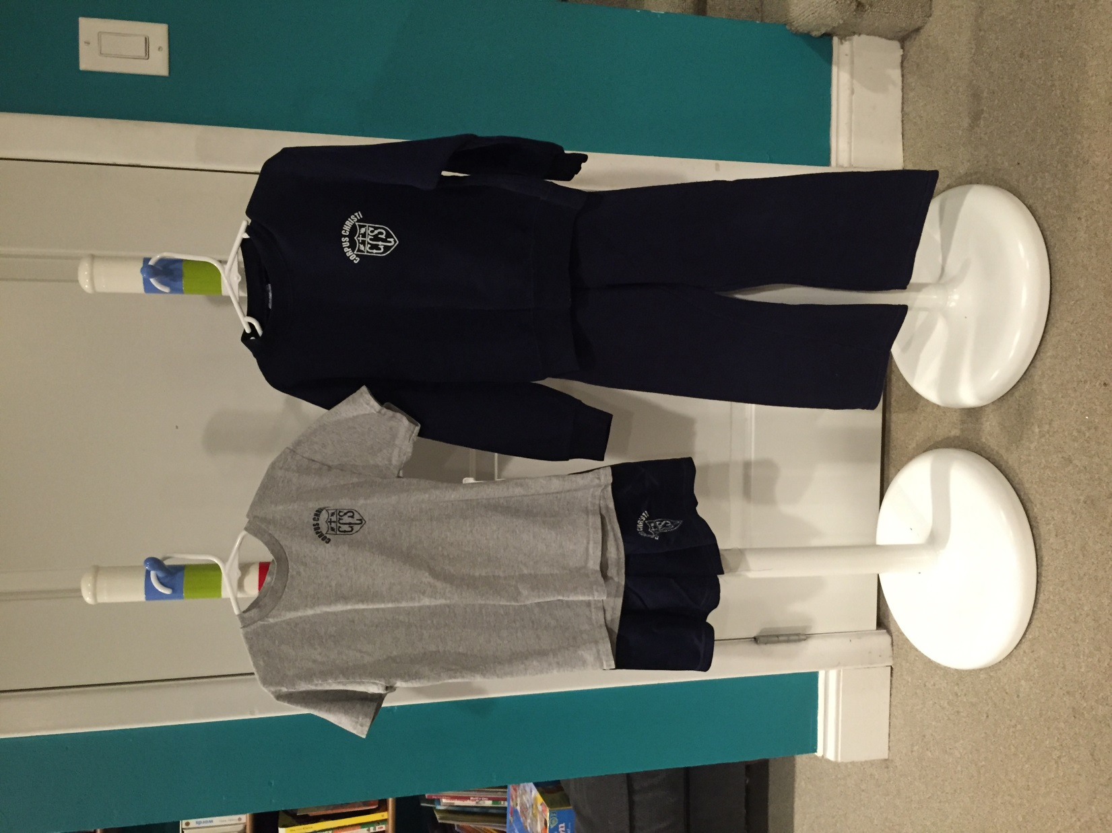
Gym Uniform: All students – K-8
Either a white banded golf shirt or gray tee shirt with the school emblem, navy mesh shorts in summer (shorts must be plain, dark navy with no stripes/markings and NO brand labels visible of any type), CCS sweatshirt, navy sweatpants in winter (must be plain with no stripes/markings and NO brand labels visible of any type), white socks and sneakers.

