https://www.scottsdaleindependent.com/news/teen-soccer-player-organizes-scottsdale-equipment-donation/

Pass It On: Teen soccer player organizes equipment donation
Oct 15th, 2018 · by Scottsdale Independent · Comments: 0
Wade Crum, Founder Of Pass It On, Organized A Donation Of Soccer Equipment. (Independent Newsmedia/Arianna Grainey)
- 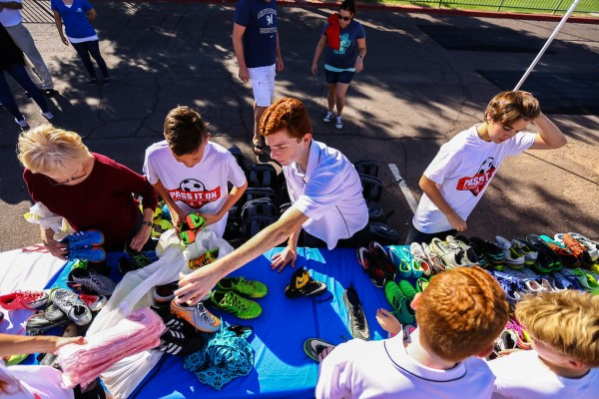
Tyler Crum Pictured Passing Some Items On Oct. 12. (Independent Newsmedia/Arianna Grainey)
Children Play With New Soccer Equipment Oct. 12 (Independent Newsmedia/Arianna Grainey)
Children Play With New Soccer Equipment Oct. 12 (Independent Newsmedia/Arianna Grainey)
Pass It On Donated Items Oct. 12 To Greater Scottsdale Boys And Girls Clubs (Independent Newsmedia/Arianna Grainey)
Pass It On Donated Items Oct. 12 To Greater Scottsdale Boys And Girls Clubs (Independent Newsmedia/Arianna Grainey)
PrevNext

More than 2,000 pieces of new and gently used soccer clothing and equipment was donated to the Boys and Girls Clubs of Greater Scottsdale on Friday, Oct. 12 through efforts made by 13-year-old Wade Crum.
The teen Phoenix Rising FC Youth Soccer player, and founder of nonprofit Pass It On, hosted the donation event at the Scottsdale Charros Branch, 6535 E. Osborn Road.
“I want to thank Ms.Chumpol of the Boys and Girls Clubs of Greater Scottsdale and everyone at the Charros Branch for all their help in making this event possible,” Mr. Crum said in a speech during the event.
“Even though I am just a kid, they never treated me like I could not do this and they believed in both my mission and me which means a lot to me.”
Mr. Crum started the collection effort and nonprofit organization with one goal in mind: to help as many children play soccer as possible.
“Essentially it is kids giving to other kids,” he said. “I got the idea by looking at all the great equipment in my closet that had piled up over the years a I grew. I knew there must be hundreds of kids like me in my club with closets full of unused equipment too.”
The goal for Mr. Crum is to achieve zero waste, and have all gear passed on to another child who can use it.
The donation event included youth soccer players and children at the Boys and Girls Club participating in soccer drills and games.
The sport of soccer has positively impacted his life in many ways, Mr. Crum says, including making new friends and learning teamwork.
“I have always used soccer as a safe haven for whenever I was not feeling great,” he said.
“Soccer helps me escape that bad feeling. Last year I didn’t make the team I wanted to make and I was very disappointed, but then I was given a warm welcome by my new team and coach in a way that made me feel better and part of a team again. I have made new friends and am grateful to them that they appointed me as the captain of my team even though I was new. I want to thank all of my new and old teammates for joining me today and showing their support.”
The Scottsdale Independent is published monthly and mailed to 75,000 homes and businesses in Scottsdale.

